**National Centre for Radio Astrophysics** 

Internal Technical Report

GMRT/OFC/April 2015

**Optical Transmitter for GMRT upgrade**

S.Sureshkumar, S.Satish Lokhande, Sanjeet Rai, Pravin Raybole

**Acknowledgement**

*We thank the Center Director and Dean GMRT for giving us an opportunity to work on the design for upgrade and valuable suggestion and motivation during the work. We thank our colleges of fiber optics lab GMRT for their help in carrying out this work at lab and during installation and testing at field.*

|  |  |  |
| --- | --- | --- |
| Revision | Date | Modification/Changes |
| Ver. 1.0 | April 2015 | Initial version R-260 |

1. **Introduction**

The broadband analog fiber optic system designed for GMRT upgrade uses 4 channel DWDM (Dense Wavelength Division Multiplexing) technique along with bi-directional link using 1310nm/1550nm WDM coupler to support the existing 1310 nm narrow band link with the upgraded broadband at 1550 nm. The DWDM channels are 200 GHz spaced and uses the channels close to 1550nm for better wavelength response over all optical components used in the link. The detail wavelength planning is shown in figure 1. Channel 193.0 THz is normally used to support the existing narrow band return link bringing in 2 IF channel from remotely located antenna. Channels 193.2 THz and 193.4 THz are used for bringing in the broadband frontend signals directly from the frontend system without any frequency translation. The 4th channel 193.6 THz is kept as spare wave length and could be used for remote RFI monitoring.

Optical Multiplexer

Optical De-Multiplexer

**193.0 THz Laser Transmitter**

**193.2 THz Laser Transmitter**

**193.2 THz Optical receiver**

**193.0 THz Optical receiver**

WDM

Coupler

WDM Coupler

WDM

Coupler

WDM Coupler

**193.4 THz Optical receiver**

**193.4 THz Laser Transmitter**

**Spare**

**Spare**

**1310 ORx**

**1310 OTx**

Figure 1. Optical multiplexing scheme of upgraded GMRT

**2.0 Building blocks of an Optical Transmitter and its working**

An analog optical transmitter design uses the following building blocks shown in figure 2. These building blocks ensure various stringent requirements of a DWDM based analog fiber optic transmitter.

Figure 1. Optical multiplexing scheme of upgraded GMRT

|  |  |  |
| --- | --- | --- |
| Revision | Date | Modification/Changes |
| Ver. 1.0 | April 2015 | Initial version |

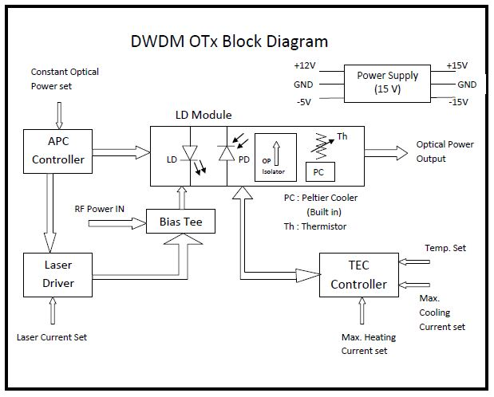

Figure 2 Optical Transmitter Block Diagram

2.1 **Laser Module**

The laser module used in the optical transmitter consists of laser diode, monitor photodiode, optical isolator, thermister, Peltier cooler and RF matching circuit. The light sources used in the optical transmitter built for upgraded GMRT is a DFB (Distributed Feedback) Laser diode having highly linear current verses optical power characteristics with very narrow spectral width suitable for DWDM multiplexing. DWDM channel uses the same type of laser diode but tuned to the wavelength ( 193.0, 193.2, 193.4, 193.6 THz ) specified by the 4 channel DWDM coupler.

The monitor photodiode uses a tapped laser source from the main laser output and produces a monitoring photocurrent which is used in the APC (Automatic Power Control) circuit of the optical transmitter. The photocurrent is compared with a reference value and the APC circuit produces an error voltage to correct the laser bias current.

The laser module used for GMRT upgrade is a cooled laser module and has a thermister to monitor the temperature of the laser. The thermister is a negative temperature coefficient resistor whose resistance decreases with increase in laser temperature. This is connected to the TEC ( Thermo Electric Controller ) circuit and the circuit produces an error voltage which controls the current through the Peltier coller inside the laser module which helps in cooling and heating the laser depending on the temperature of the laser.

The optical isolator is a most important component of an analog optical transmitter using DFB laser which reduces any optical power entering the laser due to connector or coupler reflections. DFB lasers are very sensitive to optical reflection and hence they come with built in optical isolators.

|  |  |  |
| --- | --- | --- |
| Revision | Date | Modification/Changes |
| Ver. 1.0 | April 2015 | Initial version |

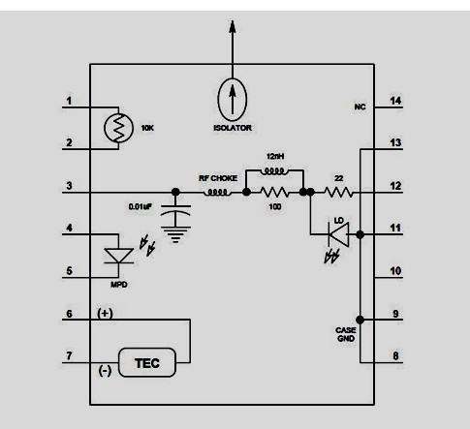 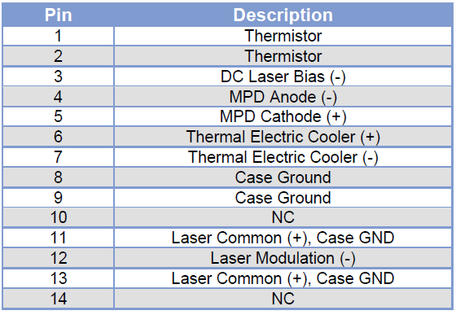

Figure 3 Laser module internal block diagram with pin configuration

The Laser module has a built in broadband bias Tee which connects both DC bias to the laser and the modulating RF signal to the laser diode. The RF input is matched with a 22 ohm resistor shown in figure 2.

2.2 **Laser Driver and APC control**

The laser driver is an (IC) integrated circuit module with which the laser bias current can be programmed. The programmed bias current is a fixed operating current of the laser which is above laser threshold and below the maximum current of the laser. The IC has built in APC circuit which connects to the monitoring photodiode of the laser module and based on the error voltage due to variation in operating laser power is feedback to the laser driver circuit which adjusts the laser current to produce constant optical power output. The variation in optical power could happen due to change in operating temperature and with aging of the device. The laser bias current could be varied by +/- 10 mA about the set fixed bias current. The laser driver is built with slow start power supply to the laser with thermal shutdown. The driver also has an alarm which turns on if the APC control is out of loop due to insufficient current from the monitoring photodiode which could be a laser failure.

2.3 **Thermoelectric cooler controller**

The TEC circuit uses a module which connects the thermister and Peltier cooler of the laser diode module. The TEC circuit module set the operating temperature of the laser and the temperature of the laser is monitored using the thermister and feedback and compared with the set operating temperature of the laser. An error voltage is generated which drives Peltier cooler of the laser module. The direction of the current decides the cooling and heating of the Peltier device. The cooling current to the laser module is limited to 1.2 A and the heating current is limited to 0.8 A for safe operation of the TEC and Laser module during initial power ON requirement. For GMRT upgrade the transmitter is set at 20 degree Celsius and could maintain temperature within +/- 0.1 degree Celsius for slow cooling and heating conditions.

|  |  |  |
| --- | --- | --- |
| Revision | Date | Modification/Changes |
| Ver. 1.0 | April 2015 | Initial version |

2.4 **DC Regulated power supply**

The regulator card has +/- 15V DC as input voltage and produces +/-12 V and +/-5V DC output voltage to drive a load of 1 A capacity. The +/-12 V output voltage can be adjusted with the variable resistor provided in the circuit. Figure 4 shows the assembled power supply card for optical transmitter.

2.5 **RF pre-amplifier**

The optical transmitter is equipped with an RF pre-amplifer at the input of the optical transmitter to provide sufficient RF gain to operate the laser diode in linear region. Sirenza amplifer with a gain of 20 dB is used within the optical transmitter PIU as shown in figure 5.

2.6 **PIU connections**

The (OTX) optical transmitter PIU has a DIN connector for DC input, SMA connector for RF input, E2000 optical connector for optical output and 9 pin D-type connector and banana sockets for DC bias voltage monitoring for local and remote monitoring of the PIU.



Figure 4 Assembled optical transmitter card with PIU input and output connection details

|  |  |  |
| --- | --- | --- |
| Revision | Date | Modification/Changes |
| Ver. 1.0 | April 2015 | Initial version |

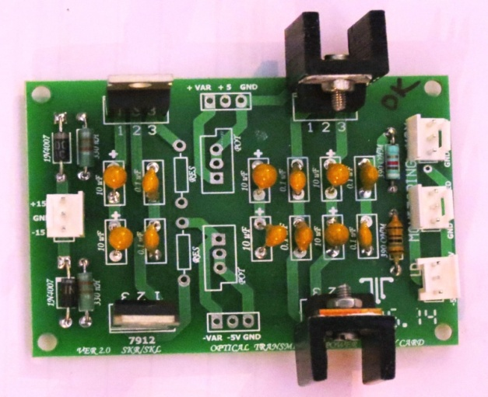 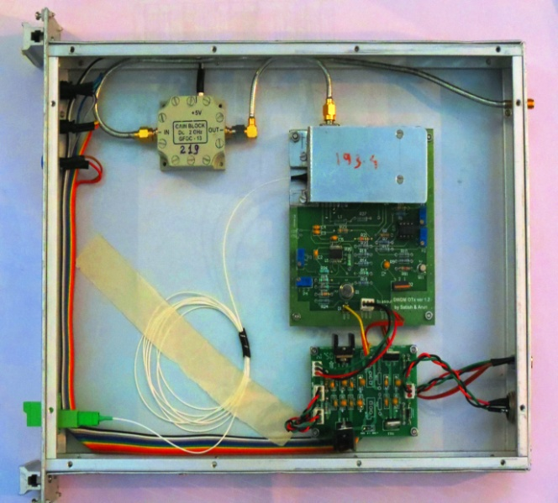

Figure 5 Power supply card Figure 6 Fully assembled optical transmitter unit

3.0 **Optical transmitter specifications**

3.1 **Optical Parameters**

Laser Type : DWDM – Cooled DFB Laser

Optical Wavelength : 200 GHz ITU Grid (channels - 30, 32, 34, 36)

Optical Power at Bias : 10 dBm at 60 mA

Optical Bias at 22 °C : 60 mA

Threshold current : 20 mA at 25 °C

Operating Temperature : -40 to +85 °C

Wavelength drift : 40 pm over operating temperature range

Optical Return loss : 40 dB

Thermistor Resistance : 10 KΩ

3.2 **RF Parameters**

Frequency response : 5 – 3 GHz

Slope Efficiency : 0.12 mW/mA

Monitor PD responsitivity : 0.2 mA/mW

Monitor PD darkcurrent : 0.2 µA

Input impedance : 50 Ω

Input Return loss : 10 dB

Relative Intensity Noise : -155 dB/Hz

Input P1dB : -3 dBm with 20 dB pre-amplifier.

3.3 **Optical Transmitter DC operating conditions**

DC Positive supply : +15 V, 130 mA during operation

DC Negative supply : -15 V, 110 mA during operation

Power ON requirement : 1.2 A

|  |  |  |
| --- | --- | --- |
| Revision | Date | Modification/Changes |
| Ver. 1.0 | April 2015 | Initial version |

4.0 **Optical transmitter performance**

The optical transmitter performance with temperature and the tracking of TEC cooler controller is shown in figure 6.

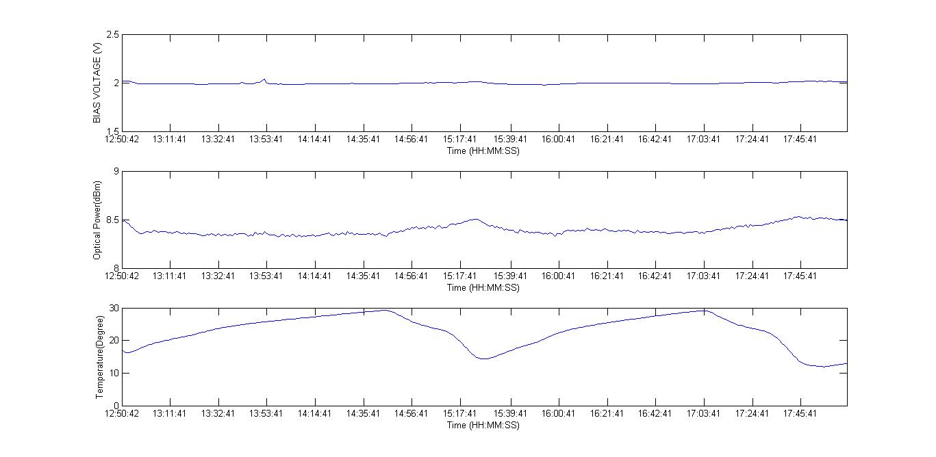

Figure 7: Performance of Optical transmitter with temperature

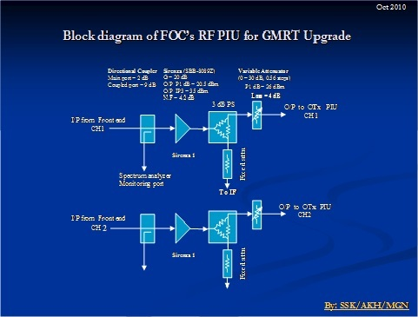

Figure 8: Interface details of frontend and fiber optic system with RFI PIU

|  |  |  |
| --- | --- | --- |
| Revision | Date | Modification/Changes |
| Ver. 1.0 | April 2015 | Initial version |

5.0 **Interface between Frontend and Broadband Fiber optics system**

The RF interface PIU1 connecting frontend system output to broadband fiber optic system at antenna base is shown in figure 8. Each polarization of the frontend signal is split into two outputs with a 3 dB power splitter and one output is connected to the existing IF system of ABR rack in the antenna shell to support the existing narrow band system of GMRT and the other is connected to broadband fiber optic transmitter unit. The broadband signal through upgraded fiber optic system uses a switchable attenuator to adjust the frontend signal level to the fiber optic transmitter for ensuring uniform operation and in linear range.

6.0 **Conclusion**

The designed optical transmitter uses 200 GHz spaced DWDM cooled laser with highly linear characteristics for analog application like RF over fiber application. The optical transmitter has very high input P1dB operating level to sustain radio frequency interference within the band. The optical power of the transmitter is +10 dBm and could easily drive 40 km distance and by using it for a maximum distance of 22 km for GMRT application there is sufficient margin available to support additional cable cut loss. The RF input operating point is selected at -45 dBm at lower end so that with increase in RFI level the laser always operate at linear region without saturation.

**References**

1. RF gain block for broadband analog fiber optic link, M.Gopinathan, S.Sureshkumar, July 2011.
2. Signal flow analysis of fiber optic system for GMRT upgrade, Arunkumar Hedallikar, S.Sureshkumar, Feb 2012.
3. (Preliminary report ) Signal flow analysis of broadband analog fiber optic system with 10 dB fixed attenuator and post amplifier, Ankur, S.Sureshkumar, Nov 2014.
4. Broadband analog fiber optic link – Optical receiver, Satish Lokhande, S.Sureshkumar, Nov 2014.

|  |  |  |
| --- | --- | --- |
| Revision | Date | Modification/Changes |
| Ver. 1.0 | April 2015 | Initial version |