Project Report

On

**“WEB APPLICATION TOOLS FOR RFI DATA”**

Submitted By

Suvidha Subhash Kavale

Guided By

Mr. S Sureshkumar

Mr. Sanjeet Kumar Rai



**National Center for Radio Astrophysics**

TATA INSTITUTE OF FUMDAMENTAL REASERCH

GIANT METERWAVE RADIO TELESCOPE

ACKNOWLDGEMENT

It has been great honour and privilege to undergo training at Giant Meterwave Radio Telescope (GMRT). I am very much thankful to Mr. Suresh Kumar for providing me this great opportunity to work at such a prestigious place under his efficient guidance and also providing all facilities and support to meet the project requirements. I would like to take opportunity to express my humble gratitude to Mr. Sanjeet Rai under whom I executed this project his constant guidance and willingness to share his vast knowledge made me to understand this project and its manifestation in great depth and helped to complete the assigned task.

INDEX

1. INTRODUCTION
2. SOFTWARE USED

2.1 XAMPP SERVER INSTALLTION ON LINUX

2.1.2 INTRODUCTION

2.1.2 INSTALLTION STEPS

2.2 XAMPP SERVER INSTALLTION ON LINUX

2.2.1 INSTALLTION STEPS

1. LANGUAGE USED

3.1 HTML5

3.2 CSS3

3.3 JAVASCRIPT

3.4 PHP

1. FRAMEWORK USED

4.1 BOOTSTRAP

1. OUTPUT
2. CODE AND FUNCTION
3. FILES AND FOLDER
4. REFERENCE

**1.** **INTRODUCTION**

* 1. **Need of Project**

The aim of developing the WEB APPLICATION TOOLS FOR RFI DATA Page is to maintain the database of work carried out at Front end and OF System with detailed information. Upgraded Frontend system consist of four bands i.e. 130-260 MHz, 250-500 MHz, 550-900 MHz and L-band, with this web tool we can keep record of upgrade activities, like number of upgraded antenna with their band names, the spare component and used components for upgrade activities. Similarly it also keep database for upgraded fiber optics system, with this we can access fiber route details and no. of splicing with their loss details. In addition, inventory software is also made which will keep records of available components in both frontend and fiber optics lab, when it has been purchased, number of times it has been withdrawn from stock with person detail who has withdrawn it.

* 1. **Requirement**

**Hardware Requirement**

|  |  |
| --- | --- |
| Processor | Intel Dual Core |
| RAM | 1 GB |
| Hard Disk | 80GB |

**Software Requirement**

|  |  |
| --- | --- |
| Operating System | Linux, Windows |
| Programming Language | HTML5, CSS3 |
| Scripting Language | JavaScript, JQuery, PHP |
| Framework | Bootstrap |

1. **SOFTWARE USED**
   1. **LAMP SERVER INSTALLATION ON LINUX (UBUNTU)**
      1. **Introduction**

LAMP is an Open source Web development platform that uses Linux as the operating system, Apache as the Web server, and MySQL as the relational database management system and PHP as the object-oriented scripting language. (Sometimes Perl or Python is used instead of PHP.)

Linux is a Unix-like computer operating system assembled under the model of free and open source software development and distribution.

The role of LAMP's web server has been traditionally supplied by Apache. Apache is the most widely used web server software. It is developed and maintained by an open community of developers under the auspices of the Apache software foundation Released under the Apache license. Apache is open source software. A wide variety of features are supported, and many of them are implemented as compiled module, which extend the core functionality of Apache. These can range from server-side programming language support to authentication schemes.

PHP is a server side scripting language designed for web development but also used as a general purpose programming language. PHP code is interpreted by a web server via a PHP processor module, which generates the resulting web page. PHP commands can optionally be embedded directly into an HTML source document rather than calling an external file to process data. It has also evolved to include a command line interface capability and can be used in standalone graphical applications.

* + 1. **Installation Steps**

**Apache Installation:**

* Update the repositories. Command: #yum check-update
* Install Apache Package:

Command: #yum install httpd

* Start the service

Command: #systemctl start httpd.service

* Enable it at startup

Command: #systemctl enable httpd.service

* Exclude http service from firewall.

Command: #firewall-cmd --permanent --add-service http

* Restart firewall service.

Command: #systemctl restart firewalld.service

* Apache installation is over. For testing, open your browser window type in url

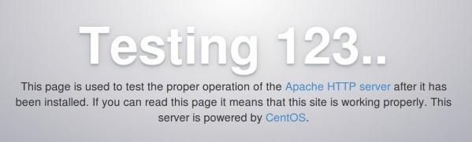“localhost/System IP address”, you can see apache demo page like below.

**MySql Installation**

* Start installing MariaDB, MySQL drop-in replacement Command: #yum install mariadb-server mariadb
* Start the service

Command: #systemctl start mariadb

* Enable at startup.

Command: #systemctl enable mariadb.service

* To secure your DB installation.

Command: #mysql_secure_installation

* 1. Current password (Leave blank and hit Enter).
  2. Enter new password.
  3. Re Enter password and Hit enter for all the other options. Note: MySql is not being used for these project.
* MariaDB installation is over. For testing, Check login into DB using the below Command: [root@gpuuser ~]# mysql -u root –p

Enter password:

Welcome to the MariaDB monitor. Commands end with ; or g.

Your MariaDB connection id is 10

Server version: 5.5.37-MariaDB MariaDB Server

Copyright (c) 2000, 2014, Oracle, Monty Program Ab and others. Type 'help;' or 'h' for help. Type 'c' to clear the

current input statement. MariaDB [(none)]>

**PHP Installation**

* Install PHP and other recommended packages**.**

Command: #yum install php php-mysql

* Now restart apache service.

Command: #systemctl restart httpd.service

* For testing, Create a file **phpinfo.php** in **/var/www/html/** (Default root directory) and add the below code.

<?php phpinfo(); ?>

* Now open localhost or serverIP/phpinfo.php in your browser. You will see PHP version and other configuration details like below.

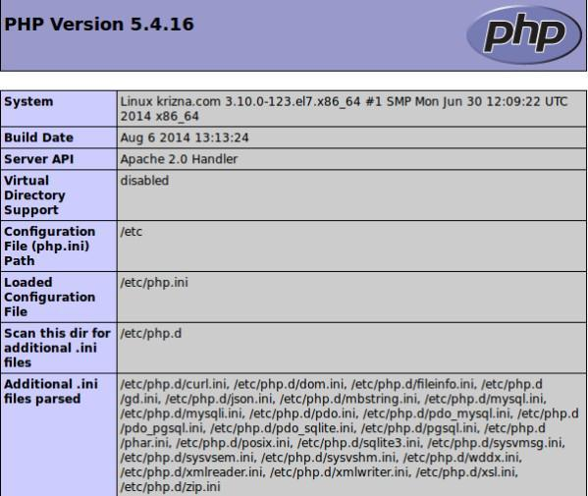

Versions used

* Operating system: centos 7.21511(core).

To check Centos version, type the following Command. Command: # cat /etc/centos-release.

* Apache version:

To check Apache version, type the following Command. Command: # httpd -v.

* MySql version: MySql-15.1

To check MySql version, type the following Command. Command: # mysql --version.

* PHP version: PHP-5.4.16

To check PHP version, type the following Command. Command: # php –v

Important Note:

* To write a PHP, JavaScript and HTML script, use any editor like vim or geditor.
* Use following path to save a script

Path: /var/www/html/your_folder_name/script_name.

* To see the web page, open your URL and type into

Localhost OR system_ip_address/your_folder_name/script_name

* 1. **LAMP SERVER INSTALLATION ON LINUX (CentOS)**

**2.2.1Step One—Install Apache**

To install apache, open terminal and type in this command:

**sudo yum install httpd**

Once it installs, you can start apache running on your VPS:

**sudo service httpd start**

That’s it. To check if Apache is installed, direct your browser to your server’s IP address (eg. http://12.34.56.789). The page should display the words “It works!" like [this](https://assets.digitalocean.com/tutorial_images/NLSJR.png). <https://assets.digitalocean.com/tutorial_images/NLSJR.png>

## How to find your Server’s IP address

You can run the following command to reveal your server’s IP address.

**ifconfig eth0 | grep inet | awk '{ print $2 }'**

## Step Two—Install MySQL

MySQL is a powerful database management system used for organizing and retrieving data on a virtual server

To install MySQL, open terminal and type in these commands:

**sudo yum install mysql-server**

**sudo service mysqld start**

During the installation, MySQL will ask you for your permission twice. After you say Yes to both, MySQL will install.

Once it is done installing, you can set a root MySQL password:

**sudo /usr/bin/mysql_secure_installation**

The prompt will ask you for your current root password.

Since you just installed MySQL, you most likely won’t have one, so leave it blank by pressing enter.

**Enter current password for root (enter for none):**

**OK, successfully used password, moving on...**

Then the prompt will ask you if you want to set a root password. Go ahead and choose Y and follow the instructions.

CentOS automates the process of setting up MySQL, asking you a series of yes or no questions.

It’s easiest just to say Yes to all the options. At the end, MySQL will reload and implement the new changes

**By default, a MySQL installation has an anonymous user, allowing anyone**

**to log into MySQL without having to have a user account created for**

**them. This is intended only for testing, and to make the installation**

**go a bit smoother. You should remove them before moving into a**

**production environment.**

**Remove anonymous users? [Y/n] y**

**... Success!**

**Normally, root should only be allowed to connect from 'localhost'. This**

**ensures that someone cannot guess at the root password from the network.**

**Disallow root login remotely? [Y/n] y**

**... Success!**

**By default, MySQL comes with a database named 'test' that anyone can**

**access. This is also intended only for testing, and should be removed**

**before moving into a production environment.**

**Remove test database and access to it? [Y/n] y**

**- Dropping test database...**

**... Success!**

**- Removing privileges on test database...**

**... Success!**

**Reloading the privilege tables will ensure that all changes made so far**

**will take effect immediately.**

**Reload privilege tables now? [Y/n] y**

**... Success!**

**Cleaning up...**

**All done! If you've completed all of the above steps, your MySQL**

**installation should now be secure. Thanks for using MySQL!**

## 

## 

## Step Three—Install PHP

PHP is an open source web scripting language that is widely used to build dynamic webpages.

To install PHP on your virtual private server, open terminal and type in this command:

**sudo yum install php php-mysql**

Once you answer yes to the PHP prompt, PHP will be installed.

## PHP Modules

PHP also has a variety of useful libraries and modules that you can add onto your server. You can see the libraries that are available by typing:

**yum search php-**

Terminal then will display the list of possible modules. The beginning looks like this:

php-bcmath.x86_64 : A module for PHP applications for using the bcmath library

php-cli.x86_64 : Command-line interface for PHP

php-common.x86_64 : Common files for PHP

php-dba.x86_64 : A database abstraction layer module for PHP applications

php-devel.x86_64 : Files needed for building PHP extensions

php-embedded.x86_64 : PHP library for embedding in applications

php-enchant.x86_64 : Human Language and Character Encoding Support

php-gd.x86_64 : A module for PHP applications for using the gd graphics library

php-imap.x86_64 : A module for PHP applications that use IMAP

To see more details about what each module does, type the following command into terminal, replacing the name of the module with whatever library you want to learn about.

yum info *name of the module*

## Once you decide to install the module, type:

**sudo yum install *name of the module***

You can install multiple libraries at once by separating the name of each module with a space.

Congratulations! You now have LAMP stack on your droplet!

We should also set the processes to run automatically when the server boots (php will run automatically once Apache starts):

**sudo chkconfig httpd on**

**sudo chkconfig mysqld on**

Although LAMP is installed on your virtual server, we can still take a look and see the components online by creating a quick php info page

To set this up, first create a new file:

**sudo nano /var/www/html/info.php**

Add in the following line:

<?php

phpinfo();

?>

Then Save and Exit.

Restart apache so that all of the changes take effect on your virtual server:

**sudo service httpd restart**

Finish up by visiting your php info page (make sure you replace the example ip address with your correct one): http://12.34.56.789/info.php

## Install phpMyAdmin

Now, we are ready to install the phpMyAdmin package. This software is not available in the CentOS 6 default repositories. However, it is avialable in the EPEL repos (Extra Packages for Enterprise Linux).

We can add access to the EPEL repositories to our system by typing:

**sudo yum install epel-release**

After accepting the new repository, you can install the phpMyAdmin package by typing:

**sudo yum install phpmyadmin**

This will install phpMyAdmin. We still must configure it though.

## Configure phpMyAdmin

For security purposes, we should lock down access to the phpMyAdmin interface to a specific IP address.

### Find Your IP Address

You will need to know the IP address of the computer you plan on using to access your databases. This is a security precaution so that unauthorized people cannot connect.

**Note: This is the not the IP address of your VPS, it is the IP address of your home or work computer.**

### Configure Apache Files

The phpMyAdmin package installs an Apache Virtual Host file that is used to configure web access. Open the file with the following command:

**sudo nano /etc/httpd/conf.d/phpMyAdmin.conf**

By default, this configuration only allows access from the same computer that is hosting the software. Because the databases, web server, and administration software are hosted on a VPS instead of your home computer, we will have to adjust these values.

This is where the IP information about your home computer comes in handy. We will change every reference to 127.0.0.1 with the IP address you found.

There should be four locations that you need to change:

**/etc/httpd/conf.d/phpMyAdmin.conf. . .**

**Require ip your_workstation_IP_address**

**. . .**

**Allow from your_workstation_IP_address**

**. . .**

**Require ip your_workstation_IP_address**

**. . .**

**Allow from your_workstation_IP_address. . .**

Save and close the file.

You need to restart the server with the following command:

**sudo service httpd restart**

## See the Results!

Your interface should now be configured and ready to access.

Point your web browser to your **VPS** IP address followed by "/phpmyadmin"

<http://VPS_IP_address/phpmyadmin>

You will be asked to log in. Use the user **root** and the password that you selected during the MySQL configuration stage.

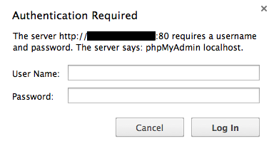

* 1. **XAMPP SERVER INSTALLATION ON WINDOWS**

**2.3.1Step One—Install XAMPP ON WINDOWS**

To install XAMPP in windows 7, first you need to download the XAMPP installer for windows. To download the XAMPP installer for windows, visit the URL [https://www.apachefriends.org/download.html.](http://www.apachefriends.org/en/xampp-windows.html)

1.This page shows the latest version of XAMPP for windows. It also shows the versions of Apache, PHP, MySQL, and other softwares included in this version of XAMPP.

2.Now, go to the "Download" section in the page. Here, you will see XAMPP for Windows, Linux, and Mac OS X. We can easily download the XAMPP installer for Windows.

3. After downloading the installer, double click on the executable(.exe) file to start the XAMPP installation process. Click Yes, if User Account Control dialog box appears.

Select your language in the dialog box then click OK.

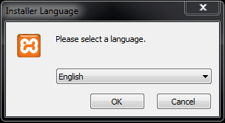

**4)** This dialog box below shows that you should avoid installing XAMPP to C:\Program Files.

. 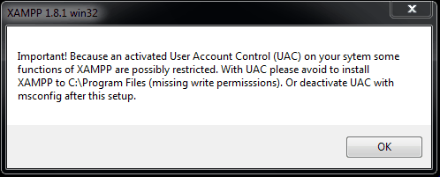

**5**)Click Next.

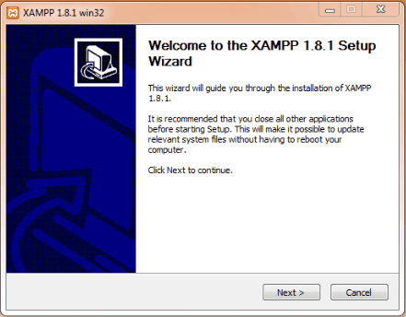

**6)** Verify that all the checkboxes are checked, then click Next.

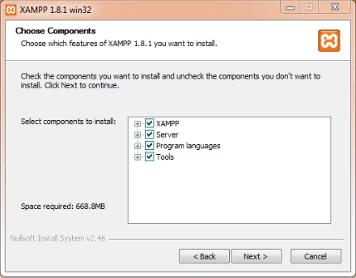

Verify that the Destination Folder is set to C:\xampp[,](http://c/xampp) then click Install.

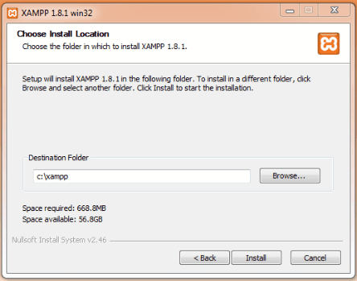

**7)** You will see the installation progresses. Wait for the process to complete.

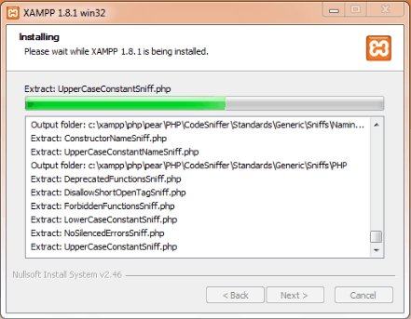

**8)** Click Finish to finish the installation process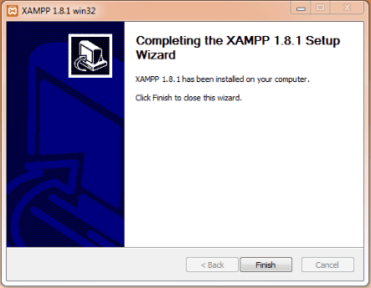

**9)** The dialog box asks: Do you want to start the Control Panel now?

You can choose to start the Control Panel now. Clicking Yes will directly open the XAMPP control panel. Please see the Note below to know how to start XAMPP Control Panel.

The installation is complete.

**10)** If the XAMPP control panel is not already started, find the XAMPP control panel in the start menu or the its desktop icon, right click on it and select "Run as administrator". Click "Yes" on the "User Account Control" popup, and wait for the XAMPP control panel to start. You will see the XAMPP control panel running.

**11)** Click on the Start button next to Apache, and wait for apache to start. After the Apache has started, click on the Start button next to MySQL. Wait for MySQL to start. Both Apache and MySQL are running now.

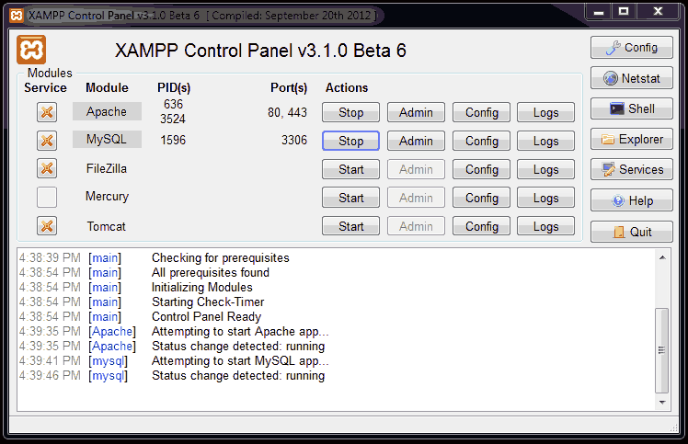

**12)** Now, open your web browser like Mozilla Firefox or Chrome.

Type “localhost” in the address bar and click enter. The browser will be redirected to “localhost/xampp/splash.php”. The browser should display the page shown below.



If your browser displays the above page, XAMPP is installed successfully and working properly.

Click on the language you want to use in the displayed page. You will see the page as shown below.

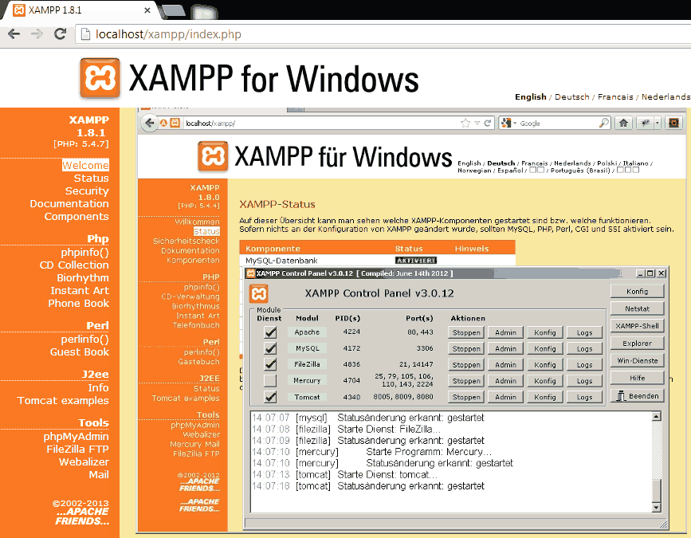

XAMPP is ready to run your blog or website locally on your computer.

1. **LANGUAGE USED**
   1. **HTML5**

**Hypertext Markup Language**, commonly referred to as **HTML**, is the standard markup

Language used to create web pages. Along with CSS, and JavaScript, HTML is a cornerstone

Technology, used by most websites to create visually engaging web pages, user interfaces for web applications, and user interfaces for many mobile applications. Web browsers can read HTML files and render them into visible or audible web pages. HTML describes the structure of a website semantically along with cues for presentation, making it a markup language, rather than a programming language.

HTML elements form the building blocks of all websites. HTML allows images and objects to be embedded and can be used to create interactive forms. It provides a means to create structured documents by denoting structural semantics for text such as headings, paragraphs, lists, links, quotes and other items. The language is written in the form of HTML elements consisting of *tags* enclosed in angled brackets (like <html>). Browsers do not display the HTML tags and scripts, but use them to interpret the content of the page. HTML can embed scripts written in languages such as JavaScript which affect the behavior of HTML web pages.

A **web form**, **web form** or **HTML form** on a web page allows a user to enter data that is sent to a server for processing. Forms can resemble database forms because web users fill out the forms using check boxes, radio buttons, or text-fields.

<!DOCTYPE html>

<html>

<head>

<title>This is a title</title>

</head>

<body>

<p>Hello world!</p>

</body>

</html>

* 1. **CSS3**

**Cascading Style Sheets** (**CSS**) is a style sheet language used for describing the presentation of a document written in a markup language. Although most often used to set the visual style of web pages and user interfaces written in HTML and XHTML, the language can be applied to any XML document, including plain XML, SVG and XUL, and is applicable to rendering in speech, or on other media. Along with HTML and JavaScript,CSS is a cornerstone technology used by most websites to create visually engaging web pages, user interfaces for web applications, and user interfaces for many mobile applications. CSS is designed primarily to enable the separation of document content from document presentation, including aspects such as the layout, colors, and fonts.

This separation can improve content accessibility, provide more flexibility and control in the specification of presentation characteristics, enable multiple HTML pages to share formatting by specifying the relevant CSS in a separate .css file, and reduce complexity and repetition in the structural content, such as semantically insignificant tables that were widely used to format pages before consistent CSS rendering was available in all major browsers. CSS makes it possible to separate presentation instructions from the HTML content in a separate file or style section of the HTML file. For each matching HTML element, it provides a list of formatting instructions. For example, a CSS rule might specify that "all heading 1 elements should be bold", leaving pure semantic HTML markup that asserts "this text is a level 1 heading" without formatting code such as a <bold> tag indicating how such text should be displayed.

This separation of formatting and content makes it possible to present the same markup page in different styles for different rendering methods, such as on-screen, in print, by voice (when read out by a speech-based browser or screen reader) and on Braille-based, tactile devices. The CSS specifications are maintained by the World Wide Web Consortium (W3C). Internet media type (MIME type) text/css is registered for use with CSS by RFC 2318 (March 1998). The W3C operates a free CSS validation service for CSS documents.

* 1. **JavaScript**

**JavaScript** (sometimes abbreviated JS) is a prototype-based scripting language that is

Dynamic, weakly typed and has first-class functions. It is a mulch-paradigm language, supporting object-oriented, imperative, and functional programming styles. JavaScript was formalized in the ECMAScript language standard and is primarily used in the form of client-side JavaScript, implemented as part of a Web browser in order to give enhanced user interfaces and dynamic websites. This enables programmatic access to computational objects within a host environment. JavaScript's use in applications outside Web pages for example in PDF documents, site-specific browsers, and desktop widgets is also significant. Newer and faster JavaScript VMs and frameworks built upon them (notably Node.js) have also increased the popularity of JavaScript for server-side web applications. JavaScript uses syntax influenced by that of C. JavaScript copies many names and naming conventions from Java, but the two languages are otherwise unrelated and have very different semantics. The key design principles within JavaScript are taken from the self and Scheme programming languages. Loading new page content or submitting data to the server via AJAX without reloading the page (for example, a social network might allow the user to post status updates without leaving the page)

* Animation of page elements, fading them in and out, re sizing them, moving them, etc.
* Interactive content, for example games, and playing audio and video
* Validating input values of a Web form to make sure that they are acceptable before being
* Submitted to the server.
* Transmitting information about the user's reading habits and browsing activities to various
* Websites. Web pages frequently do this for web analytic, ad tracking, professionalization or
* Other purposes.

JavaScript is used along with the HTML codes embedded among them only through the following

Syntax:

<script type=”text/javascript”>

//codes to be executed//

document.write( H ello!‘);

</script>

* 1. **PHP**

What is PHP?

* PHP is an acronym for "PHP: Hypertext Preprocessor"
* PHP is a widely-used, open source scripting language
* PHP scripts are executed on the server
* PHP is free to download and use

What you should already know?

Before you continue you should have a basic understanding of the following:

* HTML
* CSS
* JavaScript

What can PHP Do?

* PHP can generate dynamic page content
* PHP can create, open, read, write, delete, and close files on the server
* PHP can collect form data
* PHP can send and receive cookies
* PHP can add, delete, modify data in your database
* PHP can be used to control user-access
* PHP can encrypt data

With PHP you are not limited to output HTML. You can output images, PDF files, and even flash movies. You can also output any text, such as XHTML and XML.

Why PHP?

* PHP runs on various platforms (Windows, Linux, UNIX, Mac OS X, etc.)
* PHP is compatible with almost all servers used today (Apache, IIS, etc.)
* PHP supports a wide range of databases
* PHP is free. Download it from the official PHP resource: [www.php.net](http://www.php.net/)
* PHP is easy to learn and runs efficiently on the server side

Syntax

<!DOCTYPE html>  
<html>  
<body>  
  
<?php  
echo "<h2>PHP is Fun!</h2>";  
echo "Hello world!<br>";  
echo "I'm about to learn PHP!<br>";  
echo "This ", "string ", "was ", "made ", "with multiple parameters.";  
?>   
  
</body>  
</html>

1. **FRAMEWORK USED**

**Introduction**

Bootstrap is the most popular HTML, CSS, and JavaScript framework for developing responsive, mobile-first web sites. Bootstrap is completely free to download and use!

**What is Bootstrap?**

* Bootstrap is a free front-end framework for faster and easier web development
* Bootstrap includes HTML and CSS based design templates for typography, forms, buttons, tables, navigation, modals, image carousels and many other, as well as optional JavaScript plugins
* Bootstrap also gives you the ability to easily create responsive designs

## Why Use Bootstrap?

Advantages of Bootstrap:

* **Easy to use:** Anybody with just basic knowledge of HTML and CSS can start using Bootstrap
* **Responsive features:** Bootstrap's responsive CSS adjusts to phones, tablets, and desktops
* **Mobile-first approach:** In Bootstrap 3, mobile-first styles are part of the core framework
* **Browser compatibility:** Bootstrap is compatible with all modern browsers (Chrome, Firefox, Internet Explorer, Safari, and Opera)

## Where to Get Bootstrap?

There are two ways to start using Bootstrap on your own web site.

You can:

1. Download Bootstrap from getbootstrap.com
2. Include Bootstrap from a CDN

**Syntax**

<!DOCTYPE html>

<html lang="en">

<head>

<title>Bootstrap Example</title>

<meta charset="utf-8">

<meta name="viewport" content="width=device-width, initial-scale=1">

<link rel="stylesheet" href="http://maxcdn.bootstrapcdn.com/bootstrap/3.3.7/css/bootstrap.min.css">

<script src="https://ajax.googleapis.com/ajax/libs/jquery/1.12.4/jquery.min.js"></script>

<script src="http://maxcdn.bootstrapcdn.com/bootstrap/3.3.7/js/bootstrap.min.js"></script>

</head>

<body>

<div class="container">

<h1>My First Bootstrap Page</h1>

<p>This part is inside a .container class.</p>

<p>The .container class provides a responsive fixed width container.</p>

</div>

</body>

</html>

1. **OUTPUT**
2. **MAIN PAGE:**

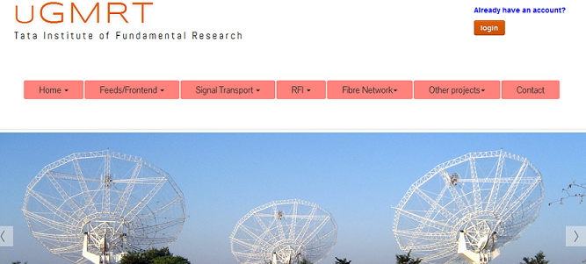

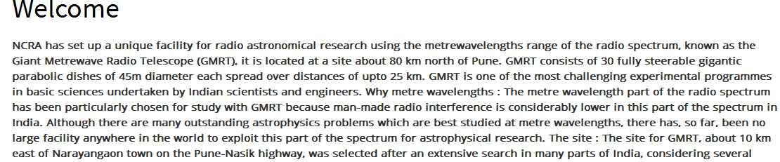

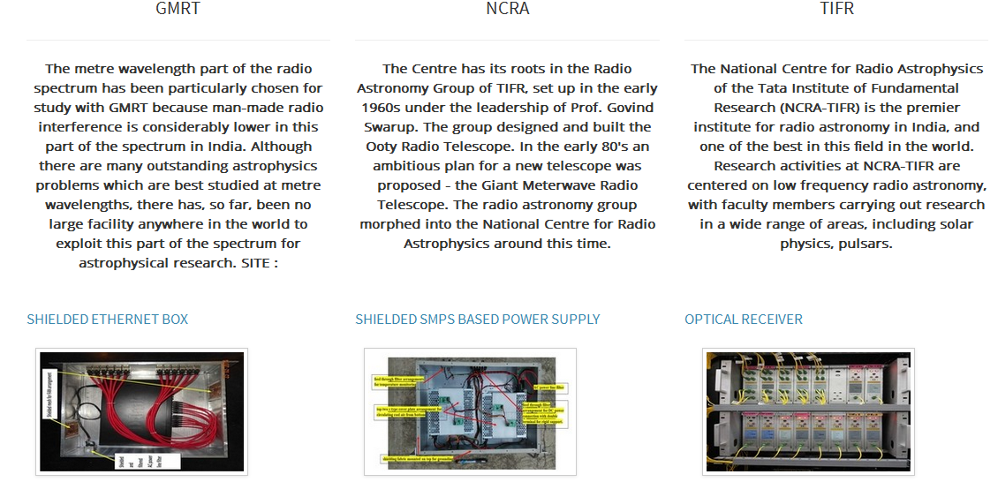



1. **SPLICING DETAILS:**

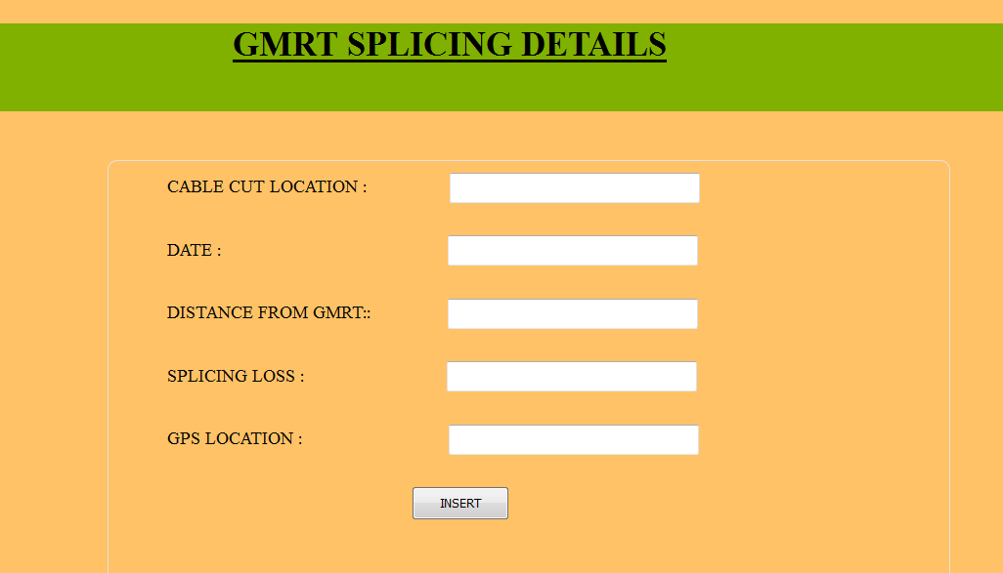

1. **SPLICING OUPUT:**

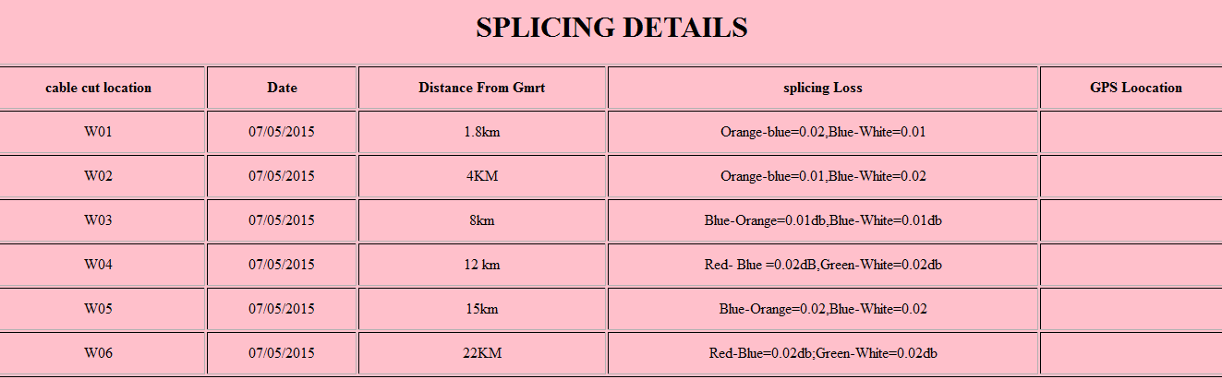

1. **CALL SHEET:**

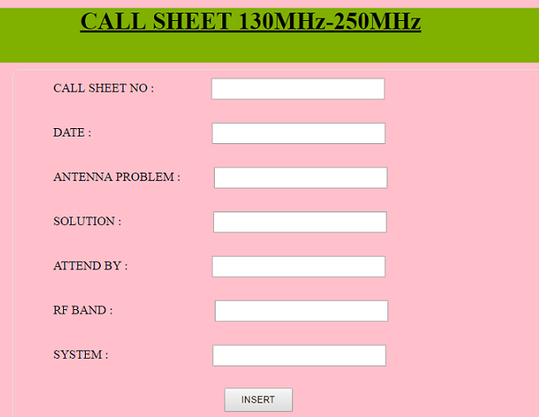

1. **ARCHIVE SUBMENU:**

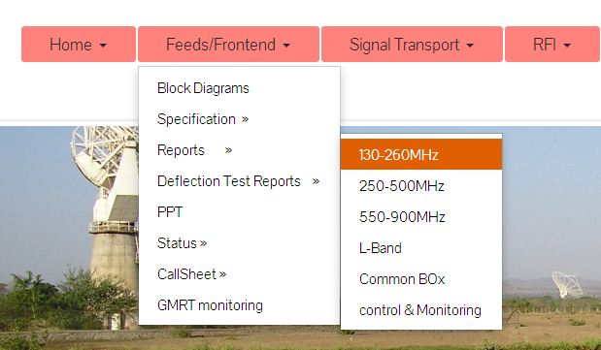

1. **STAFF AVALIBILITY:**

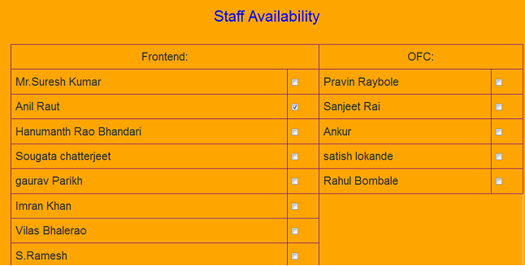

**7.ANTENNA STATUS:**

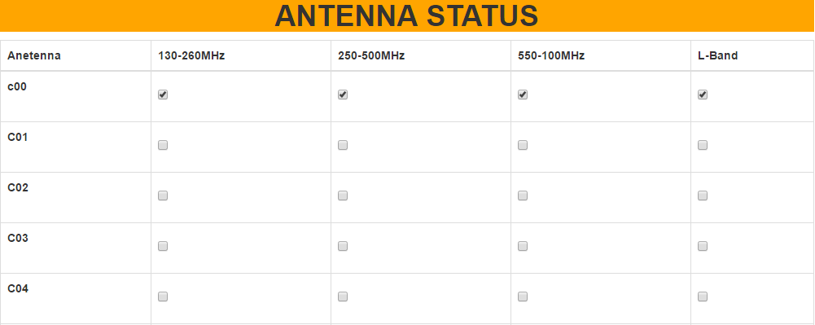

**8. BROWSE /DELETE FUNCTION:**

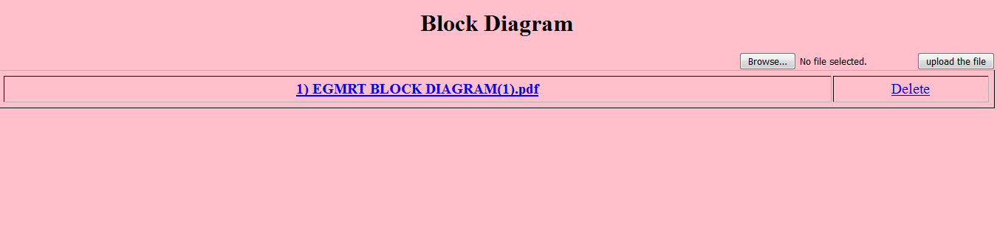

**9. FRONT END SUB MENU:**

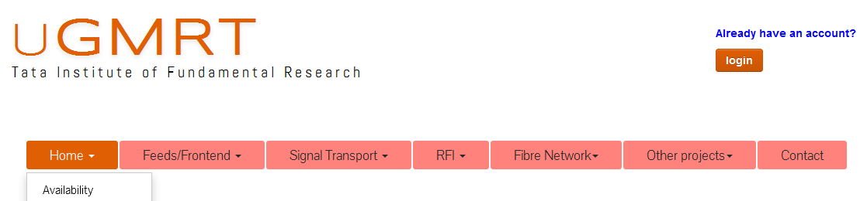

**10. FRONT END SUB MENU:**

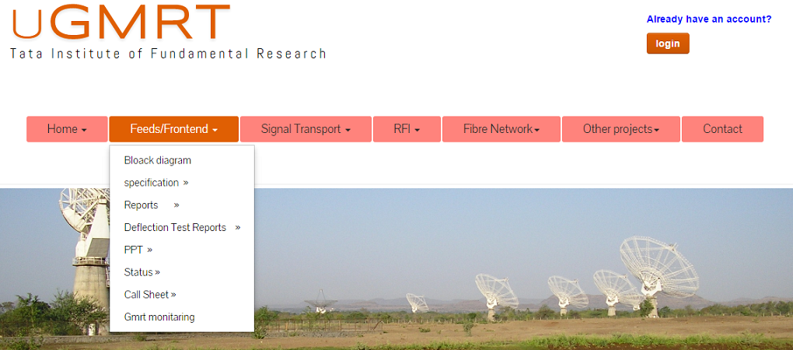

**11. SIGNAL TRANSPORT SUBMENU:**

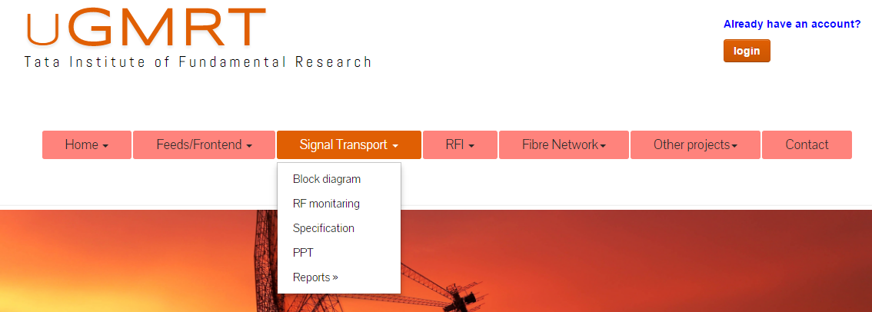

**12. RFI SUB MENU:**

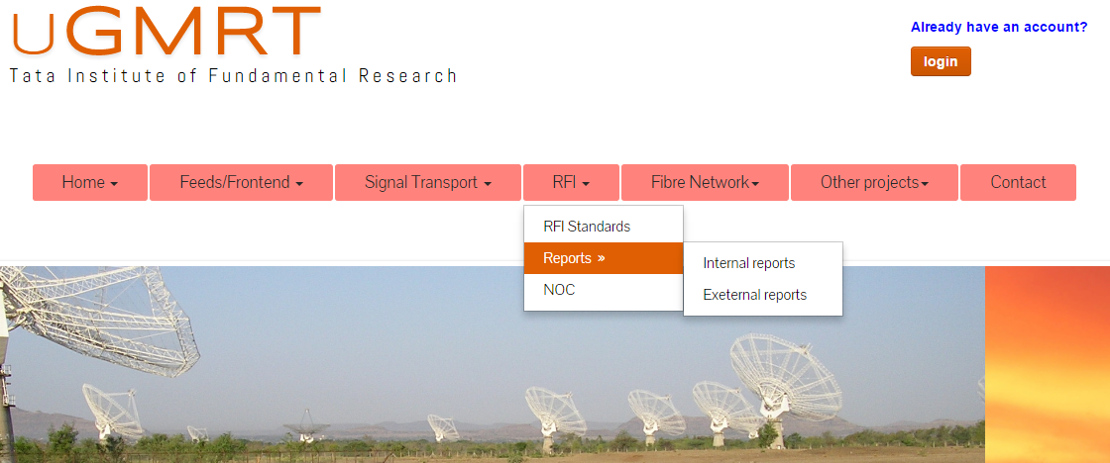

**13. FIBER NETWORK SUBMENU:**

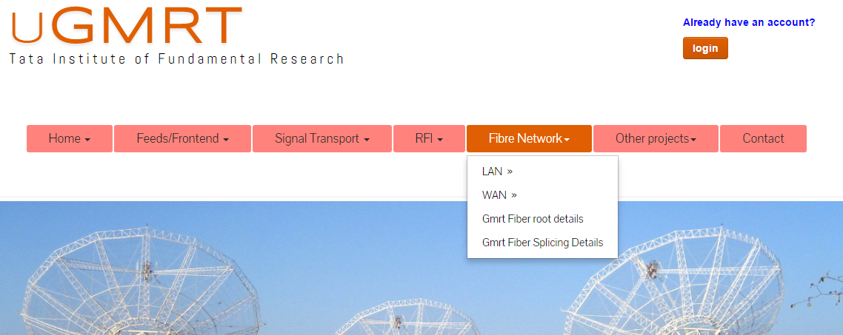

**14. OTHER PROJECT:**

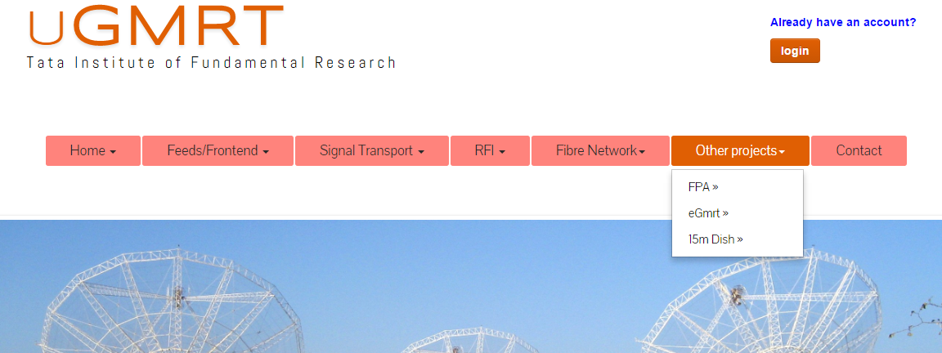

**15. CONTACT US:**

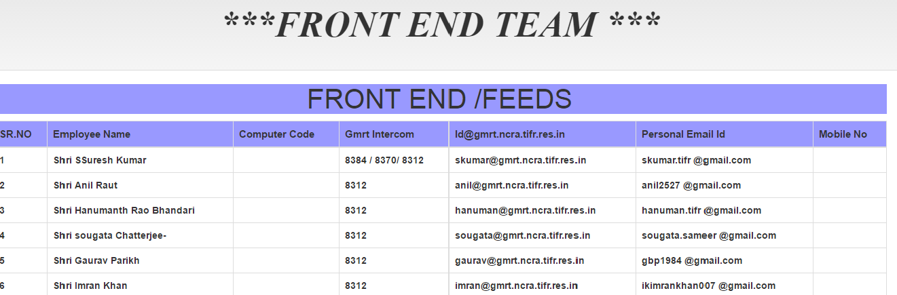

**16. LOGIN AND LOGOUT**

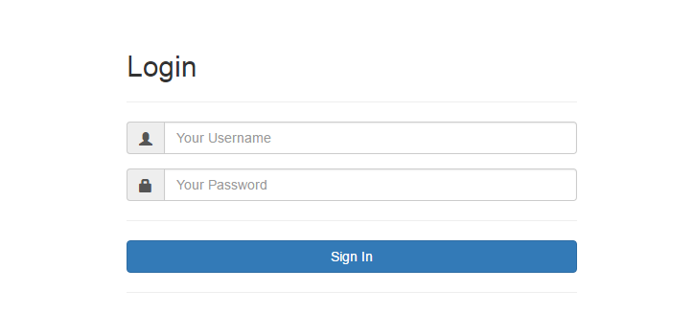

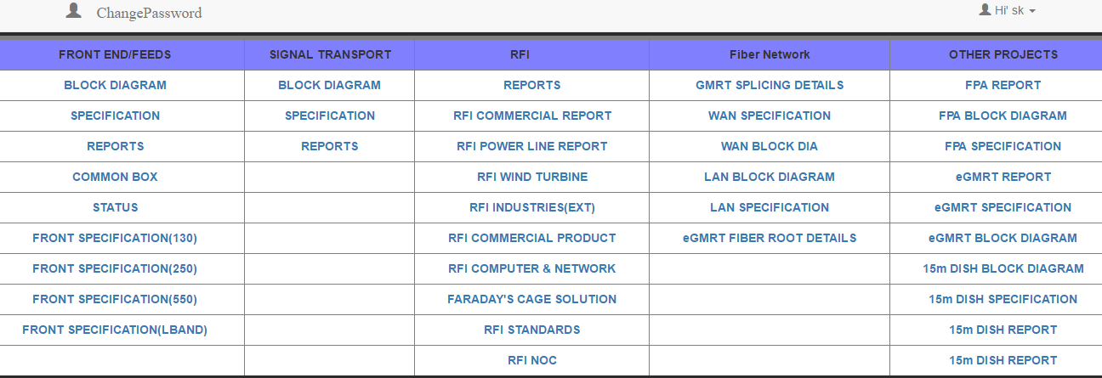

**16. STOCK MANAGEMENT TOOL DASHBOARD:**

**16.1 OVERVIEW**

**Stock management** is the function of understanding the **stock** mix of a company and the demands on that stock.The demands are influenced by both external and internal factors and are balanced by the creation of purchase order request to keep supplies at a reasonable or prescribed level.

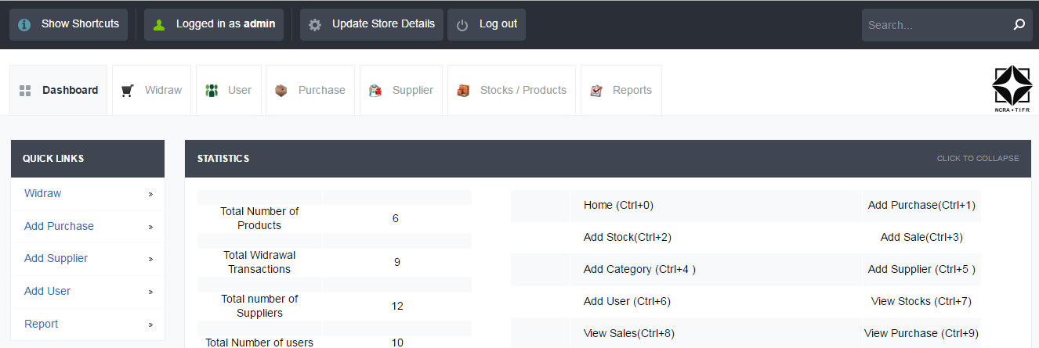

**16.2 FUNCTION :**

* Stock management tools is designed, developed and released for maintaining the stock of front end. Once this tool is installed, the purchase, widrawal, user,suppliers information can stored and we can get the reports for same.
* Maintaining a balance between too much and too little inventory
* Avoiding missing out on sales due to out-of-stock situations.

**16.3 WIDRAWAL FUNCTION:**

Widrawal function is used to widraw component .user have to enter user name,Items name ,quantity ,then click on + symbol ,we can add description to it then click Add button.

The information will be save, we can view this information by clicking on view widrawal Items

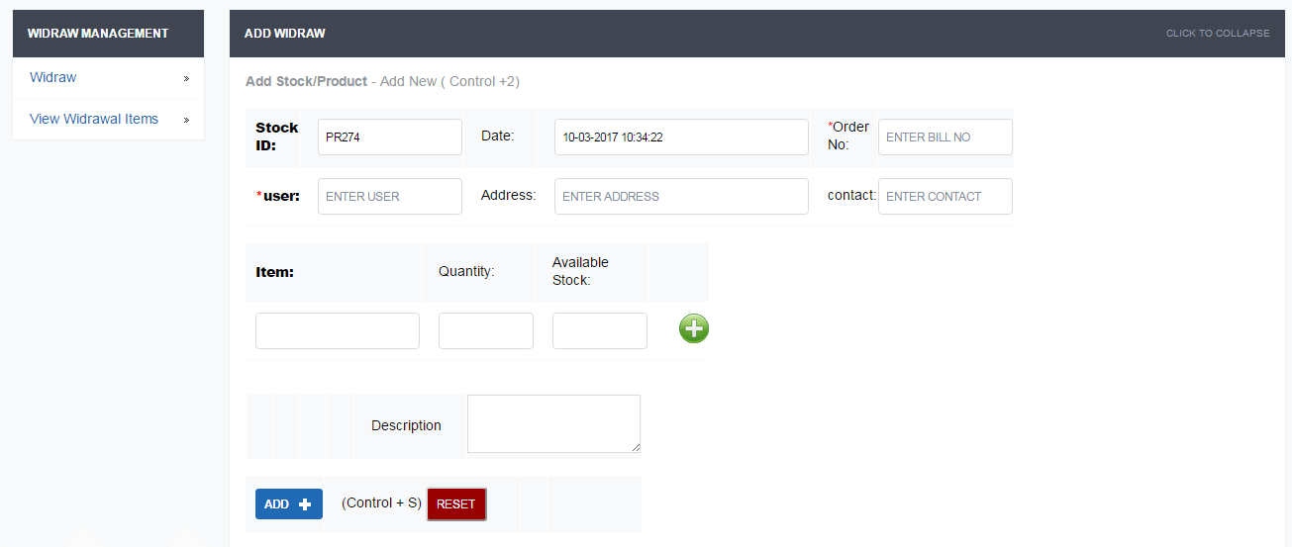

**16.4 PURCHASE FUNCTION:**

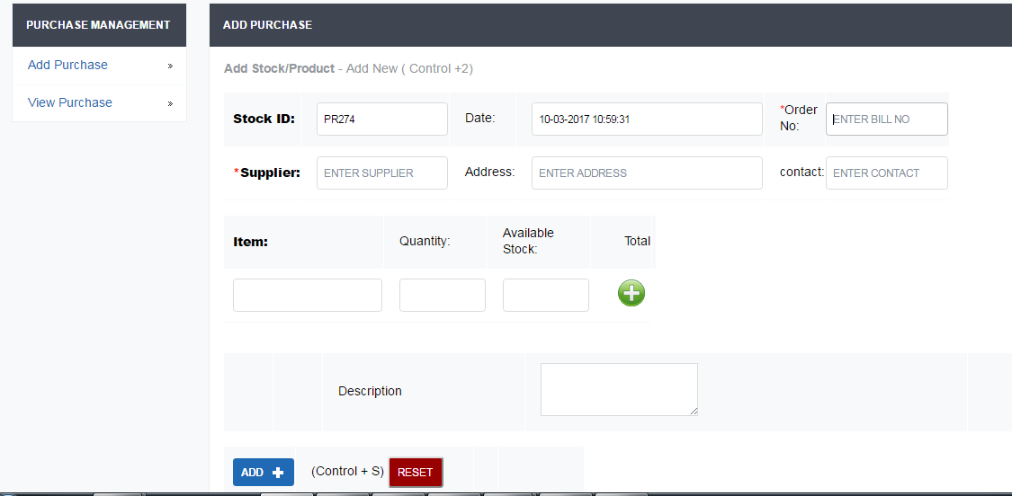

**16.5 SUPPLIER:**

In this tool we can add the supplier details i.e. contact no, supplier name,adresss .

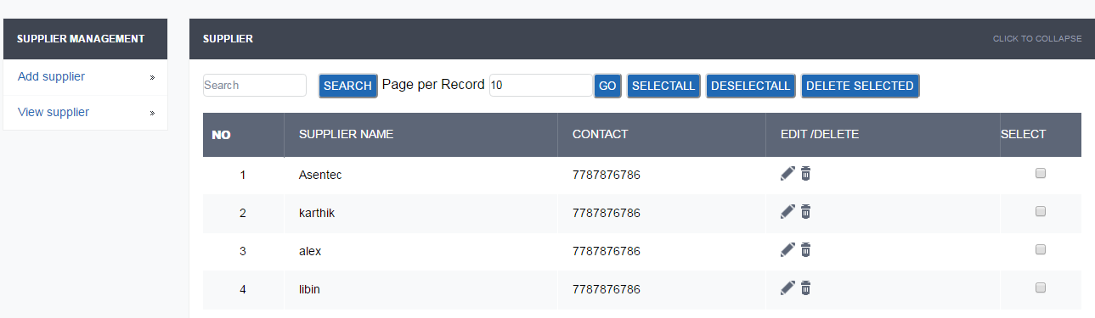

**16.6 STOCK/PRODUCT:**

In this tool we can add the stock details i.e. supplier , component name, component category .we can view stock name, purchase date, stock. We can also view the available stock by using view stock available option

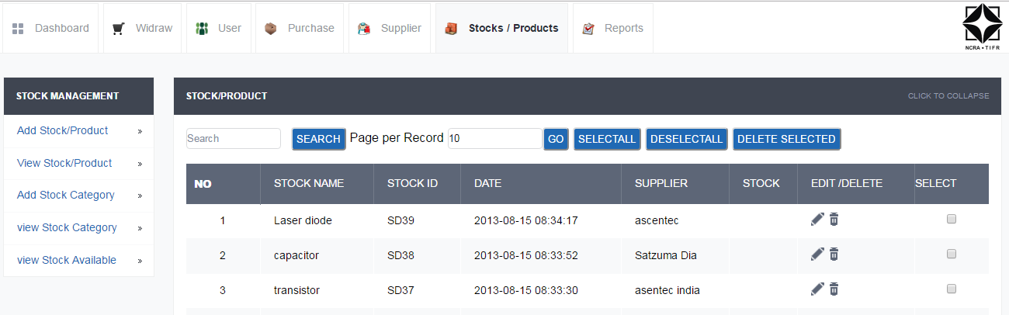

**16.7 REPORTS:**

In this option we can see purchase report, widthrawal report. The available stock quantity, date of purchase or widthrawal with time will display on result table.

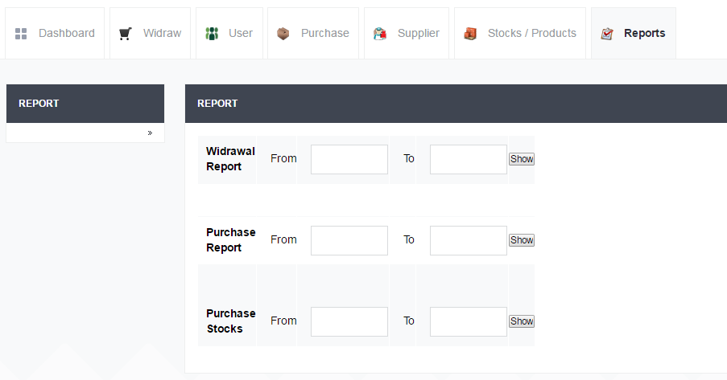

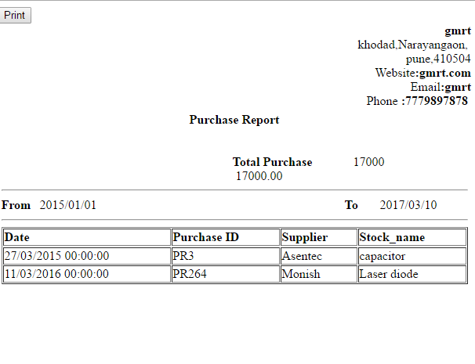

1. **CODE AND FUNCTION**
2. **CALL SHEET:**
   1. **CODE**

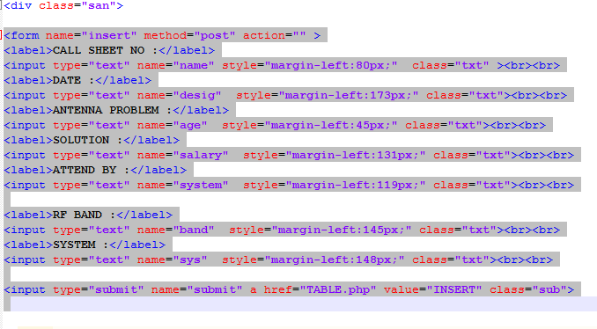

* 1. **CALL SHEET DISPLAY TABLE:**

**1.2.1CHANGES**

HOW TO ADD NEW DETAILS TO CALL SHEET 130MHz-250MHz MENU.

STEP 1

Ex: **front end\login\home.php\call sheet\130MHz-250MHz…**

STEP 2:- Fill the form

STEP 3:- Click on Insert

STEP 4:- Table will appear as shown below fig.

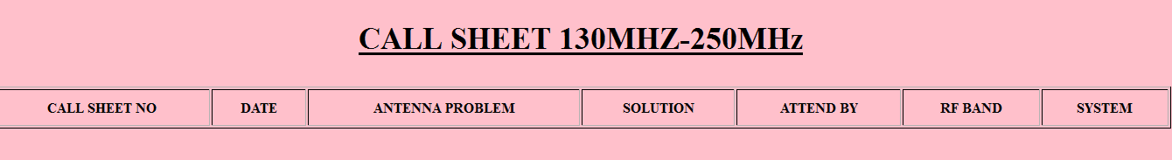

Fig: callsheet table

**2**. **SPLICING DETAILS:**

* 1. **FUNCTION**

This function is very useful in keeping the details of splicing work done in past, the data will be useful in finding the total loss of the link, places where the splice are done, if suppose due to any reason re-splice has to be done, it will the exact location and we can compare the improvement we achieve with current joint from previous record.

**2.2 CODE**

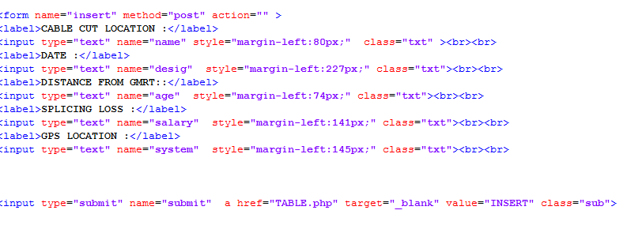

**2.3 SPLICING DETAILS :-**



* + 1. **CHANGES**
  1. If user wants to add latest SPLICING details in Gmrt Splicing details , so go as per following instruction.

STEP 1:- GOTO **Front end\login\** **GMRT SPLICING DETAILS**

STEP 2:- Fill the Details.

STEP 3:-Details will be displayed in the table.

STEP 4.if someone wants to make Changes in details edit /delete option

* 1. **BROWSE/DELETE FUNCTION :-**

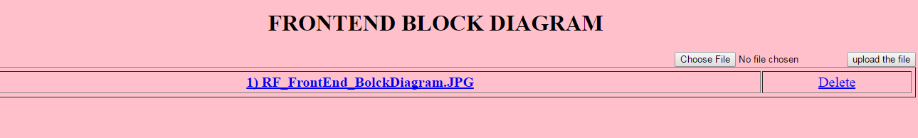

* 1. **FUNCTION OF BROWSE OPTION**

1. If user wants to add latest REPORT in any menu , so go as per following instruction.

STEP 1:- GOTO **Front end\login\** **GMRT …..**

STEP 2:- Browse the report.

STEP 3:-Details will be displayed in the table.

STEP 4.if someone wants to make Changes in details edit /delete option is there.

* 1. **CHANGES**

If user wants to add latest documents in any folder or secure that document, so go as per following instruction.

STEP 1:- GOTO **login\home.php**

STEP 2:- Copy Paste Latest Documents name in table

STEP 3:- GOTO **Front end\home.php\** you will get the file, open that file you will get the HTML code.so you can add more options which you want secure just by adding row in table, and make folder in uploads put your document in that folder .

STEP 4:- Make Changes in code as shown in following fig.

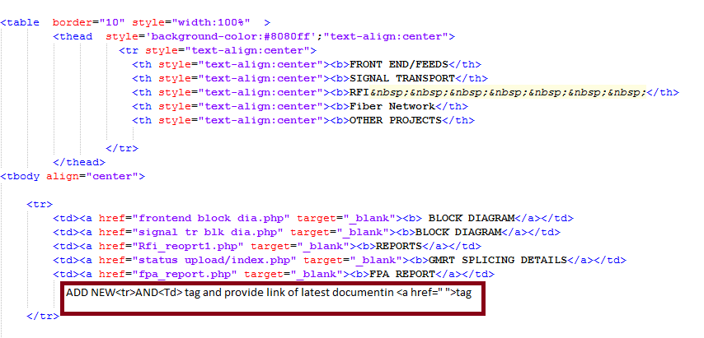

**7 FILES AND FOLDER**

**7.1 INDEX_FILES**

**7.1.1 NEED**

Index files folder includes different CSS, JQuery, and Bootstrap Files.

**CSS Files**

Use of CSS is the recommended way of defining how HTML pages are displayed. You should use HTML to define the basic structure (using elements such as <h1>, <p>, <li>, etc.) and CSS to define how these elements should appear (e.g. heading should be in bold Arial font, paragraphs should be indented, etc.).

**JS Files**

If we want to have a script run on some event, such as when a user clicks somewhere, then we will place that script in the head.

**7.1.2 LOCATION**

Front end\index_files

**7.1.3 INCLUDE_FILES**

INDEX_FILES folder includes CSS, font, image, js Folder and bootstrap Files. CSS folder includes bootstrap.css, dynamic.css, prmenu.css files. Font folder includes glypicons. images folder includes various images which are used in the website.

**7.2 TARGET_FILES**

**7.2.1 NEED**

GMRT Front end System includes various sub system like RFI ,eGMRT ,signal transport etc. and each system having its separate information, documents, block diagram etc., so here we kept separate folder for each sub system which is easy to understand for future use.

In future anyone wants to update the information about particular system (like eGMRT so directly go to respective folder and update the information and that information will reflect in main page.

We have added latest update so target_files folder is used for latest updates

**7.2.2 LOCATION**

Front end\target_files

**7.2.3 INCLUDE_FILES**

As I said earlier we make a separate folder for each system, so whatever systems available in drop down list of Front end Webpage that much folders we have created. Each Folder contains the information, Documents, Block Diagram, PPT, Images etc. about the respective System.

**7.3 INDEX.PHP**

**7.3.1 NEED**

An index.php file is the main file of GMRT Front end Webpage which contains the HTML, JavaScript, JQuery and PHP Code.

**7.3.2 LOCATION**

Front end/index.php

**7.3.3 INCLUDE_CODING**

An index.html includes HTML, CSS, PHP, JavaScript, and JQuery Code.

**7.4 CONTACT.PHP**

Contact.php gives the information about Front end Members like computer code, GMRT Intercom, GMRT email id etc.

**7.5USER.SQL**

User.sql is a database file which contains the information about database and table name along with this it also having the attributes of table such as UserName and Passwod which is used to secured the files.

1. **REFERANCES**
   * [www.w3schools.com](http://www.w3schools.com)
     + JavaScript and CSS3 Tutorials
   * [www.stackoverflow.com](http://www.stackoverflow.com)
     + Several JavaScript code snippets for different purposes. Forum where
       - People post their problems and doubts with codes and the community solves it
   * [www.tutorialspoint.com](http://www.tutorialspoint.com)
     + All tutorials and code snippets are available.
   * [www.webdeveloper.com](http://www.webdeveloper.com)
     + Several HTML, CSS, JavaScript tutorials available.