Sun and Heliosphere:
Extreme coronal mass ejection events during 12−23 July 2012:
In the current solar cycle, though weak, a group of large active regions produced wide and fast Coronal Mass Ejections (CMEs) during 12-23 July 2012. In this study, we investigated some of these events, based oninterplanetary scintillation (IPS) measurements made with the Ooty Radio Telescope (ORT). The interplanetary disturbance associated with the ultra fast eruption on July 23, 2012 occurred at the back side of the sun and the near-Earth environment missed its severe impact. However, the STEREO mission, favorably located to view the far-side of the inner heliosphere, could provide valuable information about the above extreme event. ORT IPS measurements on a large number of radio sources allowed the reconstruction of 3-D view of the heliosphere. The ORTresults, consistent with the STEREO measurements, showed the capacity to track even the far-side moving CME and its associated disturbances. From the ORT images, we could also detect a sharp increase in speed at the shock front moving ahead of the CME. The ORT images also revealed that the expansion of the CME was limited up to about 0.7−1 AU and expanded rather fast after ~1 AU, which was likely due to the propagation of the CME between two magnetic walls caused by opposite polarity coronal holes on the sun [Manoharan P.K.(RAC)NCRA-TIFR].

Characteristics of homologous flares and the initiation of associated coronal mass ejections:
We study the continuous flux emergence and the occurrence of a pair of homologous flares in the active region 1882 on 25th October 2013. These X1.7 and X2.1 class flares, both associated with coronal mass ejections, occurred at the same location on the solar disk in a time interval of ~7 hours. They showed similar morphology and identical characteristics in the mode of initiation and energy release processes, though the second event was energetic. Solar magnetogram images of the active region revealed that newly emerging intense positive flux in to the negative polarity of a pre-existing bipolar region turned it to have complex configuration and cause the first X class flare to occur. This emergence of magnetic flux to the same flaring site caused the onset of the second X-class flare. A type III burst followed by a type II was observed for both the events and the speeds of the CME as well as type II burst reflected the energies associated with the eruptions. Also, the magnetic energy calculations in the flaring site showed that, during the first flare, the full magnetic energy was not utilized. The remaining part of the energy got utilized during the second event and gave it a homologous behavior [Induja M.S. and Manoharan P.K. ((RAC) NCRA-TIFR)].

Steadily declining activity during solar cycles 23-24 and its consequences on the propagation of coronal mass ejections in the inner heliosphere:
The activity of the current solar cycle in its maximum phase is low compared to the corresponding maxima of cycles 22 and 23. Interplanetary Scintillation (IPS) observations made with the Ooty Radio Telescope (ORT) at 327 MHz revealed a steady decline of solar wind speed and density turbulence between cycles 22 and 24. In this study, in association with the above steady decline of activity, we considered initiation and propagation characteristics of CMEs. We analysed 35 CME events at different representative phases of solar cycles 23 and 24. The near-sun dynamics of these events were obtained from white-light images. In the midway between the sun and the earth, the size and speed of CMEs were estimated from ORT IPS measurements. The results of this study are consistent with the idea that a considerable deceleration of CMEs is effected in the distance range of 0.5-1 AU. This confirms the role of drag forces (as well as the energy possessed by the CME itself) on effecting the speed profiles of the CME. When less energy is transferred to the solar wind in the midway between Sun and Earth, the energy dissipation in the 0.5 to 1 AU is rather large. However, if a large amount of energy gets dissipated in the first half of Sun-Earth distance, nearly similar amount of energy is also transferred to the ambient solar wind in the next half distance. However, in the peculiar minimum period, we observe a marginal value deceleration in the entire Sun-Earth distance. These are in well agreement with the steady decline of density turbulence in the interplanetary medium [Induja M.S. and Manoharan P.K. ((RAC) NCRA-TIFR)].

Low Frequency Radio Experiment (LORE):
High temporal and frequency resolution observations of solar generated disturbances below 15 MHz in the near-Sun region and in the Sun-Earth distance are essential to understand the structure and evolution of solar eruptions (e.g., flares, coronal mass ejections (CMEs)) and their associated solar wind disturbances. This study presents a case study of Low Frequency Radio Experiment (LORE) payload to probe the corona and the solar disturbances at solar offsets greater than 2 solar radii below 30 MHz. The LORE, although not part of Aditya-L1 mission, can be complimentary to planned Aditya-L1 coronagraph and its other on-board payloads as well as synergistic to ground based observations, which are routinely carried out by the Ooty Radio Telescope. We discuss the baseline design and technical details of the proposed LORE and it is particular suitability for providing data on the detailed time and frequency structure of fast drifting Type-III and slow drifting Type-II radio bursts with unprecedented time and frequency resolution as well as goniopolarimetry, made possible with better designed antennas and state-of-art electronics, employing FPGAs and an intelligent data management system. This would enable wide ranging studies such as studies of nonlinear plasma processes, CME in-situ radio emission, CME driven phenomena, interplanetary CME driven shocks, ICMEs driven by decelerating IP shocks and space weather effects of solar wind interaction regions [Manoharan P.K., Joshi B.C., and Naidu A.K. (NCRA-TIFR).

Homologous flare-CME events and their metric type II radio burst association:
Active region NOAA 11158 produced many flares during its disk passage. At least two of these flares can be considered as homologous: the C6.6 flare at 06:51 UT and C9.4 flare at 12:41 UT on February 14, 2011. Both flares occurred at the same location (eastern edge of the active region) and have a similar decay of the GOES soft X-ray light curve. The associated coronal mass ejections (CMEs) were slow (334 km/s and 337 km/s) and of similar apparent widths (43 and 44 degrees), but they had different radio signatures. The second event was associated with a metric type II burst while the first one was not. The COR1 coronagraphs on board the STEREO spacecraft clearly show that the second CME propagated into the preceding CME that occurred 50 minutes before. These observations suggest that CME-CME interaction might be a key process in exciting the type II radio emission by slow CMEs [Yashiro S. and Indo-US Project Team].

Our Galaxy
Fine structure in galactic neutral hydrogen:
Observations of Galactic HI 21cm absorption towards the extended source 3C138 were used to estimate the structure function of the HI opacity fluctuations at AU scales. Using Monte Carlo simulations, we showed that that there is likely to be a significant bias in the estimated structure function at signal-to-noise ratios characteristic of our observations, if the structure function is constructed in the manner most commonly used in the literature. We developed a new estimator that is free from this bias and used it to estimate the true underlying structure function slope on length-scales ranging from 5 to 40 AU. From a power-law fit to the structure function, we derive a slope that is similar to the value observed at parsec scales. The estimated upper limit for the amplitude of the structure function is also consistent with the measurements carried out at parsec scales. Our measurements are hence consistent with the HI opacity fluctuation in the Galaxy being characterized by a power-law structure function over length-scales that span six orders of magnitude. [Chengalur J.N. (NCRA-TIFR), Dutta P., Roy N., Goss W. M.(NRAO, Socorro), Arjunwadkar M.(Pune Univeristy,), Minter A. H.(University of Iowa,), Brogan C. L.(National Radio Astronomy Observatory,USA) and Lazio T. J. W.(Naval Research Laboratory,USA)]
A deep investigation of the Cygnus region at decimeter wavelengths:
The newest gamma-ray surveys list up to a third of sources of unknown nature with most of the identified ones emit at radio waves. The northern-sky Cygnus region is extremely rich in stellar objects and contains many unidentified sources, and there are no radio surveys with enough angular resolution and sensitivity to study the sources at the mentioned bands. In 2014, we initiated a Giant Metrewave Radio Telescope (GMRT) survey at 325 and 610 MHz along the region, to find counterparts to high-energy sources through radio observations. The first campaign covered the Cyg OB2 association at both frequencies, and the whole region at 325 MHz. A second campaign will survey the region of Cyg OB8, at 610 MHz. We aim at studying the low-frequency radio emission coincident with gamma-ray sources locations, to confirm cross-identifications, and explore the nature of the UNIDS; but also at studying the energetic stellar objects and characterize their emission regime at decimeter wavelengths. The determination of counterparts of gamma-ray sources in star-forming regions will help to clarify the role of young stars and collective wind effects in the acceleration of galactic cosmic rays (Paula B. (IAR-CONICET, Argentina) and Ishwara Chandra CH (NCRA-TIFR)]
First detections of 610 MHz radio emission from hot magnetic stars:
Magnetic Field in Massive Stars (MiMeS) represents a consortium of international team of experts (PI:Gregg Wade) with the aim to address the questions related to complex and puzzling magnetic fields of massive stars (Wade et al. 2012). I am the PI of the radio part of the MiMeS project. As a pilot project, we were allocated 40 hours of GMRT time and 36 hours of VLA time. We observed 8 OB-stars with the GMRT. While we detected 5 B stars in both 1420 and 610 MHz bands, noneof the three O-stars are detected. We associate the non-detection of the O-stars with the free-free absorption of the radio emission. Our 610 MHz detections are the first detection of at such low frequencies. We have also witnesses extreme variability in the radio flux density of one of the B-stars, in accordance with its rotational period. [Chandra P. (NCRA-TIFR), Wade G. A. (Royal Military College of Canada, Canada), Sundqvist J. (University of Delaware, USA), Oberoi D. (NCRA-TIFR), Grunhut J. H. (4European Southern Observatory, Germany), et.al]
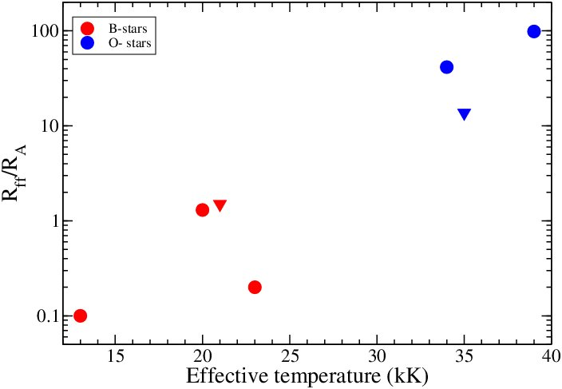
Ratio of free-free absorption radius to Alfven radius versus the effective temperature for the observed sample of magnetic OB stars. Here red circles andblue circles are for B- and O- type stars. The inverted triangle indicate upper limits. One can see that the ratio is much higher for O stars, likely cause oftheir non-detections.

A complete radio study of SNR G15.4+0.1 from new GMRT observations with search for pulsations in associated TeV source HESS J1818-154:
The supernova remnant (SNR) G15.4+0.1 is considered to be the possible counterpart of the gamma-ray source HESS J1818−154. A detailed radio study that includes the search for pulsations and a model of the broadband emission for the SNR G15.4+0.1/HESS J1818-154 system was carried out with the goal of getting a complete view of this remnant and understanding the nature of the gamma-ray flux. Deep low-frequency imaging and pulsar observations at 624 and 1404 MHz towards G15.4+0.1 were carried out with the GMRT obtaining for the first time high sensitivity and high resolution images at these frequencies. These observations used the unique capability of GMRT to carry out simultaneous imaging and time-series observations. The time series observations used the wide beam incoherent array and a sensitive targeted phased array observations to search for pulsations towards the centroid of HESS J1818-154 in particular, and any other pulsar associated by chance in general. The new radio data were correlated with observations of the source at X-ray and infrared wavelengths, from XMM-Newton and Herschel observatories respectively. To characterize the neutral hydrogen (HI) medium towards G15.4+0.1, data from the Southern Galactic Plane Survey was used. The spectral energy distribution (SED) was modeled using both hadronic and leptonic scenarios. From the combination of the new GMRT observations with existing data, a continuum spectral index of -0.62 was derived for the whole remnant. The local synchrotron spectra of G15.4+0.1, calculated from the combination of the GMRT data with 330 MHz observations from the Very Large Array, tends to be flatter in the central part of the remnant, accompanying the region where the blast wave is impinging on the molecular gas. No spectral index trace was found indicating a radio counterpart to the pulsar wind nebula proposed from previous X-ray observations. In addition, the search for radio pulsations did not discover any associated pulsars, weakening the possibility of putative pulsar wind nebula. On the other hand, emission at far-infrared wavelengths is observed in the region, where the SNR shock is interacting with dense molecular clumps. We also identified HI features forming a shell that wraps most of the outer border of G15.4+0.1. Characteristic parameters were estimated for the shocked HI gas. We found that a purely hadronic model is compatible with the broadband emission known so far, although more sensitive high energy data is needed to distinguish such a model from a leptonic model. These results have since been published in a refereed journal [Supan L.,Castelletti, G (Instituto de Astronomiay Fisica del Espacio (IAFE), Argentina) JoshiB. C., Surnis M. P. (NCRA-TIFR) SupanitskyD. (Instituto de Astronomia y Fisica del Espacio (IAFE), Argentina) ]
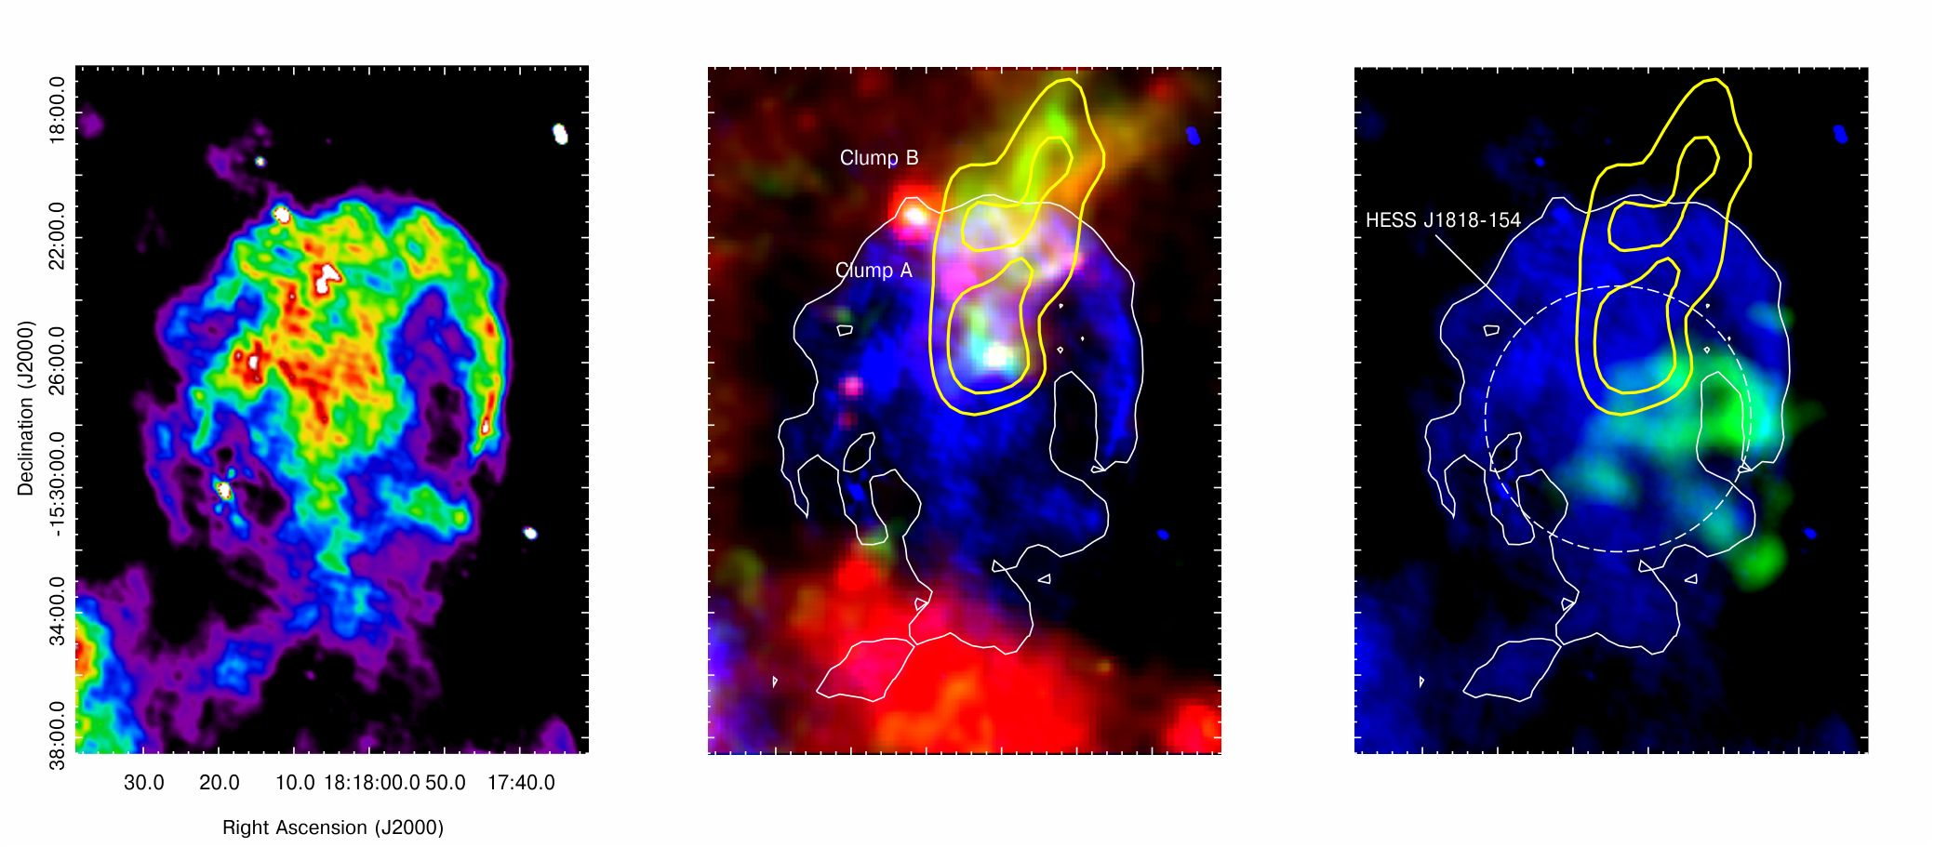Multiwavelength view of SNR G15.4+0.1. (a)Total intensity image of SNR G15.5+0.1 at 624 MHz obtainedwith the GMRT. The rms noise level in the image is 0.48 mJy/beam. (b) A color composite image showing the new radio image at624 MHz of G15.4+0.1 (in blue) and FIRemission as observed by Herschel at 70 micron (inred), and 250 micron (in green). (c) comparisonof the radio continuum emission at 624 MHzof the SNR (in blue) and the X-ray emission(in yellow) as observed by XMM-Newton inthe 1-8 keV energy range. The dashed whitecircle indicates the size and location of theTeV source HESS J1818-154. The yellow contours delineate the 13CO line emission in the 46-50.3 km/s range.

Pulsars and Transients
Accurate millisecond pulsar profiles using coherent dedispersion :
Using sensitive data with the GMRT, we had started work towards collating a set of high quality low frequency profiles of millisecond pulsars (MSPs), with the aim of studying the profile statistics and frequency evolution in detail and to compare with the similar behaviour for normal period pulsars. During this year, the data were supplmented by new observations with the GMRT using the recently developed coherent dedispersion pipeline, which yielded improved results for MSPs where earlier profiles were smeared due to residual dispersion remaining from incoherent dedispersion (as illustrated for PSR J0034-0534 in the accompanying figure). The interesting conclusions about the behaviour of MSPs vis-a-vis normal pulsarsthat emerges from this study are that (a) there is very little evolution of the profiles of MSPs with frequency, as compared to normal pulsars (confirming earlierstudies) (b) there are some cases where there the width of the profiles of MSPs reduces with decreasing frequency, which is an interesting new trend, opposite to what is generally seen for normal pulsars. [Gupta Y. (NCRA-TIFR), Agarwal D. (IISER, Trivandrum), De K. (IISc, Bengaluru) and Rajwade K. (West Virginia University)]

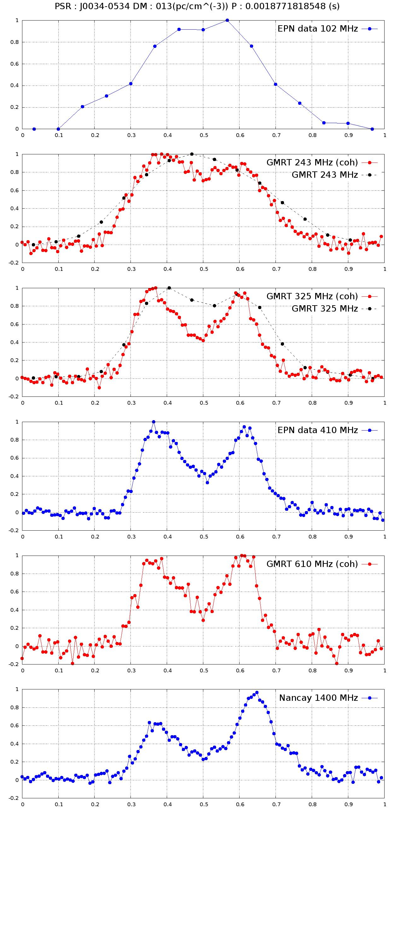
Multi-frequency average profiles for the millisecond pulsar J0034-0534, illustrating the change in the shape of the emission pulse. Note the small increase in the separation of the components with increasing frequency. The benefit of coherent dedispersion for low frequency observations with theGMRT can be seen by comparing the dotted and solid curves for the profilesat 243 and 325 MHz -- the solid curves show significantly better resolution of the structure of the profile, allowing more accurate inferences to be made.

Discovery of a transitional redback millisecond pulsar with the GMRT and FERMI gamma-ray detection:
XSS J12270-4859 is an X-ray binary associated with the Fermi LAT gamma-ray source 1FGL J1227.9-4852. In 2012 November/December, the source underwent a transition where the X-ray and optical luminosity dropped suddenly and spectral signatures of an accretion disk disappeared. We discovered of a 1.69 millisecond pulsar (MSP), J1227-4853, at a dispersion measure of 43.5 pc cm⁻³ associated with this source, using the GMRT at 607 MHz. Our discovery confirms that the system has transitioned to an active radio MSP. This is the 3rd system after PSR J1824-2452I and PSR J1023+0038 showing evidence of back-and-forth state switching between radio MSP and low-mass X-ray binary (LMXB) states. We performed the radio timing observations of MSP J1227-4853 with the GMRT and the Parkes telescope allowing precise determination of the rotational and orbital parameters of the system. The companion mass measurement of 0.17 to 0.46 Msun suggests that this is a redback system with 40% of its orbit being eclipsed. We carried out an unique study of simultaneous imaging and time-domain analysis for PSR J1227-4853. PSR J1227-4853 is one of the few eclipsing binary system, where such studies are done to directly probe the cause of eclipse. Using this radio timing ephemerides while folding the ~1 year of data from the Large Area Telescope on board the Fermi Gamma-ray Space Telescope, we achieved a significant detection of gamma-ray pulsations after the transition, at the known spin period. The partial alignment of the radio and gamma-ray light-curve peaks suggests that at least some of the radio emission may originate at high altitude in the pulsar magnetosphere, in extended regions co-located with the gamma-ray emission site [R. J.(Jodrell Bank Centre for Astrophysics, University of Manchester, UK and NCRA-TIFR), Ray P. S.(Space Science Division, Naval Research Laboratory, Washington, USA), Bhattacharyya B., Stappers B.(Jodrell Bank Centre for Astrophysics University of Manchester), J.N.Chengalur, (NCRA-TIFR), Deneva J.(Cornell University, USA), Camilo F. (Columbia University, US), Johnson T. J.,(College of Science, George Mason University,USA) Wolff M.,(Space Science Division, Naval Research Laboratory,USA ) Hessels J. W. T. (Netherlands Institute for Radio Astronomy (ASTRON) Netherlands & Institute for Astronomy, University of Amsterdam, The Netherlands), Bassa C. G. (ASTRON, The Netherlands Institute for Radio Astronomy, The Netherlands), Keane E. F. (Centre for Astrophysics and Supercomputing, Swinburne University of Technology, Australia), Ferrara E. C., Harding A. K.,( NASA Goddard Space Flight Center, USA) Wood K. S. (Space Science Division, Naval Research Laboratory, USA)]
On detecting millisecond pulsars at the galactic centre:
We have attempted to resolve the mystery of the lack of detected pulsars at the Galactic Centre (GC) region by arguing that the high stellar density in the central parsec around the GC is likely to result in a pulsar population dominated by millisecond pulsars (MSPs), similar to the situation in globular cluster environments. Earlier GC pulsar searches have been largely insensitive to such an MSP population, accounting for the lack of pulsar detections. We estimate the best search frequency for such an MSP population with present and upcoming broad-band radio telescopes for two possible scattering scenarios, the ``weak-scattering'' case suggested by the recent detection of a magnetar close to the GC, and the ``strong-scattering'' case, with the scattering screen located close to the GC. The optimal search frequencies are approximately 8 GHz (weak-scattering) and approximately 25 GHz (strong-scattering), for pulsars with periods in the range 1 ─ 20 ms, assuming that GC pulsars have a luminosity distribution similar to that of MSPs in the rest of the Milky Way. We have found that 10 ─ 30 hour integrations with the Very Large Array and the Green Bank Telescope (GBT) would be sufficient to detect MSPs at the GC distance in the weak-scattering case. However, if the strong-scattering case is indeed applicable to the GC, observations with the full Square Kilometre Array would be needed to detect the putative MSP population. We have now used the GBT to carry out a deep 26-GHz search for MSPs at the GC, and have also obtained GBT time to carry out a similar deep search at ≈ 8 GHz. [Kanekar N., Macquart J-P. (Curtin University, Australia), Ransom S. (National Radio Astronomy Observatory, USA), Roshi A. (National Radio Astronomy Observatory, USA), Frail D. (National Radio Astronomy Observatory, USA)]
Synchrotron radio emission from the recurrent nova system V745 Scorpii:
Recurrent novae are binary stellar systems consisting of an accreting white dwarf and an evolved giant star. These systems are characterised by repeated outbursts due to thermonuclear burning on the surface of the white dwarf as it accretes matter from the companion. The outburst causes a sudden brightening of the system observed at many wavebands. The recurrent nova system V745 Scorpii recorded an outburst on 6 February 2014 and was monitored at regular intervals at 610 MHz using the GMRT. We have modelled the resulting light curve using a parametric model generally used to explain the early evolution of a supernova explosion. The best model fit to the data predicts that the emission at 610 MHz became visible on day 9.5 when the foreground became sufficiently transparent and the maximum emission was on day 23 following the outburst. The spectral index of the radio emission is fixed at -0.5 and a temporal decay index of -1.3 is estimated. Our model predicts that the 235 MHz peaked around day 35 which is confirmed by our GMRT observations and that emission at 1.4 GHz peaked around day 10. The previous outburst in V745 Sco was recorded in 1989 and the best model fit to this data predicts that the emission at 1.4 GHz would have peaked on day 18 then. Since both the outbursts are of similar energies setting up shocks of similar energy, this might be indicative of evolution in the recurrent nova environment. We note that Kantharia et al. (2007) had deduced a reduction in the environmental densities between two outbursts separated by 21 years in another recurrent nova system, RS Ophiuchi using radiative transfer arguments. Such reduction in densities, if found to be common in recurrent novae systems, would result in important consequences for the evolutionary path followed by recurrent novae such as being progenitor systems of type 1a supernova and also explain why synchrotron radio emission is not detected from all recurrent novae systems [Kantharia N. G (NCRA-TIFR), Dutta Prasun (IISER Bhopal), Roy N., Anupama G.C. (IIA Bangalore), Ishwara-Chandra C.H. (NCRA-TIFR), ChitaleAbhay,Prabhu T.P. (IIABangalore), BanerjeeD.P.K., AshokN.M.]
X-Ray and radio emission from type IIn supernova Sn 2010jl:
We carried out comprehensive study of an extremely bright (Mv < -20) Type IIn supernova SN 2010jl in radio and X-ray bands with the Very Large Array (VLA), Chandra, XMM-Newton and Swift-XRTin order to understand the early circumstellar interaction. While this supernova is the brightest X-ray supernova ever, it is one of the weakest in radio bands. We have witnessed a dramatic evolution of the column density from the material surrounding the supernova. This has given us information about the environments of this supernova in an unprecedented detail. [Chandra P. (NCRA-TIFR), Chevalier R. A. (University of Virginia, Charlottesville, VA), Chugai N. (Russian Academy of Sciences, Russia), Fransson C. (Stockholm University, Swede), and Soderberg A. M. (Smithsonian Astrophysical Observatory, Cambridge]
A Real time software backend for pulsar and IPS observations at the Ooty Radio Telescope called PONDER :
A new real-time versatile backend, the Pulsar Ooty Radio Telescope New Digital Efficient Receiver (PONDER), was commissioned at the Ooty Radio Telescope (ORT) last year and has been used for studies of scatter-broadening in pulsars, single pulse studies and pulsar timing. PONDER has been designed to operate along with the legacy analog system of the ORT. PONDER makes use of the current state of the art computing hardware, a Graphical Processing Unit (GPU) and sufficiently large disk storage to support high time resolution real-time data of pulsar observations, obtained by coherent dedispersion over a bandpass of 16 MHz. Four different modes for pulsar observations are implemented in PONDER to provide standard reduced data products, such as time-stamped integrated profiles and dedispersed time series, allowing faster avenues to scientific results for a variety of pulsar studies. Additionally, PONDER also supports general modes of interplanetary scintillation (IPS) measurements and very long baseline interferometry data recording. The IPS mode yields a single polarization correlated time series of solar wind scintillation over a bandwidth of about four times larger (16 MHz) than that of the legacy system as well as its fluctuation spectrum with high temporal and frequency resolutions. The key point is that all the above modes operate in real time. Good stability of receiver was demonstrated with frequent pulsar timing observations yielding pulsar timing data with residuals in few tens of micro-seconds over more than three months (Figure 2). PONDER was also used for a large study of scatter-broadening in pulsars and long nulls in PSR J1709-1640. A data quality better than the legacy system was obtained for IPS measurements on a large number of sources. Improvements to obtain much higher timing precision are continuing and the backend was in continuous use for most of the last year. The design and the principal operations of PONDER have since been published in a refereed journal [Naidu A.K., JoshiB. C., ManoharanP. K., Krishnakumar M. A. ( RAC) NCRA-TIFR)]
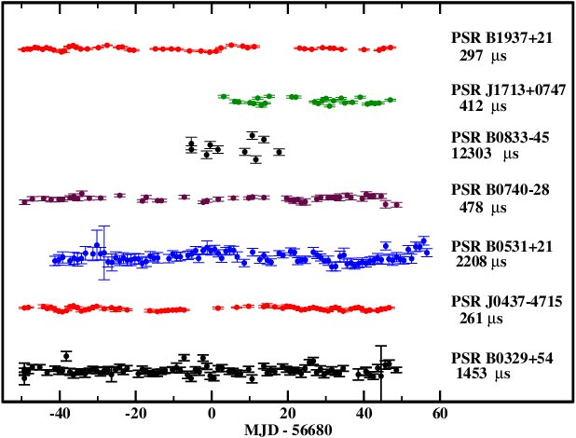
The timing residuals for 7 pulsars observed over 100 days.
These residuals were obtained after subtracting barycentre corrected times-of-arrival of the pulses from those redicted using the known rotational model of each pulsar. The name of pulsar and peak-to-peak amplitude of the residuals is indicated on the right hand side of the plot.

Scatter broadening measurements of 124 pulsars at 327 MHz with the Ooty Radio Telescope:
The measurements of scatter broadening time-scales (τ_{sc}) for 124 pulsars at 327 MHz, using the upgraded Ooty Radio Telescope (ORT), were carried out last year. These pulsars lie in the dispersion measure range of 37 - 503 pc cm⁻³ and declination ( δ ) range of − 57 deg <δ< 60 deg. New τ_{sc} estimates for 58 pulsars were obtained, significantly increasing the sample of all such measurements by about 40 % at 327 MHz. Using all available τ_{sc} measurements in the literature, the dependence of τ_{sc} on dispersion measure was investigated. These measurements, together with previously reported values for τ_{sc}, affirm that the ionized interstellar medium upto 3 kpc is consistent with Kolmogorov spectrum, while it deviates significantly beyond this distance [KrishnakumarM.A., MitraD., Naidu A.K., Joshi B. C. and ManoharanP. K. (RAC) NCRA-TIFR)]
Monitoring of intermittent pulsar PSR J1838+1523:
PSR J1838+1523 (Figure 3) was discovered in a blind survey along the Galactic plane conducted using the Giant Meterwave Radio Telescope (GMRT). The pulsar is peculiar as it is not detectable for durations as large as 280 days and appears to be similar to only three such ``intermittent'' pulsars. The pulsar was monitored at the GMRT once every 20 days and almost daily at the ORT last year, but remained in the ON state throughout the year, which enabled determining its sky coordinates using pulsar timing techniques. Images from the previous years, observed at this position, indicated continuum emission (Figure 4) at epochs, when pulsed emission from the pulsar could not be detected and this is being investigated currently. The monitoring observations are continuing [SurnisMayuresh, JoshiB. C. (NCRA-TIFR), McLaughlin M. A. (West Virginia University, USA), Manoharan P. K. and Krishnakumar M. A. (RAC) NCRA-TIFR)]

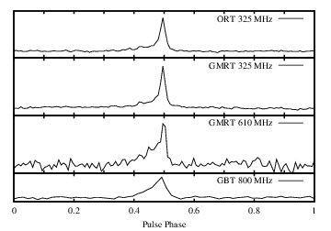  Multifrequency integrated profiles for PSR J1838+1523. The profiles were obtained from observations with the ORT at 326.5 MHz, GMRT at 325 and 610 MHz and the Green Bank telescope at 800 MHz | 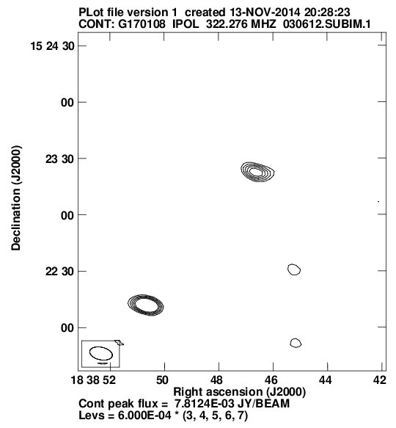  Continuum emission seen at the position of the pulsar, derived from the pulsar timing observations last year, in the observations with the GMRT on June 3, 2012. No pulsed emission was detected during these observations. The pulsar is the source at the centre, whereas the source at the bottom left as a known NVSS source.

Upper limits on the pulsed radio emission of SGR 1935+2154 from the Ooty Radio Telescope and the Giant Meterwave Radio Telescope:
SGR 1935+2154 was observed soon after its reported detection by SWIFT (GCN 16520; GCN 16522; ATEL 6299), using the Ooty Radio Telescope (ORT) and the Giant Meterwave Radio Telescope (GMRT), at 326.5 and 610.0 MHz respectively, at the position indicated in the initial XRT detection. The source was observed with the ORT on July 9 and 14, 2014 at 326.5 MHz with 16 MHz band-pass. Both the data sets were incoherently dedispersed to 2240 trial DMs ranging from 0 - 1500 pc cm⁻³ followed by a harmonic and single pulse search. No significant pulsation was detected. An upper limit on pulsed flux density of 0.4 mJy for an assumed 10 % duty cycle is estimated for the average emission at 326 MHz. Observations for about 2 hours were carried out using the GMRT on July 14, 2014, with 610 MHz receiver of 33.33333 MHz band-pass. The GMRT was used in a phased array of 15 antenna. No significant pulsation was detected indicating a limit of 0.2 mJy for an assumed 10 % duty cycle for the average emission at 610 MHz. At the GMRT, simultaneous imaging observations, at 610 MHz, were also carried out. No significant radio source is detected in the image at the position of the SGR, although a diffuse source, 7' West of the SGR position, was seen, which may be associated with SNR G57.2+0.8 [SurnisMayuresh P, KrishnakumarM A, MaanY., JoshiB C, ManoharanP K, (RAC) NCRA-TIFR)]

Extra – Galactic Astronomy & Cosmology
Star formation infaint dwarf galaxies:
We used data for faint (MB > -14.5) dwarf irregular galaxies drawn from the Faint Irregular Galaxy GMRT Survey (FIGS) to study the correlation between the surface densities of atomic gas and star formation rate in the galaxies. The estimated gas-phase metallicity of our sample galaxies is Z ~ 0.1 solar; Understanding star formation in such molecule-poor gas is of particular importance since it is likely to be of direct relevance to simulations of early galaxy formation. We found a nearly linear relation between the star formation rate and the atomic gas density. The corresponding gas consumption time-scale is ~10 Gyr, i.e. significantly smaller than the ~100 Gyr estimated for the outer regions of spiral galaxies. The gas consumption time-scale for dwarfs is intermediate between the values of ~100 ~2 Gyr estimated for the outer molecule-poor and inner molecule-rich regions of spiral discs. [Chengalur J.N., Roychowdhury S. (NCRA-TIFR),Kaisin S. S., Karachentsev I. D. (Special Astrophysical Observatory, Russian Academy of Sciences, Russia)]
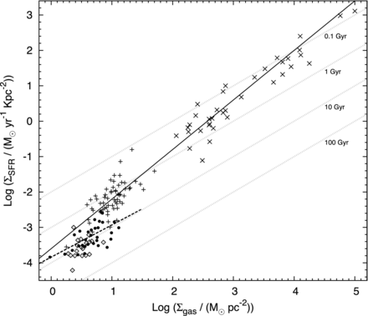
Plot of the star formation rate density as a function of the gas columndensity. Crosses indicate data for starburst and spiral galaxies, and the solid line is the "canonical" disc-averaged Kennicutt???Schmidt law for the starformation rate. compared to our results. Crosses and pluses represent circumnuclear starbursts and spirals from Kennicutt (1998), respectively. Open diamonds represent low surface brightness galaxies, while filled circlesrepresent dwarf galaxies drawn from the FIGGS survey. The best-fittingpower law to the FIGGS sample galaxies is shown as the dashed line. Faintgrey dotted lines mark different gas consumption time-scales. As can beseen, star formation is less efficient in dwarf galaxies, and they hencehave a significantly longer gas consumption timescale than spiral galaxies.

Velocity structure & dynamics of dwarf galaxies:
We modeled the observed vertical distribution of the neutral hydrogen in the faint edge-on dwarf irregular galaxy KK250. Our model assumes that the galaxy consists of axisymmetric, coplanar gas and stellar discs in the external force-field of a spherical dark matter halo, and in vertical hydrostatic equilibrium. The velocity dispersion of the gas is left as afree parameter in the model. Our best-fitting model is able to reproduce the observed vertical distribution of the HI gas, as well as the observed velocity profiles. The best-fitting model has a large velocity dispersion (~22 km/s) at the centre of the galaxy, which falls to a value of ~8 km/s by a galactocentric radius of 1 kpc. The minimum intrinsic half-width at half-maximum (HWHM) of the HI vertical distribution in KK250 is ~350 pc. For comparison the HWHM of the vertical distribution of the HI in the solar neighbourhood is ~70-140 pc. Our results are hence consistent with other observations which indicate that dwarf galaxies have significantly puffier gas discs than spirals[Chengalur J.N., Patra N. N.), Banerjee A., (NCRA-TIFR) and Begum A.(IISER Bhopal)]
GMRT detections of redshifted HI-21cm absorption at z > 2:
We have used the new wide-band 250-500 MHz receivers of the GMRT to obtain detections of HI 21cm absorption in four Damped Lyman-Absorbers (DLAs) at z ≥ 2. For two of the DLAs, the inferred low spin temperatures are consistent with the anti-correlation between metallicity and spin temperature in DLAs that has been earlier obtained by our group. We have also obtained Keck-ESI spectra of one of the DLAs, and find that both the metal-line and HI-21cm absorption in this system are amongst the widest ever found in a DLA. The GMRT observations have now doubled the number of DLAs at z  2 with detections of redshifted HI-21cm absorption. [Kanekar N,(NCRA-TIFR), Prochaska J. X.(University of California, Santa Cruz, USA), Chengalur J. N. (NCRA-TIFR)]
The discovery of a radio halo (Plck G147.3-16.6) using GMRT:
In some merging galaxy clusters, Mpc-scale diffuse radio synchrotron emission is found, which indicates the presence of relativistic particles and magnetic fields in the intracluster medium. The diffuse emission is, classified depending on the location, morphology, and polarization properties, called as a radio halo. It has been proposed that radio halos trace particles re-accelerated by turbulence generated during a cluster merger event, and the majority of the presently known halos and relics are located at low and moderate redshifts. Recent X-ray and Sunyaev-Zel'dovich observations have dramatically increased the number of known distant galaxy clusters. Using the Giant Metrewave Radio Telescope, we discovered diffuse radio emission in the binary-merging cluster PLCK G147.3-16.6 located at z = 0.65. We classify the emission as a giant radio halo due to the large physical extent of about 0.9 Mpc and low-surface brightness. The radio halo power is consistent with that expected from the known correlation between X-ray luminosity or the cluster integrated Sunyaev-Zel'dovich signal and radio power. Our observations also suggest that more of these distant radio halos could be discovered with the Giant Metrewave Radio Telescope. [van Weeren R. J. (Leiden University, The Netherlands), Intema H. T. (National Radio Astronomy Observatory Socorro) Lal D. V. (NCRA-TIFR), et al.]
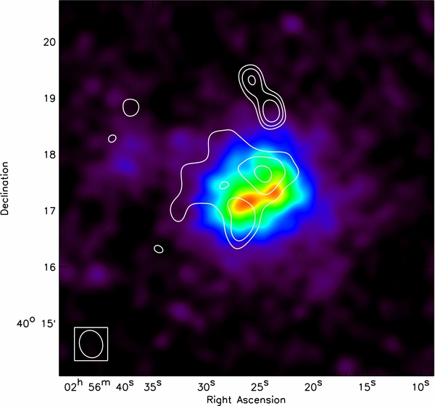
XMM-Newton MOS+pn 0.5–3.0 keV X-ray image of PLCK G147.3−16.6 convolved with a 16'' FWHM Gaussian. Radio contours from the low-resolution GMRT 610 MHz image (Figure 2; right panel) are overlaid in white. Contour levels are drawn at , with σ_{rms} = 0.175 mJy beam⁻¹.
The gas mass of star-forming galaxies at z ≈ 1.3:
We have used the GMRT 610 MHz receivers to carry out a deep search for HI-21cm emission from star-forming galaxies at z ≈ 1.3, aiming to measure their average gas mass via a stacking analysis. Four fields of the DEEP2 survey were observed, containing 851 target galaxies with redshifts that placed the HI-21cm line within the GMRT's frequency coverage. A final root-mean square noise of approximately 3µJy was achieved on the stacked HI-21cm spectrum, per 315 km/s channel, with no evidence for an HI-21cm emission signal in the spectrum. This yields the limit M_{HI,ave}≤ 2.5 X 10¹⁰ M_{ʘ} on the average gas mass of the star-forming galaxies in the DEEP2 fields. This is the first direct constraint on the gas mass of galaxies at high redshifts, z ≥ 1. [KankearN., Sethi S. (Raman Research Institute, Bangalore), Dwarakanath K. S. (Raman Research Institute, Bangalore)]
183.3 GHz water emission from a high-redshift starburst galaxy :
I have used the Ka-band receivers of the Very Large Array to detect redshifted water (H₂O)183.3 GHz emission from the z = 3.9 starburst galaxy, APM08279+5255. This is the first detection of this transition at cosmological distances, opening a new window on studies of the interstellar medium of high-redshift galaxies. Detailed modelling of local physical conditions in APM08279+5255 is now being carried out, and we have also obtained observing time on the Plateau de Bure Interferometer to carry out searches for this transition in other high-redshift starburst galaxies [KanekarN., Omont A.(Institute d'Astrophysique de Paris, France), Yang C., Beelen A. (Universite Paris-Sud, France)]

Fast radio bursts with the GMRT:
A new class of transients, fast radio bursts (FRBs), have been discovered by the High Time Resolution Universe (HTRU) survey underway at Parkes. These are thought to be originating from cosmological distances. Over the past year, we have been making steady efforts to leverage the capabilities of GMRT for undertaking effective follow-ups of FRBs and thereby to make an important contribution in this fast-emerging field of radio astronomy. We have an ongoing program where we shadow (i.e. co-track) a fraction of the Parkes survey. We have also been making use of the GMRT for undertaking triggered follow-ups of FRBs to search for any potential afterglows. Two publications have already resulted from this work. [Petroff E., KeaneE. F., D. Barr,S. Bhandari (Swinburne University of Technology,Australia), ReynoldsJ. E., SarkissianJ. E., EdwardsP. G, StevensJ., BremC., ReynoldsJ. E., Johnston S. (Australia Telescope National Facility, Australia), Bhat N. D. R. (Curtin University, Australia), Chandra P. and Kudale S. (NCRA)]

Lyman-α emitters gone missing: evidence for late reionization?:
We combine high resolution hydrodynamical simulations with an intermediate resolution, dark matter only simulation and an analytical model for the growth of ionized regions to estimate the large scale distribution and redshift evolution of the visibility of Lyα emission in 6 ≤z≤ 8 galaxies. The inhomogeneous distribution of neutral hydrogen during the reionization process results in significant fluctuations in the Lyα transmissivity on large scales, and is sensitive not only to the ionized fraction of the intergalactic medium by volume and amplitude of the local ionizing background, but also to the relative velocity shift of the Lyα emission line due to resonant scattering. We reproduce a decline in the space density of Ly α emitting galaxies as rapid as observed with a volume-weighted neutral fraction of ~ 30 (50) per cent at z = 7 (z=8), and a typical Lyα line velocity offset of 100 kms ⁻¹ redward of systemic at z=6 which decreases toward higher redshift. The latest Planck results indicate such a recent end to reionization is no longer disfavoured by constraints from the cosmic microwave background [ChoudhuryT. R. (NCRA-TIFR), PuchweinE., Haehnelt M. (Institute of Astronomy, University of Cambridge, UK), Bolton J. (University of Nottingham, UK)]
21 cm signal from cosmic dawn: Imprints of spin temperature fluctuations and peculiar velocities:
The 21 cm brightness temperature δT_{b} fluctuations from reionization promise to provide information on the physical processes during that epoch. We present a formalism for generating the δT_{b} distribution using dark matter simulations and an one-dimensional radiative transfer code. Our analysis is able to account for the spin temperature T_{S} fluctuations arising from inhomogeneous X-ray heating and Lyα coupling during cosmic dawn. The δT_{b} power spectrum amplitude at large scales (k ~ 0.1 Mpc⁻¹ ) is maximum when ~ 10% of the gas (by volume) is heated above the CMB temperature. The power spectrum shows a "bump"-like feature during cosmic dawn and its location measures the typical sizes of heated regions. We find that the effect of peculiar velocities on the power spectrum is negligible at large scales for most part of the reionization history. During early stages (when the volume averaged ionization fraction
0.2) this is because the signal is dominated by fluctuations in T_{S}. For reionization models that are solely driven by stars within high mass( 10⁹ M_{ʘ} ) haloes, the peculiar velocity effects are prominent only at smaller scales ( k 0.4 Mpc ⁻¹ ) where patchiness in the neutral hydrogen density dominates the signal. The conclusions are unaffected by changes in the amplitude or steepness in the X-ray spectra of the sources [GharaR., ChoudhuryT. R. , Datta Kanan (NCRA-TIFR)]
Modeling the neutral hydrogen distribution in the post-reionization Universeintensity mapping:
We model the distribution of neutral hydrogen (HI) in the post-reionization era and investigate its detectability in 21 cm intensity mapping with future radio telescopes like the Square Kilometre array (SKA). We rely on high resolution hydrodynamical N-body simulations that have a state-of-the-art treatment of the low density photoionized gas in the Inter-Galactic Medium (IGM). The HI is assigned a-posteriori to the gas particles following two different approaches: a halo-based method in which HI is assigned only to gas particles residing within dark matter halos; a particle-based method that assigns HI to all gas particles using a prescription based on the physical properties of the particles.
The HI statistical properties are then compared to the observational properties of Damped Lyman-α Absorbers (DLAs) and of lower column density systems and reasonable good agreement is found for all the cases. Among the halo-based method, we further consider two different schemes that aim at reproducing the observed properties of DLAs by distributing HI inside halos: one of this results in a much higher bias for DLAs, in agreement with recent observations, which boosts the 21 cm power spectrum by a factor ~ 4 with respect to the other recipe. Furthermore, we quantify the contribution of HI in the diffuse IGM to both Ω_{HI} and the HI power spectrum finding to be subdominant in both cases. We compute the 21 cm power spectrum from the simulated HI distribution and calculate the expected signal for both SKA1-mid and SKA1-low configurations at 2.4 ≤z≤ 4. We find that SKA will be able to detect the 21 cm power spectrum, in the non-linear regime, up to k ~ 1h/Mpc for SKA1-mid and k ~ 5h/Mpc for SKA1-low with 100 hours of observations. We also investigate the perspective of imaging the HI distribution. Our findings indicate that SKA1-low could detect the most massive HI peaks with a signal to noise ratio (SNR) higher than 5 for an observation time of about 1000 hours at z = 4, for a synthesized beam width of 2'. Detection at redshifts z ≥ 2.4 with SKA1-mid would instead require a much longer observation time to achieve a comparable SNR level [Villaescusa-Navarro Francisco, Viel Matteo (INAF -- Osservatorio Astronomico di Trieste, Trieste, Italy), DattaKanan, Choudhury T. R. (NCRA-TIFR)]
Measuring the equation of state of the high-z general intergalactic medium using curvature statistics:
We study the mean and median curvature statistics as probes of the thermal state of the intergalactic medium (IGM) in the z< 6 universe. We find that the mean and median absolute curvatures exhibit tight correlation with the temperatures at characteristic overdensities ₁ and₂ respectively at each redshift. Hence, they provide two independent probes of the same underlying temperature-density distribution, and may be used together to recover both parameters T₀ and γ of the IGM effective equation of state. We quantify the associated errors in the recovered parameters T₀ and γ from the intrinsic scatter in the characteristic overdensities and the uncertainties in the curvature measurement [PadmanabhanHamsa, Srianand R. (IUCAA, India), Choudhury T. R. (NCRA-TIFR)]
Kiloparsec-scale radio emission in Seyfert and LINER galaxies:
Seyfert and LINER galaxies are known to exhibit compact radio emission on ~10-100 pc scales, but larger Kiloparsec-Scale Radio structures (KSRs) often remain undetected in sub-arcsec high-resolution observations. We investigated the prevalence and nature of KSRs in Seyfert and LINER galaxies using the 1.4 GHz VLA data from the FIRST and NVSS surveys. Our sample consisted of 2651 sources detected in FIRST and of these 1737 sources also had NVSS counterparts. Considering the ratio of total to peak flux density (θ =(Sint/Speak)^{1/2}) as a parameter to infer the presence of extended radio emission we showed that ≥30 per cent of FIRST-detected sources possess extended radio structures on scales larger than 1.0 kpc. The use of low-resolution NVSS observations heled us to recover faint extended KSRs that are resolved out in FIRST observations and resulted in ≥42.5 per cent KSR sources in FIRST-NVSS sub-sample. This fraction is only a lower limit owing to the combination of projection, resolution and sensitivity effects. Our study clearly demonstrated that KSRs may be more common than previously thought and are foundacross all redshifts, luminosities and radio loudness. The extranuclear radio luminosity of KSR sources was found to be positively correlated with the core radio luminosity as well as the [OIII] λ5007 Å line luminosity and this can be interpreted as KSRs being powered by AGN rather than star formation. The distributions of the (Far Infrared) FIR-to-radio ratios and mid-IR colours of KSR sources are also consistent with their AGN origin. [Ishwara-Chandra C. H. and Wadadekar Y.(NCRA-TIFR), SinghV., BeelenA.(IAS, France) and Kharb P. (IIA Bengaluru)]
Multiwavelength characterization of faint ultra steep spectrum radio sources: A search for high-redshift radio galaxies:
Ultra steep spectrum (USS) radio sources are one of the most efficient tracers of powerful high-z radio galaxies (HzRGs). Using our 325 MHz GMRT observations (5σ ~ 800 μJy) and 1.4 GHz VLA observations (5σ ~ 80-100 μJy) available in two subfields (VLA-VIMOS VLT Deep Survey
(VLA-VVDS) and Subaru X-ray Deep Field (SXDF)) of the XMM-LSS field, we derived a large sample of 160 faint USS radio sources and characterized their nature. We attempted to unveil the nature of our faint USS sources using diagnostic techniques based on mid-IR colors, flux ratios of radio to mid-IR, and radio luminosities. Redshift estimates were available for 86/116 (~74%) USS sources in the VLA-VVDS field and for 39/44 (~87%) USS sources in the SXDF fields with median values (z −median) ~1.18 and ~1.57, respectively, which are higher than estimates for non-USS radio sources (z−median non-USS ~0.99 and ~0.96), in the two subfields. The MIR color-color diagnostic and radio luminosities are consistent with most of our USS sample sources athigher redshifts (z> 0.5) being AGN. The flux ratio of radio to mid-IR (S1.4 GHz/S3.6 μm) versus redshift diagnostic plot suggested that more than half of our USS sample sources distributed over z ~ 0.5 to 3.8 are likely to be hosted in obscured environments. A significant fraction (~26% in the VLA-VVDS and ~13% in the SXDF) of our USS sources without redshift estimates mostly remained unidentified in the existing optical, IR surveys, and exhibited high radio to mid-IR flux ratio limits similar to HzRGs, and so, can be considered as potential HzRG candidates. Our study showed that the criterion of ultra steep spectral index remains a reasonably efficient method to select high-z sources even at sub-mJy flux densities. In addition to powerful HzRG candidates, our faint USS sample also contains populations of weaker radio-loud AGNs potentially hosted in obscured environments [Wadadekar Y., Sirothia S., Ishwara-Chandra C.H., Basu A. (NCRA-TIFR), Singh V.,BeelenA.(IAS,France), Omont A. (Institute d'Astrophysique de Paris, France), McAlpine K. (University of Western Cape, South Africa), Ivison R. J. (ESO, Germany), Oliver S. (University of Sussex, UK),Farrah D. (Virginia Tech, USA), Lacy M. (NRAO, USA)]

Physical properties of the gamma-ray binary LS 5039 through low and high frequency radio observations:
We have studied in detail the 0.15-15 GHz radio spectrum of the gamma-ray binary LS 5039 to look for a possible turnover and absorption mechanisms at low radio frequencies, and to constrain the physical properties of its emission. The GMRT and VLA data show that the radio emission of LS 5039 is persistent on all time scales and no signature of orbital modulation. The spectra reveal a power-law shape with a curvature below 5 GHz and a turnover at 0.5 GHz, which can be reproduced by a one-zone model with synchrotron self-absorption plus Razin effect. The Razin effect is reported for first time in a gamma-ray binary, giving further support to the young non-accreting pulsar scenario [Marcote B., Ribo M., Paredes J. M. (University of Barcelona)and Ishwara-Chandra C. H. (NCRA-TIFR)]
Probing obscured, high redshift galaxies using deep P-band continuum imaging with GMRT:
We have carried out a deep (150 MJy rms) P-band, continuum imaging survey of about 40 square degrees of sky in the XMM-LSS, Lockman Hole and ELAIS-N1 fields with the GMRT. Our deep radio data, combined with deep archival observations in the X-ray (XMM/Chandra), optical (SDSS,CFHTLS),near-infrared (UKIDSS, VISTA/VIDEO), mid-infrared (Spitzer/SWIRE, Spitzer/SERVS) and far-infrared (Spitzer/SWIRE, Herschel/HerMES) will enable us to obtain an accurate census of star-forming and active galaxies out to z~2. This panchromatic coverage enables accurate determination of photometric redshifts and accurate modeling of the spectral energy distribution. We are using our large, merged photometric catalog of over 10000 galaxies to pursue a number of science goals. [WadadekarY., SirothiaSandeep, Ishwara-Chandra C. H. (NCRA-TIFR), Singh Veeresh (University of Kwazulu-Natal, South Africa), BeelenA.(IAS, Paris), Omont A. (Institute d'Astrophysique de Paris, France)]

Usage of the GMRT for science observations:
GMRT Observing Cycle 26 ran from 17 April 2014 to 22 September 2014 and Cycle 27 ran from 16 October 2014 to 6 April 2014, with the gap in between being the biannual maintenance break when the telescope is not available for science observations. As shown in the accompanying figures, a total of 51 proposals for 1574 hours in Cycle 26 and 53 proposals for 1748 hours in Cycle 27 were allocated observing time by the GMRT Time Allocation Committee, which also indicate that the GMRT continues to be in high demand, with an oversubscription factor of 2 or more. The break-up of this usage between Principal Investigators (PIs) from different parts of the world can be seen in the pie-chart, which shows about half of the users of the GMRT are from abroad, and the other half from different institutions in India. The figures also display the relative usage of the different wave bands of the GMRT, for both the cycles, showing that the most commonly used ones are the 21 cm, 50 cm and 90 cm bands. In addition to this, some amount of observing time was also used by proposals approved under the Director's Discretionary Time category (for target of opportunity observations and other special requirements).
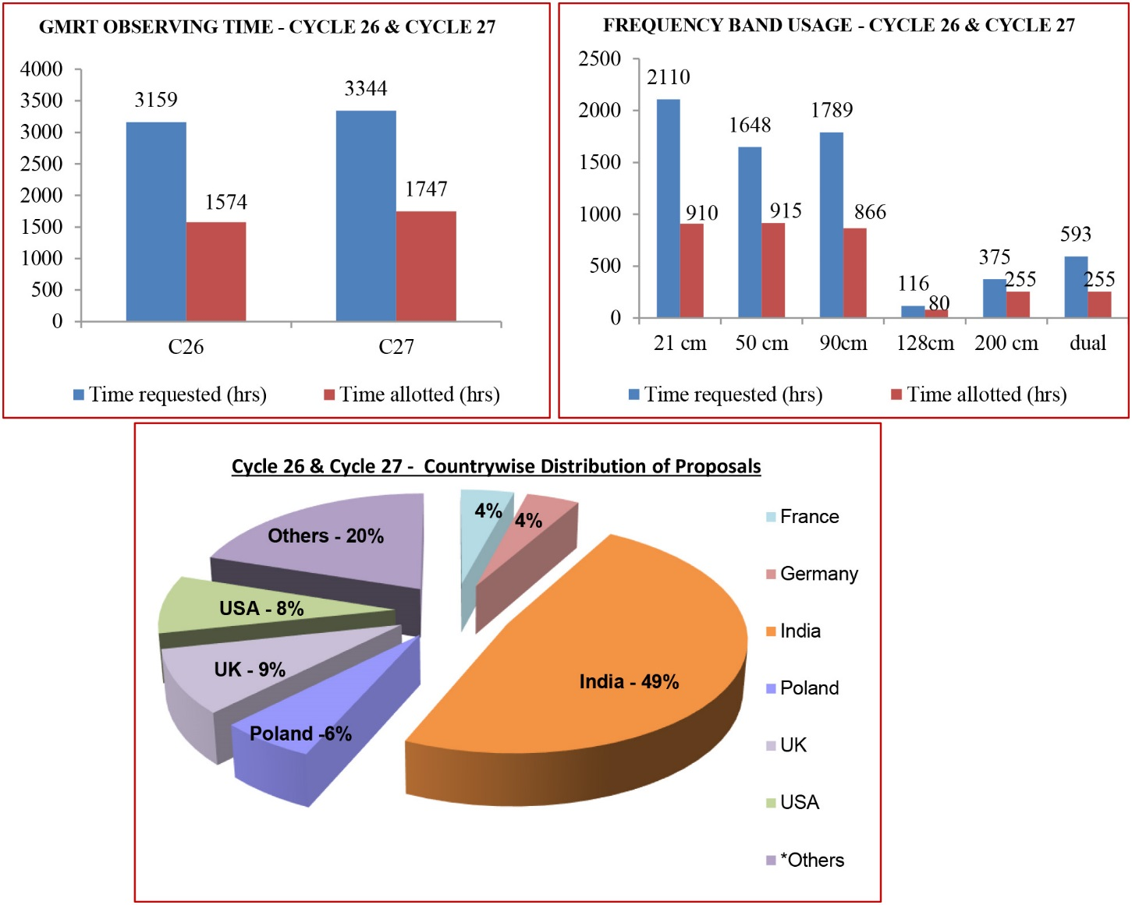
Usage of GMRT by the world-wide astronomy community, for observing cycles 26 & 27, covering April 2014 to March 2015

Radio Physics Laboratory
The Radio Physics Laboratory (RPL) hosted the third ``Pulsar Observatory for students (POS)'' program at Ooty Radio Telescope like last two years. The first leg of the program with lectures on pulsar astronomy was held between July 14 to 17, 2014, which was attended by 24 students. The students then came in three batches till January 2015 to conduct live pulsar observations with ORT, where the participants were introduced to pulsar data analysis. A new feature of the school this year was the emphasis on pulsar timing and pulsar timing array for gravitational wave detection and this is likely to be strengthened into a workshop next year. At the end of the year, RPL hosted seventh radio astronomy winter school for College and University students (RAWSC-14) between December 22, 2014 to December 31, 2014, which received an enthusiastic response from college students as usual. The school was attended by 32 students drawn from all over India and seems to have become an exposure summer school of choice for the undergraduate science students. RPL also put up a stall at the Annual Science day exposition at the GMRT on February 28, 2015 and also participated in local astronomy outreach events, such as an event organised before the Astronomical Society of India meeting at NCRA in February 2015. RPL also undertook an expansion of its facilities with procurement of laboratory equipment, antenna design software and radio astronomy receivers. The work horse of RPL, 4-m antenna, was retrofited with a new stepper motor drive for rotation in both axes. Improvement in design of Affordable Solar Radio Telescope (ASRT) continues and a group of students were involved in mechanical design of a 5-m antenna. Newly acquired antenna design software, FEKO, was used to design simple antennas by the students [Joshi B. C. with Roy S.(NCRA-TIFR), Gopakumar A. (TIFR), BagchiJ., Gupta N. (IUCAA), KrishnakumarK,. ManoharanP. K, RajaA. Jesu (RAC) NCRA-TIFR), Saikia D J (Cotton College University, Guwahati), Bhattacharya D.(IUCAA)]
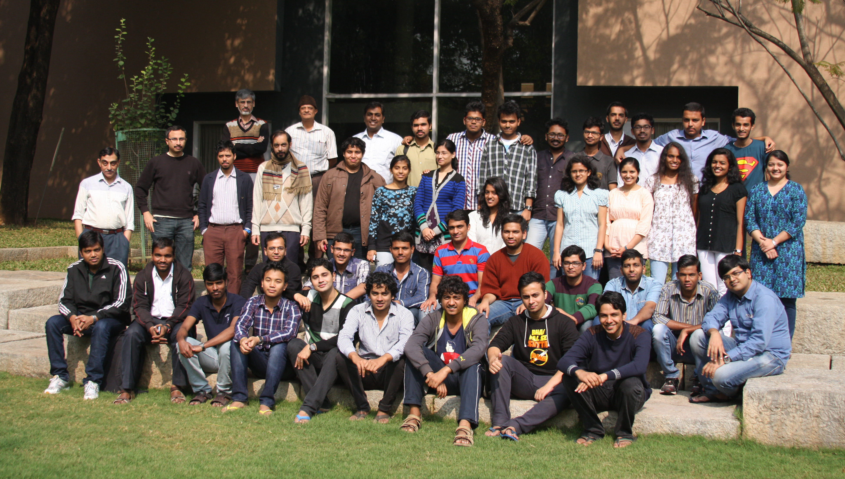
Participants in Radio Astronomy School for College students (RAWSC2014) hosted by IUCAA & NCRA
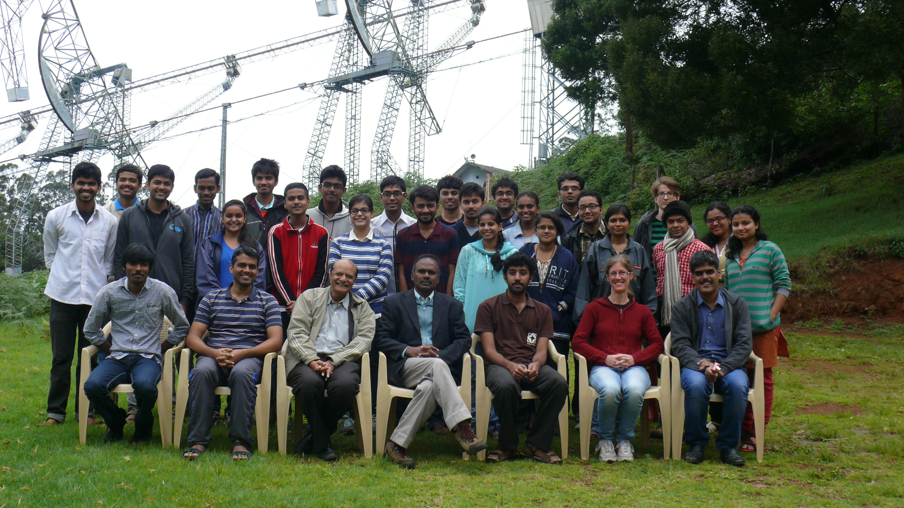
Participants in Pulsar Observing for Student (POS-2014) workshop at RAC Ooty

Instrumentation and Facilities
Upgrade of the GMRT electronics systems :
The GMRT is undergoing a major upgrade which includes broad band seamless frequency coverage from 50 to 1500 MHz with improved sensitivity and maximum instantaneous bandwidth of 400 MHz. This is accompanied by other upgrades such as a next generation monitor & control system, a modern antenna servo system, improvements to the mechanical systems of the antennas, enhancements in data storage and computing resources, and matching improvements in infrastructure facilities relating to civil and electrical systems. The upgrade requires several improvements to the front-end and back-end electronics systems of the telescope, including the fibre-optic system that connects these two systems. Many of these upgrade activities have crossed the prototyping, testing and acceptance stages and are in mass production phase, while a few others are in final stages of prototyping and testing. Highlights of some these upgrade activities during this year are as follows :
Upgrades of the GMRT front-end and fibre-optic systems :
- GMRT front-end and fibre-optic systems :
The main changes being carried out to the front-end systems are the design and implementation of new, broadband feeds; matching RF front-end electronics systems with improved dynamic range; and associated improvements in the support electronics. For the fibre-optic system, there is a new scheme for transfer of broadband signals from each antenna to the central receiver room, while maintaining the availability of the existing system for transfer of narrow band signals with IF carriers.

1.1 As a part of the upgrade of the GMRT feeds the following has been achieved :
(a) The cone-dipole feed designed the for 250-500 MHz frequency range has been installed on 14 of the 30 GMRT antennas, and the remaining feeds are available for installation.
(b) The dual ring feed designed for the 130-260 MHz band and installed on 3 antennas, has been found to have very good performance around 150 MHz, but needs some improvement of performance around 235 MHz end of the band.
(c) For the 550-900 MHz range, the activitiy for choosing between a couple of different realisations of the cone-dipole feed and a horn based feed that was designed for the GMRT by the CSIRO team in Australia, advanced significantly with an optimized version of the cone-dipole feed emerging as the likely choice. [Bandari H. R., Sankarasubramanian G, Ramesh S]

1.2. For the upgrade of the GMRT front-end systems, the following are the highlights :
(a) For the 130-260 MHz band, the pre-final version of the new front-end system was developed. It has a wireline based quadrature hybrid, a significantly improved low noise amplifier and narrowly tuned notch filters to block interfering signals from commercial TV and wireless systems. The system was installed in 3 antennas with the upgraded feed. [Bhalerao V. B, Prajapati A, Vawhal A, Sureshkumar S]
(b) For the 250-500 MHz band, the team completed the design of the final version of the front-end system, which features an improved low noise amplifier with 20 Kelvin noise temperature, notch filters and meta-material based switched sub-band filters. The units went into mass production and will gradually be installed on all the antennas, alongwith the wideband 250-500 MHz feed. [Raut A. N, Temkar V.B, Chaterjee, S, Parikh G P, Prajapati A]
(c) For the 550-900 MHz band, designed near completion for the upgraded front-end system to go with the prototype feed. The system uses in house developed low cost switched sub-band filter and special notch filters for rejecting TV and Mobile signals. In addition, the existing 610 MHz feed was upgraded with wideband frontend system for exploiting the full feed bandwidth in 8 antennas. [Bhalerao V B, Khan I, Prajapati A, Kumbhar G C, Ramesh S, Sureshkumar S]
(d) An upgraded high dynamic range version of the common box electronics that comes after the front-end systems has been designed and the prototype is in final stages of integration. It has a much better dynamic range (1 dB compression and IP3 points) and appears to be successful in handling broadband signals without saturation. [Temkar V. B., Kumbhar G.C.]

1.3. Highlights from the uprade of signal transport and fiber-optics systems are asfollows:
The RF over fiber system using Dense Wavelength Division Multiplexing (DWDM) to bring back the wideband signals from the upgraded systems while continuing to support the existing narrow-band IF systems and including a 1 Gbe bi-directional ethernet link, has now been successfully installed in 24 of the 30 antennas. Furthermore, work on equipping the fiber optic system at the central electronics building with RF frontend signal monitoring and in-line optical power monitoring, reached an advanced stage with design completed and installation in progress. [Sureshkumar S., Raybole P., Lokhande S., Rai S., Prajapati A., Gopinathan M.]

Upgrades of the GMRT back-end systems :
- GMRT back-end systems :
As part of the GMRT upgrade, new back-end systems are being implemented to achieve the upgrade system specifications like increased bandwidth of 400 MHz, direct processing of RF signals, increased dynamic range, improved channel resolution in the digital back-ends etc. Some of the main developments are as follows.

2.1. Analog back-end system :
The complete Analog Backend system for 30 antennas has been completed and released for use. This system has an improved dynamic range, facility for variable gain, selectable signal bandwidth and individual LO signal for each antenna. Additional features like power equalisation of the 30 antenna signals has also been implemented and released. Further, the system has been provided with a wide range of monitoring tools for online health check of the system. Work was also started on providing additional features like signal spectrum monitoring at the central station, selectable RF filter bank to improve the signal to noise ratio, and increased freedom to set different LO frequencies for the two polarisation channels. Work has also started towards finalisation of the Hydrogen-maser based frequency standard to be installed at the GMRT observatory to provide VLBI capability. [Ajithkumar B., Shinde N., Nanaware D.K., Ganla A., Dhende A., ShriHari G., Phakatkar S., Hande P.J., Vishwakarma A.]

2.2. Digital back-end systems :
A 16-antenna, dual polarization version of a GPU-based hybrid correlator and beamformer (with incoherent and coherent modes and a pulsar preprocessor) was completed. It has Atmel dual ADC boards for digitisation of the baseband signal, Casper FPGA boards for data packetisation & transfer to the computer nodes having NVIDIA K20 GPUs, and infiniband connectivity between the nodes for data transfer. This system can currently process 200 MHz bandwidth with 4 K to 16 K spectral channels, and includes support for a full Stokes mode, and is expandable to 400 MHz bandwidth. [Reddy S. H., Kudale S., Shelton G.J., Ajithkumar B.,Gupta Y.]

Currently work is in progress to develop the next version of the system with support upto 32 antennas, dual polarisation with 400 MHz bandwidth, 16 K frequency channels and wide range of integration times. Further, the implementation of many useful modes like narrow band mode for spectral line observations, poly-phase filter banks for improved isolation between frequency channels and implementation of Walsh demodulation is well under way. Various RFI cancellation algorithms have been tested and are ready to be implemented in the final Backend system. [Reddy S. H., Chaudhari S. C., Buch K. D., Halagali I.M., Bhonde I.S., Ajithkumar B., Gupta Y.]

New monitor &control system for the upgraded GMRT :

3. New monitor &control system :
TocontrolandcoordinatetheupgradedGMRTsystemsforperformingastronomicalobservations, efforts are on to develop a next generation MonitorandControl(M&C)system.This includes modernhardwareandsoftwarearchitecturalfeaturescomparedtotheexistingGMRTcontrolsystem, including futuristic developments that could be of relevance to next generation radio telescopes such as the SKA. Some of the highlights are as follows.

3.1. New M&C hardware systems :
NewMonitorandControlModules(MCM)developedbasedonRabbitRCM4300micro-controller, completed the mass production phase with the wiring and testing of 120 cards. Theseareused as the main controlling units in the upgraded M&C system that is being designed. The Rabbit card was successfully interfaced with most of the GMRT systems : servo, optical fibre, sentinel, feed positioning system, analog back-end etc., and a bsic set of high level commands have been implemented. Other hardware such as the layer-2 ethernet switches required at the antenna base, were also procured [Kanade C., Sisodiya N., Misal M., Sateesh C, Kodilkar J, Nayak S, Kantharia N.]

3.2. New M&C software – online_version 2 :
ThenewM&CsystemsoftwarecalledONLINEVersion2.0(Online-V2) being developed by an in-house team, reached an advanced stage of completion during this period. Online-V2followsaclient-serversoftwarearchitectureandthedesignisbasedon the TCP/IPcommunication protocol. In this upgraded system, the Rabbit MCM directly communicates with OnlineV2 through the Layer 2 network switch at the antenna base and Layer 3 switch in the receiver room. OnlineV2 uses multi-threading for parallelizing the communication with 30 antennas and Python as the higher level operator interface. The Linux, Apache, MySQL, PHP (LAMP) model of free and open software is used in the development of OnlineV2. Python, Perl, Javascript, QT/QML, gnuplot are used in addition to Readline libraries for higher level interfaces and web-based utilities. The new M&C system has several new features, including improved performance with minimal time for configuring the telescope facility to restore the default values with minimal downtime after power failure. Online-V2wastestedwith various sub-systems in the lab and in-situ environments. It was also tested on 16 antennas with a single MCM card interfacing with the sentinel system and the upgraded wideband optical fibre system. [Uprade R., Sisodiya N.,Kanade C.,Misal M.,Sateesh C,Katore S.,Bhong D., Sherkar S. , Nayak S, Kantharia N.]

3.3. Next generation M&C software system :
NCRA is actively involved in the development of a next generation M&C system applicable for large systems (including radio telescopes like the GMRT and the SKA), in collaboration with the TRDDC research laboratory and partners from software industry. As a first step of this effort, a modern M&C system software is being developed for the GMRT, which can be used as a demonstrator for SKA and can help evaluate and test various kind of prototypes required in the SKA design. The design phase for this next generation GMRT M&C System as a SKA prototype was completed, which delivered the Software Architecture Description and Graphical User Interface documents. This work was completed by the Tata Consultancy Services Limited, Pune after close collaboration work with the NCRA. The Software Architecture supports a modular, hierarchical design and specification driven approach, which can be adapted for larger scale radio telescope like the SKA. A prototyping study to explore the possible technology choices for the final production version, was also completed. Selected technologies like EPICS (Experimental Physiscs and Industrial Control System), CSS (Control System Studio) were evaluated by building a M&C system prototype at PoC level. This work is also expected to have direct relevance and feedback into the work towards design of the M&C system for the SKA telescope. [Kodilkar Jitendra S., Nayak S., Joardar S., Gupta Y.]

3.4. GMRT User Tools (GUT) and support for remote observing :
Several monitoring tools that can help an user absentee observe at GMRT from any part of the world have been developed and are currently available at www.gmrt.ncra.tifr.res.in/~astrosupp. These include tools and documents required by an user before their observing and can help the user estimate the integration times, sensitivity, search for appropriate calibrators, estimate the sky availability of the source and create observing files. Programmes that can enable a user while observing to check the observing status, antenna status, complex visibility data quality and look at the antenna gains estimated on calibrators are also made available. A CASAPY script to generate a quick look image of the calibrator source is also provided. The post-observing tools such as for conversion of the raw data format known as LTA to FITS format are under development. A scheme to provide authenticated login for observers from outside NCRA to use these tools is being developed. [Katore Santaji, Sherkar Sachin, Kantharia N. G.]
GMRT servo system upgrades
The successful commissioning of new Brush-less DC (BLDC) motors and drives continued on more antennas of the GMRT and a total of 12 antennas were completed by the end of this year. This upgrade has significantly reduced the down time of the antennas due to servo system problems and routine motor maintenance. The commissioning of the new PC/104 based servo control computer was also extended to more GMRT antennas, with 9 more completed this year, taking the total to 20 systems installed so far. In a collaborative effort with Case Western University and Bhabha Atomic Research Centre, new control algorithms are being developed to improve the tracking performance of the antennas by a factor of 3, which is likely to lead to a significant improvement of the dynamic range of the GMRT images [SabhapathySuresh, BagadeShailendra, KumarAmit, ThiygarajB., HaokipT, GadekarSamir, PawarAbhishek, DesaiPriyanka, Ranka Trupti and Joshi B C (NCRA,GMRT-TIFR) with BARC reactor control division]

Square Kilometre Array (SKA)
NCRA leads Indian participation in the international SKA project :
The Square Kilometre Array (SKA) is the most ambitious international radio astronomy project ever attempted. It aims to build a telescope with 1 million square metres of collecting area, covering a large frequency range from about 50 MHz to 10 GHz, in a radio quiet region of the globe. This will result in an instrument that is 50 times more sensitive than the best today, capable of cutting edge science in several aspects of astronomy and astrophysics. As many as eleven of the major radio astronomy practicing nations are collaborating in this project, which entered a detailed design phase from November 2013 onwards, expected to last till end of 2016.
India (represented by NCRA) is now an active participant in the SKA, with NCRA having become a Full Member of the SKA Organisation in August 2014 -- this will shortly be transferred to a Full Membership of India. NCRA has been involved in the scientific and technical activities of SKA from the early days. Recently, since October 2013, NCRA has taken up the leadership of the Telescope Manager consortium, which is a collaboration of members from 7 different SKA member countries, working together towards the design of a sophisticated monitor & control system for the SKA, which will be like the brain and central nervous system of the observatory. NCRA is also involved to a smaller extent in the Central Signal Processing work package (where our contribution leverages our expertise in GPU-based digital back-end receivers), and the Signal and Data Transport work package. Many of these SKA activities are being carried out in active collaboration with partners from Indian industry. The Telescope Manager consortium has successfully completed the Preliminary Design Review phase of the work and has now embarked on the Detailed Design phase that will lead to the Critical Design Review by end of 2016.
Alongwith the above, science activities related to the SKA have also picked up momentum in India. SKA India Science Working groups have been formed in March 2014 which have been working on developing the science case and the potential user base within the country. Their activities include carrying out theoretical studies and modelling, as well as using the existing facilities like the GMRT to conduct research and investigations that will prepare the scientific community to make the best use of the SKA when it is ready. National level SKA science workshops have been held in conjunction with the ASI meetings of 2014 and 2015, and early draft versions of science case documents have been produced my many of the Indian science working groups.
In order to coordinate and oversee the growing SKA related activities within the country, a SKA India Consortium has been formed in February 2015, which presently has membership of 13 different research organisations and universities within the country [GuptaY., WadadekarY., RamanujamN.M., ChoudhuryT. R., ChengalurJ. N., GhoshS.K., Kodilkar J.P. and AjithkumarB., (NCRA-TIFR) working with partners from TRDDC, TCS, PSL and NVIDIA in India, and with colleagues from SKA members in South Africa, U.K., Australia, Canada, Italy and Portugal]

Staff List

Pune
Academic: Chandra P, Chengalur J. N., Ghosh S. K., Gupta Y, Ishwara Chandra C H, Joshi B. C., Kanekar N., Kantharia N. G., Lal D.V., Mitra D., Oberoi D, Choudhary T R., Roy J., Roy S, Saikia D. J., Sirothia S. K., Visweshwar Ram M.R., Wadadekar Y.G.

Research Scholars : Aditya J. N. H. S., Atul Mohan, Bait O. S., Basu A. K., Dey A P, Gaikwad Prakash S, Ghara R, Johri A, Kurapati S, Mishra P K, Naidu A.K., Nayana A J, Puranapanda K.C., Raut D V, Roach H, Sebastian B, Sharma R, Surnis M.

Post Doctoral Fellows: Banerjee A., Basu A., Basu R, Bhattacharyya B., Datta K K, Gajjar V.R., Kale R., Maan Y., Pandey K. L., Patra N.N.

Visiting Position: Banerjee R.

Scientific: Gardasu B., Meshram S.G., Prasad A, Ramanujam N. M., Venkatasubramani V., Konar S.

Technical: Bachal S. J., Bhilare P. D., Gole S.R., Jadhav M. K., Kamble V. S., Karekar P. G., Mhetre G.V., Murugesan S., Patil T. M., Shelar P. B., Sutar G.N., Tonde D. B., Jesu Raja P .

Administration: Gonde N.B., Adhikari S.S., Barve A. P., Bhujbal J. A., Ganeshan G., Jayasimha B. R., Joshi A., Khatavkar H. C., Khatkale S. J., Kulkarni M. M., Kulkarni S. M., Lokhande H. D., Mandhare J. D., Pandiselvan C., Patil S. V., Pawar D. V., Pawar K. R., Reena Shrikumar, Rohini Rajshekhar, Sabne M. M., Sangle B. S., Shetty S, Solanki J. K., Sonsale S.M.

Administration (Trainees): Chavan A. S., Hadawale V.B, Kamble R.D., Khandave A. U., Khandizod R.B., Memane T.S, Nirmalkar S. A., Patil P.S, Patil Sneha V, Prajapati M.S, Revadkar S.D, Shirole M.G

Auxiliary: Bahirat R. E., Dalvi F. M., Gaikwad V. V., Khole N. B., Langhi S.J., Nalawade B. T., Nalawade G. A., Pawar V. R., Raste P. K., Shelar K. S., Singh H, Sodanavar V. R.,

Project: Ashok Kumar, Kate G. J., Meghe A.A, Roy Jayashree

Khodad

Scientific: Ajith Kumar B., Amit Kumar, Ankur, Bagde S. K., Bhong D.B., Buch K.D., Chatterjee S, Chaudhari S C, Dongare S.N., Dubal S.S., Elipilli K A, Gnanaraj S.J., Goril S.K., Gupta S, Hanumanth B R, Joardar S., Kale H. S., Kamble J. R., Katore S. N., Khan I, Kodilkar J. P., Kudale S. S., Muley M.V., Nandi A.K., Nayak S., Padwal P.T., Parikh G.B., Patil M.S., Pawar A.C., Rai S.K., Raskar N.S., Raut A. N., Reddy H.S., Rodrigues I. E., Sabhapathy S, Samble M.S., Sankarasubramanian G., Sherkar S S, Shinde N. D., Shinde N.J, Sisodiya N.M., Somwanshi M. D., Suresh Kumar S., Swami R. V., Thiyagarajan B., Umbarje M. S., Uprade R.R., Vasave R. J. Trainee (Scientific) Bhatporia S J, Bhor R.D, Desai P.P.

Technical: Bachal Shailendra J, Bhalerao V. B., Bhonde I. S., Bhumkar A.K, Burle S. M., Dhende A. T., Diwane A.A., Gaikwad K. R., Gaikwad P. S., Gaikwad Y.S., Ganla A.A., Gavit S.Z., Ghangale J. L., Ghorpade D.D., Gopinathan M., Halagali I, Hande P. J., Haokip T. S., Kamble U. S., Kanade C. P., Kasar P. N., Kedari H.V., Khande D.R., Kotawadekar A.P., Kumbhar G.C., Lokhande S. K., Lolap R.K., Mirajkar S.S., Misal M.B., Nalawade J. R., Nanaware D. K., Patil B. S., Patil S. D., Phakatkar S. V., Poonattu A. M., Rajendran B., Ramesh S., Raybole P. A., Sakthivel A., Satheesh C., Shirsath S.E., Temgire D. D., Temkar V.B., Thorat G M, Thorat G. G., Thorat R.B., Vawhal A.A, Vishwakarma A.M., Walunj D. V.

Technical (Trainee ): Gujarkar S.G.
Administration : Deshmukh N. S., Joglekar A.C., Jondhale A. B., Kanade D S, Kharmale V.S., Naik R. Y., Pokharkar D. B., Shaikh I G K.

Administration (Trainees): Andhale P.P, Gunjal A.L., Ichake T.K, Shaikh M, Shete A. A.
Auxiliary:Aher V. K., Bhalshankar S. L., Bhor A. G., Bhor S. G., Chaskar B.D., Dambale D. S., Gadhave R.B, Gaikwad B. S., Gaikwad M. B., Gaikwad P. B., Gaikwad S. R., Ghangale H. K., Ghangale S. J., Ghorpade C. H., Ghorpade D. B., Gundgal D. K., Hande N. V., Karkud R. B., Khude K. R., Kotwal A. R., Kuchik D. D., Kuchik S. M., Mule N. D., Pingale R. Y., Sable B. C., Sake S. D., Shelake J. C., Shigwan R. B., Thorat D. B., Thorat K. T., Wajge B. T. Project: Gadekar S S, Gadge S.B, Gokhale U.R, Hendre.A.S, Saurabh S., Shetty V.

Ooty
Academic : Manoharan P. K.,
Post Doctoral Fellow: Dwivedi V.C.
Scientific: Kalyansundaram K., Mittal Amit Kumar, Rajamohan S., Ravikumar D., V.Satya Gireesh Gantyada , Varghese E. A.

Technical: Aravindakrishnan K. G., Chandrasekaran R., Chandrasekharan V., Kumaresan N. , Raja K., Senthil Kumar S.J., Sivakumar. S., Venkatasubramani R., Venkatesha C. M.
Technical (Trainee ): Jude N.R, Praveen P, Samson Christy P. R.
Administration: Lali Shantha Kumari N., Packiaraj V.

Administration (Trainees): Maria DJ, Shyam V.

National and International Involvement
Chandra, P.
- Member, Astronomical Society of India

Chengalur, J.N.
Member,
- National Committee of the IAU
- AIRIES Scientific Advisory Committee
- SKA Science Working Group
- SKA Science Review Panel

Choudhury, Roy T.
- Member, International Science Working Group on Cosmology for the SKA.
- Overall coordinator, Science Working Groups for SKA-India.

Gupta, Y.
- Leader, Telescope Manager Consortium -- an international collaboration for work on the design of the Telescope Manager system for the SKA, led by NCRA, from October 2013
- Chair, TMT-India Software Work Packages Monitoring Committee, from March 2015
Member,
- Steering Board of CASPER (Collaboration for Astronomy Signal Processing and Electronics Research), University of California, Berkeley
- Physics Sectional Committee of the Indian Academy of Sciences for 2014-15
- Scientific Organising Committee of the meeting, Tempe2014: Early Science Results from Low-frequency Radio Telescopes, December, 8-10 2014.
- Review panel of the Mid-Scale Innovations Program (MSIP) of the National Science Foundation (NSF), USA, for 2014-15.
- Indian representative on the Board of the international Square Kilometre Array Organisation, from 2011

Ishwara Chandra C.H.
- Councilor, Executive Council, Astronomical Society of India, 2013 - 2016

Joshi B.C.
Member,
- Panel on Education, COSPAR
- RadioAstron International Science Committee

Kanekar, N.
Referee,
- Astrophysical Journal,
- Astronomy & Astrophysics
- Monthly Notices of the Royal Astronomical Society
- Journal of Astrophysics and Astronomy, for the Square Kilometre Array Science Book
- Proposals for observing time on the Giant Metrewave Radio Telescope.

Lal, D. V.
Member,
1) International Astronomical Union (IAU)
2) Square Kilometre Array (SKA), Continuum-Surveys Science Working Group
3) Astronomical Society of India (ASI)
4) International Union of Radio Science (URSI)

Manoharan, P.K.
Editor,
- Solar and Terrestrial Sciences Section of Geosciences Letters, official journal of the Asia Oceania Geosciences Society (AOGS).
- Journal of Space Weather and Space Climate
- Vice-President, IAU Division E Commission 49 Interplanetary Plasma & Heliosphere
- National Coordinator, International Space Weather Initiatives (ISWI) Programme in India.
- Co-PI, Aditya-L1 Space Solar Coronagraph Project, ISRO, India
- Member, nomination committee for Axford Medal of Asia Oceania Geosciences Society (AOGS)
- Judge in selecting the best student poster presentations of the Solar and Terrestrial (ST) Section at the AOGS 2014 Conference, Sapporo, Japan.

Oberoi, D.
- Vice-Chair, MWA Solar Heliospheric and Ionospheric Coordination committee

Visits - Conference / Symposia / Workshop attended
Chengalur, J.N.
Visited
- Special Astrophysical Observatory, Russia Moscow, September 9-20, 2014
- Sydney, Australia,November 1-11, 2014
- Jodrel Bank Observatory, London, UK, December 9-15, 2014

Gupta, Y.
Visited / Attended
- Jodrell Bank, UK, April 8-11, 2014 (to participate in the Meetings of theScience Data Processing Consortium and the Telescope Manager Consortium)
- Jodrell Bank, UK , June 16-18, 2014 (to participate in the review by theSKA Science and Engineering Affairs Committee for the SKA Project)
- Geneva, June 30 - July 1, 2014(to participate in the Symposium on LowFrequency Radio Astronomy organised as part of the EWASS meeting)
- Perth, Australia, September 29 - October 2, 2014 (to participate in theAnnual SKA Engineering Meeting and the team meetings of the Telescope Managerand SADT consortia)
- Guiyang, China, October 15-17, 2014 (to participate in the 15th SKA BoardMeeting for the SKA Project)
- Jodrell Bank, UK, December 2-4, 2014 (UK to participate in the 16th SKA BoardMeeting and the 4th SKA Members Meeting for the SKA Project)
- Goa, India December 19-20, 2014 (to participate in the 2014 IEEE HPC Conference)
- Mumbai, India January 4, 2015 (to participate in the 102nd meeting of the IndianScience Congress)
- Jodrell Bank, UK, January 7-9, 2015 (to participate in the PreliminaryDesign Review Meeting of the Telescope Manager Consortium)
- Raman Research Institute, Indian Instituteof Science and Indian Institute of Astrophysics, Bangalore, India , January 19-20, 2015 (for discussions related to IndianSKA project)
- Jodrell Bank, UK March 3-5, 2015 (to participate in the 17th SKA BoardMeeting for the SKA Project)

Ishwara Chandra C.H.
Visited
- Argentine Institute for Radioastronomy (IAR-CONICET) and Department of Astronomical and Geophysical Sciences, University of La Plata (FCAyG-UNLP), Argentina, November 2 - 28, 2014 (Visiting Professor)
Joshi, B.C.
Visited / Attended
- Moscow, Russia, August 2 - 10, 2014 (40th Committee of Space Research (COSPAR) Scientific Assembly)
2) Moscow, Russia, August 8 - 10, 2014 (Radio Astron International Science Council)
3) Neutron Star Workshop,Pune, India, November 20 - 21, 2014
4) 33rd Meeting of Astronomical Society of India, Pune, India, February 17 - 20, 2015

Kanekar, N.
Visited
- Australia Telescope Compact Array, Narrabri, Australia, July 18-27, 2014.
- International Centre for Radio Astronomy Research, Perth, July 29 - August 9, 2014.
- Indian Institute of Science Education and Research, Mohali, October 2014.
- Indian Institute of Astrophysics, Bangalore, November 2014.
- Raman Research Institute, November 2014

Kodilkar, J.
- Madurai, India, (The Second National Symposium on Particles, Detectors, and Instrumentation),March 27-31 ,2015

Lal, D.V.
Visited / Attended
1) Boston MA, USA, June 25-27, 2014 (Panel Member, Chandra Reviewer)
2) Boston MA, USA July 9-11, 2014 (X-ray view of Galaxy Ecosystems)
3) Harvard-Smithsonian Center for Astrophysics (Smithsonian Astrophysical Observatory),
June 27, - July 8, 2014
4) Asia-Pacific Regional IAU Meeting (APRIM) 2014, Daejeon, Republic of Korea,
August 18-22, 2014
5) Korea Astronomy and Space Science Institute August 22-26, 2014

Manoharan, P.K.
Visited / Attended
- Goddard Space Flight Center, NASA, USA, August 4-22, 2014.
- Center for Space Plasma and Aeronomic Research (CSPAR) and Department of Space Science (SPA), The University of Alabama in Huntsville, USA, August 24-29, 2014.
- Physical Research Laboratory, Ahmadabad, India, during December 15-19, 2014.
- Solar-Terrestrial Environment Laboratory, Nagoya University, Japan, March 09-12, 2015.

Oberoi, D.
Visited
- MIT Haystack Observatory, Westford MA, September 15, 2014 to October 20, 2014

Wadadekar, Y.G.
Visited
- SKA Headquarters, Jodrell Bank, UK January 6-9, 2015

Invited Talks in Conferences and Meetings
Chandra, P.
- Studying the radio emission from the magnetic massive stars,BinaMIcs #3 and MiMeS meeting, Paris Observatory, France, July 21-25 2014,
- Shocked after violent death of Stars, 33rd Astronomical Society of India meeting, NCRA, Pune, February, 17-20, 2015

Chengalur, J.N.
- Radio Astronomy, Astronomy Olympiad Camp, HBCSE, May 7,2014
- The ISM in galaxies, Workshop on "Galaxies and Cosmology, NCRA-TIFR, Pune July 7-18, 2014
- Cold Atomic Gas in High Redshift Galaxies, The periphery of disks Conference, Sydney, Australia, November 3-6, 2014
- Gas and star formation in faint dwarf galaxies, Structure and Evolution of Galaxies, IUCAA, Pune, January 22-23, 2015
- Cold gas and star formation in nearby dwarfs, 33rd Annual Meeting of the Astronomical Society of India, NCRA-TIFR, Pune, February 17-20, 2015

Choudhury T. R.
- Cosmology and astrophysics using neutral hydrogen distribution, SKA-SA 2014 Postgraduate Bursary Conference, Stellenbosch Institute for Advanced Study, Stellenbosch, South Africa, December 2014

Gupta, Y.
- The GMRT : Current Status and Upgrade Plans,Symposium on Low Frequency Radio Astronomy, Geneva, July 1, 2014
- Some Aspects of Big Data and HPC Challenges in Astrophysics, Indo-US Workshop, IEEE HPC Conference at Goa, December 20, 2014.
- Square Kilometre Array : The Radio elescope Mega-Project, Mega Science Projects in India, 102ndmeeting of the Indian Science Congress, January 4, 2015.

Ishwara Chandra, C.H.
- AGN from Radio Perspective, Workshop on Tools and Techniques for Research in
Astrophysics at Multi-wavelengths, Department of Physics University of Calicut October 15-17, 2014
- Active Galaxies, Radio Astronomy Winter School, IUCAA,Pune,India, 2014

Joshi, B.C.
- Teaching radio astronomy with Affordable Small Radio Telescope (ASRT), 40th Committee of Space Research (COSPAR) Scientific Assembly, Moscow, Russia, August 5, 2014
- Constraining possible magnetospheric changes through simultaneous multi-frequency observations of radio pulsars, 40th Committee of Space Research (COSPAR) Scientific Assembly, Moscow, Russia, August 3, 2014
- A census of pulsars with surveys and timing with the SKA, Neutron Star Workshop, India Pune, India, November 20, 2014

Kantharia, N.G.
- Evolving red giant wind densities in recurrent nova V745 Scorpii – GMRT
Study, 33rd Astronomical Society of India, NCRA, Pune, February 17-20, 2015
- Surveying the sky in (radio) polarised emission, RoboPol and Polarimetry in Astronomy, IUCAA, Pune, January 6-7, 2015
- Studies of galaxies with GMRT - initial polarization results, Annual NCRA Academic Day, December 4-5, 2014

Kanekar, N.K.
- Do the Fundamental Constants change with time ?, Centre for Radio Astronomy Research, Curtin University, Australia, July 2014
- The Nature of High-z Damped Lyman-alpha Systems, International Centre for Radio Astronomy Research, University of Western Australia, Australia, August 2014
- Do the Fundamental Constants Change with Time?, Indian Institute of Science Education and Research, Mohali, October 2014.
- The nature of high-z damped Lyman-alpha systems, Indian Institute of Science Education and Research, Mohali, October 2014.
- Do the Fundamental Constants Change with Time?, Indian Institute of Astrophysics, Bangalore; November 2014.

Lal, D.V.
- AGN interaction with the hot gas environment, Asia-Pacific Regional IAU Meeting 2014 (APRIM 2014), Daejeon, Republic of Korea, August 18 – 22, 2014

Manoharan, P.K.
- Ooty Interplanetary Scintillation Observationsof July 2012 Energetic Events, Goddard Space Flight Center, NASA, Greenbelt, Maryland, USA, August 21, 2014
- Remote-Sensing Observations of Solar Wind in the Inner Heliosphere - Density Turbulence and Speed Distributions, CSPAR, Space Physics Division, University of Alabama, Huntsville, USA, August 28, 2014
- Ooty Interplanetary Scintillation Observations and 3-D Heliosphere, Physical Research Laboratory, Ahmadabad, India, December 19, 2014
- Ooty Recent Studies on Solar Wind Micro Turbulence, Solar-Terrestrial Environment Laboratory, Nagoya University, Japan, March 10, 2015
- Interplanetary Scintillation Studies on Solar Wind Transients in the Inner Heliosphere , Asia Oceania Geosciences Society (AOGS), 11th Annual Conference, Sapporo, Japan, July 29, 2014
- Intense Solar Energetic Particle Events and their Coronal Mass Ejections Observed during Solar Cycles 22-24, Asia Oceania Geosciences Society (AOGS), 11th Annual Conference, Sapporo, Japan, July 31, 2014
- Space Weather Effects of Solar Wind Transients in the Sun-Earth Distance, 3rd Asia Oceania Space Weather Alliance (AOSWA) Conference, Fukuoka, Japan, March 2, 2015
- Space Weather Events during 2014-15 - Ooty Interplanetary Scintillation Studies, 3rd Asia Oceania Space Weather Alliance Conference and UN Conference on Space Weather, Fukuoka, Japan, March 4, 2015.

Oberoi, D.
- Observing the Sun with the Murchison Widefield Array, General Assembly of URSI, Beijing, August 16-23, 2014
- Information from Radio Observations and the first results from the Murchison Widefield Array Coupling and Dynamics of Solar Atmosphere, IUCAA, Pune, India, November 10-14, 2014
- Studying the first type-II burst seen by the Murchison Widefield Array, Astronomical Society of India Annual Meeting, NCRA, Pune, February 17-20, 2015.

Roy, J.
- High precision pulsar timing results with the GMRT, International Pulsar Timing Array conference, Banff, Canada, June 2014
Wadadekar, Y.G.
- Evolution of galaxy morphology, Workshop on Galaxies and Cosmology, NCRA-TIFR, July 2014

Conference Organised
Chengalur, J.N.
1. Workshop on Galaxies and Cosmology,NCRA-TIFR, Pune, India, July 7-18 2014.
2. Annual Meeting of the Astronomical Society of India, NCRA-TIFR, Pune, India February 17-20

Manoharan, P.K.
- Third Workshop on Pulsar Observatory for Students (POS), RAC, Ooty, The POS program is organized by the Radio Physics Lab., NCRA and IUCAA, July 14-17, 2014

- Upgraded ORT and its possible observations, mini workshop, RAC, Ooty, December 29-30, 2014.

Non DAE Research Projects
Manoharan, P.K.
- Sun-Earth Connection and Space Weather Studies in the Three-dimensional Heliosphere”, CAWSES-India Phase 2 Programme, ISROProject, 2015
- Modernization of Ooty Radio Telescope, ISRO Project, 2010-2014

Wadadekar, S. Sirothia, C. H. Ishwara-Chandra
- Distant obscured galaxies with GMRT and Herschel, Indo-French Centre for the Promotion of Advanced Research (CEFIPRA), April 2, 2011 - March 31, 2015.

Publications

In Journals:
Basu, A.; Wadadekar Y.; Beelen A.; Singh V.; Archana K.N.; Sirothia S.; Ishwara-Chandra, C.H.
Radio-Far-infrared Correlation in “Blue Cloud” Galaxies with 0 <z< 1.2.
The Astrophysical Journal, 803, 51, 2015

Bernstein-Cooper, E. Z. ; Cannon, J. M. ; Elson, E. C. ; Warren, S. R., Chengalur, J. ; Skillman, E. D. ; Adams, E. A. K. ; Bolatto, A. D. ; Giovanelli, R. ; Haynes, M.; P.,McQuinn, K. B. W. ; Pardy, S. A. ; Rhode, K. L. ; Salzer, J. J. ,
ALFALFA Discovery of the Nearby Gas-rich Dwarf Galaxy Leo P. V. Neutral Gas Dynamics and Kinematics
The Astrophysical Journal,148, 35, 2014

Bhat, N.D.R.; Ord, S.M.; Tremblay,S.E.; Tingay,S.J.; Deshpande, A. A.; van Straten, W.; Oronsaye, S.; Bernardi, G.; Bowman, J. D.; Briggs, F.; Cappallo, R. J.; Corey, B. E.; Emrich, D.; Goeke, R.; Greenhill, L. J.; Hazelton, B. J.; Hewitt, J. N.; Johnston-Hollitt, M.; Kaplan, D. L.; Kasper, J. C.; Kratzenberg, E.; Lonsdale, C. J.; Lynch, M. J.; McWhirter, S. R.; Mitchell, D. A.; Morales, M. F.; Morgan, E.; Oberoi, D.; et.al
The Low-frequency Characteristics of PSR J0437-4715 Observed with the Murchison Wide-field Array
The Astrophysical Journal Letters, 791, 2, 6. 2014

Buch, K. D., Gupta, Y., Ajithkumar B.
Variable Correlation Digital Noise Source on FPGA — A Versatile Tool for Debugging Radio Telescope Backends
Journal of Astronomical Instrumentation, 3, 2014

Chatterjee, S. ; Raut, A. ; Kumar, S.
Band Pass Filter Bank Design (250-500 MHz) for Radio Astronomy Application Based on Metamaterial ZOR Techniques
IEEE Aerospace and Electronic Systems Magazine, 30, No.3, 22-29, 2015

Chandra, P. ; Chevalier, R. ; Chugai, N. ; Fransson, C. ; Soderberg, A.,
Circumstellar interaction in Type IIN supernova SN 2010jl
(accepted for publication in Astrophysical Journal, 2015)

Dembska, M., Kijak, J., Jessner, A., Lewandowski, W., Bhattacharyya, B., Gupta, Y.
Flux-density spectral analysis for several pulsars and two newly identified gigahertz-peaked spectra pulsars
Monthly Notices of the Astronomical Society, 445, 3105 2014

Dutta, P. ; Chengalur, J. N. ; Roy, N.; Goss, W. M. ; Arjunwadkar, M. ; Minter, A. H.; Brogan, C. L. ; Lazio, T. J. W. ,
The structure function of Galactic H I opacity fluctuations on au scales based on MERLIN, VLA and VLBA data
Monthly Notices Of The Royal Astronomical Society, 442 647 2014

Fumagalli, M. ; O'Meara, J.M. ; Prochaska, J.X. ; Rafelski, M ; Kanekar, N.,
Directly imaging damped Ly-alpha galaxies at z > 2 - III. The star formation
rates of neutral gas reservoirs at z ~ 2.7,
Monthly Notices of the Royal Astronomical Society, 446, 3178, 2015

Fumagalli, M. ; O'Meara, J. M. ; Prochaska, J. X. ; Kanekar, N., ; Wolfe, A. M.,
Directly imaging damped Ly-alpha galaxies at z > 2: II. Imaging and spectroscopic observations of 32 quasar fields
Monthly Notices of the Royal Astronomical Society, 444, 1282, 2014

Gopalkrishna ; Sirothia, S. K. ; Mhaskey, Mukul ; Ranadive, Pritesh ; Wiita, Paul J. ; Goyal, A. ; Kantharia. N. G.; Ishwara-Chandra, C. H.,
Extragalactic radio sources with sharply inverted spectrum at metre wavelengths
Monthly Notices of the Royal Astronomical Society, 443, 2824, 2014

Gajjar, V., Joshi, B. C., Kramer, M., Karuppusamy, R.,Smits, R.
Frequency Independent Quenching of Pulsed Emission,
Astrophysical Journal, 797, 8, 2014

Gitsch, M.; Manoharan, P.K.
The Summer School Alpbach
Journal of Space Weather and Space Climate, 5, E1, 2015

Hallenbeck, G. ; Huang, S. ; Spekkens, K. ; Haynes, M. P. ; Giovanelli, R. ; Adams, E. A. K. ; Brinchmann, J. ; Chengalur, J. ; Hunt, L. K. ; Masters, K. L. ; Saintonge, A. HIghMass&mdash;High H I Mass, H I-rich Galaxies at z ~ 0 High-resolution VLA Imaging of UGC 9037 and UGC 12506
Astrophysical Journal, 148, 69, 2014

Huang, S.; Haynes, M. P.; Giovanelli, R.; Hallenbeck, G.; Jones, M. G.; Adams, E.A.K. ; Brinchmann, J.; Chengalur, J.N.; Hunt, L.K.; Masters, K.L.; Matsushita S.; Saintonge A. ; Spekkens K.,
HIghMass-High H I Mass, H I-rich Galaxies at z ~ 0 Sample Definition, Optical and H&alpha; Imaging, and Star FormationProperties
Astrophysical Journal,793, 40, 2014

Hurley-Walker, Natasha; Morgan, John; Wayth, Randall B.; Hancock, Paul J.; Bell, Martin E.; Bernardi, Gianni; Bhat, Ramesh; Briggs, Frank; Deshpande, Avinash A.; Ewall-Wice, Aaron; Feng, Lu; Hazelton, Bryna J.; Hindson, Luke; Jacobs, Daniel C.; Kaplan, David L.; Kudryavtseva, Nadia; Lenc, Emil; McKinley, Benjamin; Mitchell, Daniel; Pindor, Bart; Procopio, Pietro; Oberoi, Divya; et.al
The Murchison Widefield Array Commissioning Survey: A Low-Frequency Catalogue of 14 110 Compact Radio Sources over 6 100 Square Degrees
Publications of the Astronomical Society of Australia, 31, 20, 2014

Hurley-Walker, N.; Morgan, J.; Wayth, R. B.; Hancock, P. J.; Bell, M. E.; Bernardi, G.; Bhat, N. D. R.; Briggs, F.; Deshpande, A. A.; Ewall-Wice, A.; Feng, L.; Hazelton, B. J.; Hindson, L.; Jacobs, D. C.; Kaplan, D. L.; Kudryavtseva, N.; Lenc, E.; McKinley, B.; Mitchell, D.; Pindor, B.; Procopio, P.; Oberoi, D.; et.al
VizieR Online Data Catalog: 180MHz Murchison Commissioning Survey
VizieR On-line Data Catalog: VIII/98, 31, 45H 2014

Ishwara-Chandra, C.H.; Wadadekar, Y.; Beelen, A.; Kharb, P.
Kiloparsec-scale radio emission in Seyfert and LINER galaxies
Monthly Notices of the Royal Astronomical Society 446, 599-612, 2015
Kanekar, N.
Giant Metrewave Radio Telescope Detection of Two New HI 21cm Absorbers at z~2
The Astrophysical Journal Letter, 797, L20, 2014

Kanekar, N. ; Ubachs, W. ;Menten, K.M. ; Bagdonaite, J. ; Brunthaler, A. ; Henkel, C;Muller, S. ; Bethlem, H. L. ; Dapra, M.,
Constraints on changes in the proton-electron mass ratio using methanol lines
Monthly Notices of the Royal Astronomical Society, 448, L104, 2015

Kharb, P.; Singh, V.; Gallimore, J.F.; Ishwara-Chandra, C.H.
Probing Radio Emission in Seyfert Galaxies on Parsec- and Kiloparsec-scales.
ArXiv e-prints arXiv:1402.1577 2014

Krishna, G.; Sirothia, S.K.; Mhaskey, M.; Ranadive, P.; Wiita, P.J.; Goyal, A.; Kantharia, N. G.; Ishwara-Chandra, C.H.
Extragalactic radio sources with sharply inverted spectrum at metre wavelengths
Monthly Notices of the Royal Astronomical Society, 443, 2824-2829, 2014

Krishnakumar, M. A., Mitra, D., Naidu, A.K, Joshi, B. C., Manoharan, P. K.
Scatter Broadening Measurements of 124 Pulsars At 327 Mhz,
Astrophysical Journal, 804, 23, 2015

Kolokythas, K.; O'Sullivan, E.; Raychaudhury, S.; Ishwara-Chandra, C.H.; Kantharia, N.
Radio properties of nearby groups of galaxies.
ArXiv e-prints arXiv:1402.5109, 2014

Mazumdar, P. ; Kanekar, N. ; Prochaska, J. X.,
Constraints on the gas mass of low-z damped Lyman~alpha systems
Monthly Notices of the Royal Astronomical Society, 443, L29, 2014

Majumdar, S.; Mellema, G.; Datta, K.; Jennes, H.; Choudhury, T. Roy; Bharadwaj, S.; Friedrich, M.
On the use of seminumerical simulations in predicting the 21-cm signal from the epoch of reionization
Monthly Notices of the Royal Astronomical Society, 443, 2843, 2014

Marcote, B.; Ribo M.; Paredes, J.M.; Ishwara-Chandra, C.H.
Physical properties of the gamma-ray binary LS 5039 through low and high frequency radio observations
ArXiv e-prints arXiv: 1504, 07253, 2015

Minh, Y.C. ; Kim, K.T. ; Yan, C.H. ; Park, Y.S. ; Lee, S. ; Lal, D.V. ; et al.,
Properties of the Molecular Clump and the Associated Ultracompact H II Region in the Gas Shell of the Expanding H II Region
Journal of the Korean Astronomical Society, 47, 179, 2014

Mishra, Alka; Kantharia, N.G.; Das, M.; Srivastava. D.C.; Vogel, S. N.,
Studying the radio continuum from nuclear activity and star formation in giant low surface brightness galaxies
Monthly Notices of the Royal Astronomical Society, 447, 3649, 2015

Murphy,Tara; Bell, Martin E.; Kaplan,David L.; Gaensler, B. M.; Offringa, André R.; Lenc, Emil; Hurley-Walker, Natasha; Bernardi, G.; Bowman, J. D.; Briggs, F.; Cappallo, R. J.; Corey, B. E.; Deshpande, A. A.; Emrich, D.; Goeke, R.; Greenhill, L. J.; Hazelton, B. J.; Hewitt, J. N.; Johnston-Hollitt, M.; Kasper, J. C.; Kratzenberg, E.; Lonsdale, C. J.; Lynch, M. J.; McWhirter, S. R.; Mitchell, D. A.; Morales, M. F.; Morgan, E.; Oberoi, D.; et.al
Limits on low-frequency radio emission from southern exoplanets with the Murchison Widefield Array
Monthly Notices of the Royal Astronomical Society, 446, 3, 2560-2565, 2015

Naidu, A.K., Joshi, B. C., Manoharan, P. K., and Krishnakumar, M. A.
PONDER - A Real time software backend for pulsar and IPS observations at the Ooty Radio Telescope
Experimental Astronomy, 3, 2015

Offringa, A. R.; Wayth, R. B.; Hurley-Walker, N.; Kaplan, D. L.; Barry, N.; Beardsley, A. P.; Bell, M. E.; Bernardi, G.; Bowman, J. D.; Briggs, F.; Callingham, J. R.; Cappallo, R. J.; Carroll, P.; Deshpande, A. A.; Dillon, J. S.; Dwarakanath, K. S.; Ewall-Wice, A.; Feng, L.; For, B.-Q.; Gaensler, B. M.; Greenhill, L. J.; Hancock, P.; Hazelton, B. J.; Hewitt, J. N.; Hindson, L.; Jacobs, D. C.; Johnston-Hollitt, M.; Kapinska, A. D.; Kim, H.-S.; Kittiwisit, P.; Lenc, E.; Line, J.; Loeb, A.; Lonsdale, C. J.; McKinley, B.; McWhirter, S. R.; Mitchell, D. A.; Morales, M. F.; Morgan, E.; Morgan, J.; Neben,A.R.;Oberoi, D.; et. al
The Low-Frequency Environment of the Murchison Widefield Array: Radio Frequency Interference Analysis and Mitigation
Publications of the Astronomical Society of Australia, 32, 13, 2015

Ord, S. M.; Crosse, B.; Emrich, D.; Pallot, D.; Wayth, R. B.; Clark, M. A.; Tremblay, S. E.; Arcus, W.; Barnes, D.; Bell, M.; Bernardi, G.; Bhat, N. D. R.; Bowman, J. D.; Briggs, F.; Bunton, J. D.; Cappallo, R. J.; Corey, B. E.; Deshpande, A. A.; deSouza, L.; Ewell-Wice, A.; Feng, L.; Goeke, R.; Greenhill, L. J.; Hazelton, B. J.; Herne, D.; Hewitt, J. N.; Hindson, L.; Hurley-Walker, N.; Jacobs, D.;Johnston-Hollitt, M.; Kaplan, D. L.; Kasper, J. C.; Kincaid, B. B.; Koenig, R.; Kratzenberg, E.; Kudryavtseva, N.; Lenc, E.; Lonsdale, C. J.; Lynch, M. J.; McKinley, B.; McWhirter, S. R.; Mitchell, D. A.; Morales, M. F.; Morgan, E.; Oberoi, D.; et.al
The Murchison Widefield Array Correlator
Publications of the Astronomical Society of Australia, 32, 14, 2015

Paranjape, A.; Choudhury, T. Roy
An improved model of HII bubbles during the epoch of reionization
Monthly Notices of the Royal Astronomical Society, 442, 1470,2014

Paredes, J.M.; Ishwara-Chandra, C.H.; Bosch-Ramon,V.; Zabalza,V.;Iwasawa,K.;Ribó, M
Deep GMRT radio observations and a multi-wavelength study of the region around HESS J1858+020
Astronomy and Astrophysics,561, A56, 2014

Padmanabhan, H.; Choudhury, T. Roy; Srianand, R.
Probing reionization using quasar near-zones at redshift z ~ 6
Monthly Notices of the Royal Astronomical Society,443, 3761, 2014

Patra, N. N.; Banerjee, A.; Chengalur, J. N.; Begum, A.
Modelling H I distribution and kinematics in the edge-on dwarf irregular galaxy KK250
Monthly Notices of the Royal Astronomical Society, 445, 1424, 2014

Roy, J.; Ray, P.; Bhattacharyya, B.; et al.
Discovery of Psr J1227-4853: A Transition from a Low-mass X-Ray Binary to a Redback Millisecond Pulsar
The Astrophysical Journal Letters, 800, L12, 2015

Roy, J.; Ray, P. S. ; Bhattacharyya, B. ; Stappers, B. ; Chengalur, J. N. ; Deneva J. ; Camilo, F. ; Johnson T. J. ; Wolff M. ; Hessels J. W. T. ; Bassa C. G.; Keane E. F. ; Ferrara E. C. ; Harding A. K. ; Wood K. S. ,
Discovery of Psr J1227-4853: A Transition from a Low-mass X-Ray Binary to a Redback Millisecond Pulsar
The Astrophysical Journal Letter, 800, LL12, 2015

Roychowdhury, S.; Chengalur, J. N. ; Kaisin, S. S. ; Karachentsev, I. D.,
The relation between atomic gas and star formation rate densities in faint dwarf irregular galaxies
Monthly Notices of the Royal Astronomical Society, 445, 1392, 2014

Rudnitskii, A. G., Safutdinov, E. R., Popov, M. V., Oreshko, V. V., Potapov, V. A., Gupta, Y., Sekido, M., Takefuji, K.
Pulsar distances estimated from the 21-cm absorption line
Astronomy Reports, 58, 897, 2014

Singh, Veeresh; Ishwara-Chandra, C. H.; Wadadekar, Y.; Beelen, Alexandre; Kharb, Preeti
Kiloparsec-scale radio emission in Seyfert and LINER galaxies
Monthly Notices of the Royal Astronomical Society, 446, 599, 2015

Singh, V.; Beelen, A.; Wadadekar, Y.; Sirothia, S.; Ishwara-Chandra, C. H.; Basu, A.; Omont, A.; McAlpine, K.; Ivison, R. J.; Oliver, S.; Farrah, D.; Lacy, M.
Multiwavelength characterization of faint ultrasteep spectrum radio sources: A search for high-redshift radio galaxies
Astronomy and Astrophysics, 569, 52, 2014

Smirnova, T. V., Shishov, V. I., Popov, M. V., Gwinn, C. R., Anderson, J. M., Andrianov, A. S., Bartel, N., Deller, A., Johnson, M. D., Joshi, B. C., et.al.
RadioAstron Studies of the Nearby, Turbulent Interstellar Plasma with the Longest Space-Ground Interferometer Baseline
The Astrophysical Journal Letters, 786, 115, 2014

Supan, L., Castelletti, G., Joshi, B. C., Surnis, M. P., Supanitsky, D.
A complete radio study of SNR G15.4+0.1 from new GMRT observations,
Astronomy and Astrophysics, 576, A81, 2015

Singh, V.; Ishwara-Chandra, C.H.; Wadadekar, Y.; Beelen, A.; Kharb, P.
Kiloparsec-scale radio emission in Seyfert and LINER galaxies
Monthly Notices of the Royal Astronomical Society,446, 599-612, 2015

Singh, V.; Beelen, A.; Wadadekar, Y.; Sirothia, S.; Ishwara-Chandra, C. H.; Basu, A.; Omont, A.; McAlpine, K.; Ivison, R. J.; Oliver, S.; et.al
Multiwavelength characterization of faint ultra steep spectrum radio sources: A search for high-redshift radio galaxies.
Astronomy and Astrophysics,569, A52 2014

Srivastava, S.; Kantharia, N.G; Basu, Aritra; Srivastava, D.C.; Ananthakrishnan, S.
GMRT radio continuum study of Wolf-Rayet galaxies - I. NGC 4214 and NGC 4449
Monthly Notices of the Royal Astronomical Society, 443, 860.

Tremblay, S. E.; Ord, S. M.; Bhat, N. D. R.; Tingay, S. J.; Crosse, B.; Pallot, D.; Oronsaye, S. I.; Bernardi, G.; Bowman, J. D.; Briggs, F.; Cappallo, R. J.; Corey, B. E.; Deshpande, A. A.; Emrich, D.; Goeke, R.; Greenhill, L. J.; Hazelton, B. J.; Johnston-Hollitt, M.; Kaplan, D. L.; Kasper, J. C.; Kratzenberg, E.; Lonsdale, C. J.; Lynch, M. J.; McWhirter, S. R.; Mitchell, D. A.; Morales, M. F.; Morgan, E.; Oberoi, D.; et.al.
The High Time and Frequency Resolution Capabilities of the Murchison Widefield Array
Publications of the Astronomical Society of Australia, 32, 9, 2015

van Weeren, Reinout J. ; Intema, Huib T. ; Lal, Dharam V. ; et al.,
A Distant Radio Mini-halo in the Phoenix Galaxy Cluster
The Astrophysical Journal Letters, 786, L17, 2014

van Weeren, Reinout J. ; Intema, Huib T. ; Lal, Dharam V. ; et al.,
The Discovery of a Radio Halo in PLCK G147.3-16.6 at z = 0.65
The Astrophysical Journal Letters, 781, L32, 2014

Villaescusa-Navarro,F; Viel, M. ; Datta K.; Choudhury, T. Roy; Cosmol, J.
Modeling the neutral hydrogen distribution in the post-reionization Universe: intensity mapping
Journal of Cosmology and Astroparticle Physics,9, 50, 2014

Wadadekar, Y.;Sirothia, S.; Ishwara-Chandra, C.H.; Singh, V.; Beelen, A.;Omont, A.
Probing obscured, high redshift galaxies using deep P-band continuum imaging with GMRT
ArXiv e-prints arXiv:1403.7974, 2014

Wang, W-H. ; Kanekar, N.; Prochaska, J. X.,
A search for H-alpha emission in high-metallicity damped Lyman alpha systems at z ~ 2.4
Monthly Notices of the Royal Astronomical Society, 448, 2832, 2015

Yashiro, S. ; Gopalswamy, N.; Mkel, P. ; Akiyama, S. ; Uddin, W. ; Srivastava, A.K.; Joshi, N.C.; Chandra, R. ; Manoharan, P.K. ; Mahalakshmi, K. ; Dwivedi, V.C.; Jain,R. ; Awasthi, A.K. ; Nitta, N.V. ; Aschwanden, M.J. ; Choudhary,D.P.
Homologous flare-CME events and their metric type II radio burst association
Advances in Space Research, 54, 1941, 2014

In Proceeding:
Canning, R.; Sun, M.; Sanders, J.; Clarke, T.E.; Fabian, A.; Giacintucci, S.; Lal, D.V.;et al.
Distributed heating and disruption of a cool core through gas sloshing: Abell 3581
American Astronomical Society, HEAD meeting, 2014

Dharam V. Lal
Active galactic nucleus interaction with the hot gas environment: Understanding from the radio and X-ray data
Asia-Pacific Regional IAU Meeting 2014 (APRIM), 2014

Dharam V. Lal.
X-ray View of Galaxy Ecosystems, proceedings of the Chandra Science Workshop, Radio galaxy with a twist: On the interaction of the BCG with the C4 3289 group,
Chandra Science Workshop, 2014,
(http://adsabs.harvard.edu/abs/2014xvge.confE..19L)

Huang, S.; Haynes, M. P.; Giovanelli, R.; Hallenbeck, G.; Jones, M.; Adams, E. A.; Brinchmann, J.; Chengalur, J. N.; Hunt, L. K; Masters, K.; Matsushita, S.; Saintonge, A.; Spekkens, K.
HIghMass - High HI Mass, HI-rich Galaxies at z ~ 0 (Sample Definition, Optical and H-alpha; Imaging, and Star Formation Properties),
American Astronomy Society, 224, 222.01 2014

Joshi, B. C.
Constraining possible magnetospheric changes through simultaneous multi-frequency observations of radio pulsars
COSPAR, 40, 1347, 2014

Joshi, B. C.
Teaching radio astronomy with Affordable Small Radio Telescope (ASRT), COSPAR, 40, 1346, 2014,

Manoharan, P. K., Joshi, B. C., and Naidu, A. K.
Low Frequency Radio Experiment (LORE),
COSPAR, 40, 1989, 2014

Ray, P. S.; Roy J.; Bhattacharyya, B.; Stappers, B.; Chengalur, J. N.; Deneva, J. S.; Camilo, F. M.
Discovery of a 1.69 ms radio pulsar associated with the X-ray binary XSS J12270-4859,
American Astronomy Society, 225, 346.07, 2015.
Roychowdhury, S.; Huang, M.-L.; Kauffmann, G.; Chengalur, J. N.
Kennicutt-Schmidt relation in the HI dominated regime,
International Astronomical Union, IAU Symposium,309 341, 2015.

Supan, L., Joshi, B. C., Castelletti, G., and Surnis, M.
Deep radio study towards the G22.7-0.2/HESS J1832-093 and G25.5+0.0/ HESS
J1837-069 systems
COSPAR, 40, 3237, 2014

Surnis, M. P., Krishnakumar, M. A., Maan, Y., Joshi, B. C., Manoharan, P. K.
Upper limits on the pulsed radio emission of SGR 1935+2154 from the Ooty Radio Telescope and the Giant Meterwave Radio Telescope
The Astronomer’s Telegram,6376, 1, 2014

In Books
Manohara, P.K.
Satellite mission concepts developed at the Alpbach 2013 Summer School on space weather
Editor: Journal of Space Weather and Space Climate, vol 5, March, 2015

Technical Report:
Bhalerao, V.; Sureshkumar, S.
Temprature monitoring system for Front End receiver, February 2015
http://ncralib1.ncra.tifr.res.in:8080/jspui/handle/2301/611

Bhalerao, V.; Sureshkumar, S.
GMRT 250-500 MHz FRONT END RECEIVER V-2, February 2015
http://ncralib1.ncra.tifr.res.in:8080/jspui/handle/2301/612

Khan I.; Raut, A.; Sureshkumar, S.
Technical report on design of switched filter bank for 550-900MHz band of GMRT, September 2014
http://ncralib1.ncra.tifr.res.in:8080/jspui/handle/2301/604

Kantharia, N.G
A novel mode of observing with the GMRT dual-band (610/240 MHz) feed - science prospects, April 2014.
http://ncralib1.ncra.tifr.res.in:8080/jspui/handle/2301/600

Katore, S.; Kantharia, N.G
Monitoring and studying GMRT antenna control parameters: III Temperature Monitoring, August 2014.
http://ncralib1.ncra.tifr.res.in:8080/jspui/handle/2301/603

Lal, D. V.
Flux density measurements for CasA, Crab, CygnusA & VirgoA calibrator sources from 50 to 1,450 MHz, May-2015
http://ncralib1.ncra.tifr.res.in:8080/jspui/handle/2301/617

Lal, D. V.
Characterising the performance of GWB-II: Understanding (i) the performance of two LO-lock schemes and (ii) the range of optimal values of OF attenuation, November 2014
http://ncralib1.ncra.tifr.res.in:8080/jspui/handle/2301/606

Lal, D. V.
Testing the polarisation mode of GWB-II using two LO-schemes in the GAB system, November 2014
http://ncralib1.ncra.tifr.res.in:8080/jspui/handle/2301/607

Parikh, G.; Raut, A.
RF Power monitoring Scheme for upgraded Front End and Common Box, April 2015
http://ncralib1.ncra.tifr.res.in:8080/jspui/handle/2301/621

Parikh, G.; Raut, A.
Complete signal flow analysis of 325 MHz frontend system, April 2014
http://ncralib1.ncra.tifr.res.in:8080/jspui/handle/2301/626

Raskar, N.; Kudale, S.; Lal, D. V.
Operating procedure for running GWB Correlator-II, October 2014
http://ncralib1.ncra.tifr.res.in:8080/jspui/handle/2301/596

Sherkar, S.; Raskar, N.; Lal, D.V.
Stability of noise calibration sources installed on C11, C13 and S02, 2015
http://ncralib1.ncra.tifr.res.in:8080/jspui/handle/2301/616

Shetty, V. S.; Bagde, S. K.; Kantharia, N.G; Joshi, B. C.
Proposed Visitor Centre: Study of RFI environment and site selection
March 2015,
http://ncralib1.ncra.tifr.res.in:8080/jspui/handle/2301/613

Swarup, G.
Identification of Radio Frequency Interference (RFI), its Characteristics and Mitigation to Optimize Performance of the GMRT,July-2014
http://ncralib1.ncra.tifr.res.in:8080/jspui/handle/2301/602

Lectures / Lecture Courses Given Elsewhere
Chengalur, J.N.
- Radio Astronomy , Summer School, IUCAA,Pune May 21, 2014.
- Buddhism and Science, Department of Pali and Buddhist studies, Savitribai Phule Pune University, Pune, January 31, 2015

Choudhury T. R.
- Reionization, Lecture series, IUCAA Students Academic Committee, April 2014.
- Cosmology, NIUS Camp, HBCSE, Mumbai, June 2014.
- IntergalacticMedium,Workshop on Galaxies and Cosmology, NCRA-TIFR, Pune, July 2014.
- Probing the Universe with Neutral Hydrogen Distribution, Workshop on Observational Aspects of Astrophysics and Cosmology, Visva Bharati University, Santiniketan, November 2014.

Gupta, Y.

- Overview of Radio Astronomy activities at NCRA, Indo-South Africa Meet on Cooperation in Astronomy & Astrophysics, Pune, September, 19 2014
- Telescope Manager Consortium, Annual SKA Engineering Meet,Perth, Australia, September 30, 2014
- The SKA Project : Overview, Science & Pulsars, Neutron StarWorkshop, NCRA, Pune, November 20, 2014
- Indian participation in The Square Kilometre Array Radio TelescopeProject, SKA India Workshop, NCRA, Pune, February 16, 2015
- GMRT : Current Status and Future Plans, Astronomical Society of India, NCRA, Pune, February 18, 2015

Ishwara Chandra, C.H.
- Active Galaxies, IAR, Argentina, November, 2014 (3 lectures)
- GMRT data analysis, IAR, Argentina November, 2014 (2 lectures)
- Deep Radio Surveys with GMRT, IAR, Argentina, November, 2014

Kanekar, N.K.
1. Observational Cosmology, NIUS-2014 summer school, Mumbai, June 2013.
2. High-redshift Galaxies, Workshop on Galaxies, NCRA-TIFR, Pune July 2014.
3. Radio Astronomy, Indian Institute of Science Education and Research, Mohali October 2014.
4. Observational Cosmology, Indian Institute of Science Education and Research, Mohali, October 2014.

Kodilkar, J.
- The Next Generation GMRT M&C System as a SKA Prototype,The Second National Symposium on Particles, Detectors, and Instrumentation, Madurai, March 27 – 31, 2015

Lal, Dharam V.
- The GMRT: Current Status and Ongoing Upgrade, Korea Astronomy and Space Science Institute, Republic of Korea, August 25, 2014

Manoharan, P.K.
- Solar Physics, 9th CSSTEAP Space and Atmospheric Science International School, Physical Research Laboratory, Ahmadabad, December 15 -19, 2014.

Oberoi, D.
- The Radio Sun - National Initiative for Undergraduate Studies, HBCSE, Mumbai, June 11, 2014
- Introduction to Radio Interferometry - National Initiative for Undergraduate Studies,HBCSE, Mumbai, June 11, 2014
- Heliospheric Science at Low Radio Frequencies, Visiting Students Research Programme NCRA, Pune, June, 2014
- The Radio Sun,Winter School, NCRA, December 2014

Wadadekar, Y.G.
- Introduction to Radio Astronomy,Astronomy Olympiad Training cum selectioncamp, HBCSE-TIFR, May, 3 2014,
- Distance ladders in Astronomy, Astronomy Olympiad Training cum selection
camp, HBCSE-TIFR, June, 2 2014
- Astronomy's greatest big data challenge: The Square Kilometre Array (SKA)
- Telescope, Indo-Chile Workshop on big data, BITS Pilani, Goa, June, 5 2014
- The Square Kilometer Array Telescope, seminar, IISER-Trivandrum, July,24 2014
- Why Python, Python workshop, IIST, July, 25 2014
- Numpy and Scipy, Python workshop, IIST, July, 25 2014
- Extending python with FORTRAN/C/C++, IIST Python workshop, July,27 2014
- The radio-FIR correlation in blue-cloud galaxies with z<1, DAA seminar, TIFR, November, 11 2014

Lectures by Visitors

Colloquium at NCRA
- Bhaswati Mookerjea (TIFR, Mumbai), Studies in Astrochemistry with the Herschel Space Observatory, March 30, 2015
- Tirthankar Roy Choudhury (NCRA-TIFR), Lyman-alpha emitters gone missing: Inhomogeneously reionized intergalactic medium is prime suspect! , March 27, 2015
- Luca Baiotti (Osaka University, Japan) General-relativistic simulations of binary neutron star mergers, March 23, 2015
- Amol Dighe(TIFR, Mumbai), Exploring the universe with neutrinos,March 2, 2015
- Wojciech Lewandowski(University of Zielona Gora, Poland),Thermal absorption in pulsar and magnetar radio spectra, February 13, 2015
- Sukanta Bose(IUCAA),Time-domain Astronomy with Gravitational Waves, February 9, 2015
- Surhud More (Kavli IPMU, Japan), Halo mass definitions and the evolution of the stellar mass halo mass relation, January 12, 2015
- Anupreeta More(Kavli IPMU, Japan), Space Warps: crowd sourcing the discovery of gravitational lenses, January 5, 2015
- G. C. Anupama(Indian Institute of Astrophysics, Bangalore),Stellar Explosions, December 15, 2014
- Dipankar Bhattacharya(IUCAA, Pune),Cyclotron Resonance in Astrophysics, December 8, 2014
- Biswajit Paul(Raman Research Institute, Bangalore), Birth pangs of X-ray polarimetry, November 24,2014
- A. R. Rao(TIFR, Mumbai), Gamma-ray Bursts: A new look at an old problem, November 17, 2014
- Archana Pai(Indian Institute of Science Education and Research, Thiruvananthapuram), Constraining the binary inclination angle using Multi-Detector GW observations, November 13, 2014
- Kandaswamy Subramanian(IUCAA, Pune), The origin of Cosmic Magnetism, October 20, 2014
- Preeti Kharb(Indian Institute of Astrophysics, Bangalore), Radio Outflows in Seyfert Galaxies, October 13, 2014
- Ashok Singal(Physical Research Laboratory, Ahmedabad), Large relative motion observed between three cosmic reference frames: Is the cosmological principle in jeopardy?, September 29, 2014
- Nayantara Gupta(Raman Research Institute, Bangalore), Electrons, Positrons and Fermi Bubbles, August 19, 2014
- Dhrubaditya Mitra(NORDITA, Sweden), Can we make sunspots from dynamo simulations? , July 21, 2014
- R. T. Gangadhara(Indian Institute of Astrophysics, Bangalore), Influence of Perturbations on Pulsar Radio Emission, June 16, 2014
- Harvinder Jassal(Indian Institute of Science Education and Research, Mohali),Ripples in Dark Energy, June 9, 2014
- Shravan Hanasoge (Tata Institute of Fundamental Research, Mumbai), Imaging Convection and Magnetism in the Solar Interior, June 2, 2014
- Pratik Majumdar(Saha Institute of Nuclear Physics, Kolkata), The Universe Viewed in Very High Energy Gamma Rays : Present Status and Future Directions, April 28, 2014
- Biswarup Mukhopadhyaya(Harishchandra Research Institute, Allahabad), A discovery studded with ignorance: Some hopes and fears with elementary particles, April 21,2014
- Sivarani Thirupathi(Indian Institute of Astrophysics, Bangalore), Stellar Relics form the early Galaxy, April 15, 2014
- Pankaj Kumar (Korea Astronomy and Space Science Institute, South Korea), Multiwavelength investigations of solar eruptions and associated physical processes, April 1, 2014

Seminars at NCRA
- Jessy Jose(Kavli Institute for Astronomy and Astrophysics, Beijing), Evolution of embedded clusters under triggered environments, March 9, 2015
- Kunal Mooley(Caltech, USA), Slow Transient Surveys with the VLA, December 16, 2014
- Bindu Rani(Max-Planck-Institut fur Radioastronomie, Germany), Where and how are gamma-rays produced in AGN jets?, November 11, 2014
- Wasim Raja(Raman Research Institute, Bangalore), Polarized Emission from Cassiopeia A at low radio frequencies: implications for a PWN in the making, August 12, 2014
- Aritra Basu(NCRA-TIFR), Radio-Far Infrared Correlation of Normal Galaxies with 0<z<1.2, June 6, 2014
- Veeresh Singh(Institut d'Astrophysique Spatiale, Paris), Characterization of faint ultra steep spectrum radio sources: High-z radio galaxies Versus obscured AGN population, May 12, 2014
- Aditya Rotti(IUCAA, Pune), Is the (PLANCK sky) universe isotropic ? , May 5, 2014
- Sushan Konar(NCRA-TIFR), White dwarfs in external magnetic fields: A science fiction?,April 8, 2014
- C. H. Ishwara-Chandra(NCRA-TIFR), Deep Radio Surveys at 325 MHz, April 7, 2014

Graduate Courses
Kanekar, N.K.
The Interstellar Medium, IUCAA-NCRA Graduate School March - May, 2014.

Oberoi, D.V.
Astronomical Tecniques – II, IUCAA-NCRA Graduate School, February – May, 2014

Choudhury, T.Roy
Methods of Mathematical Physics, IUCAA-NCRA Graduate School, August-September 2014

Wadadekar, Y.G.
Astronomical Techniques I: Incoherent detection, IUCAA-NCRA Graduate
School, January – February, 2015.

Ph.D. Theses / M.Sc. Theses
Kantharia N.K. (Co-guide)
Shweta Srivastava, PhD Degree awarded by Gorakhpur University
Studies of Wolf-Rayet Galaxies

Joshi, B.C.
Vishal Gajjar, Ph.D. degree, TIFR Deemed University, May 2014
On the absence of pulses from pulsars

Choudhury, T.Roy
JNHS Aditya, M.Sc. NCRA-TIFR, 2014
Constraining Scalar Field Potential Using Principal Component Analysis

Popular Science Articles / Lectures
Gupta, Y.
- In Honour of Sir Visvesvaraya: A tribute to Civil Engineering, Engineer's Day celebrations at PDCEA, Manchar, September 15, 2014.
- From the GMRT to the SKA : The Future of Radio Astronomy, College of Engineering, Pune, February 14, 2015
- Scale of our Universe,Science Day, National Centre of Cell Sciences, February 28, 2015.

Divya Oberoi,
The Invisible Sun - Chai and Why, Prithavi Theatre, April 6, 2014

Wadadekar, Y.G.
- The Square Kilometer Array Telescope, Aastronomica Club, Pune January, 18 2015
- Introducing the Night Sky, Sky Viewing SessionVidya Valley School, Pune, December 26 2014

Radio & TV Programmes
Vigyan Prasar (DST) TV series - 'A Question of Science' featuring 2 episodes onRadio Astronomy work with the GMRT titled "How does a Radio Telescope Work" and"What Does The Radio-Universe Looks Like ?" aired on Rajya Sabha TV during June 2014.

Any other information

Visitor Centre near GMRT:
An initiative by NCRA is the design and construction of a Visitor Centre near GMRT which will showcase basic astronomy experiments with special focus on radio astronomy. The design of the exhibits will be concept-based and several hands-on experiments are planned. Since radio astronomical observations are sensitive to radio frequency interference, a detailed study of the radio frequency interference environment of a Visitor Centre has been completed. Among the potential sites considered, the most suitable ones have been identified based on several parameters.
[Kantharia N.G.,Bagde S., Joshi B.C.,Shetty V.]

Public outreach programmes organized at RAC, Ooty:

National Science Day 2015 at RAC:
As one of our public outreach activities, we organized the National Science Day at the RAC on 28 February 2015. This programme included several attractions, such as (i) demonstration of the Ooty Radio Telescope’s mechanical, electrical, and electronics systems, (ii) watching the live observations of celestial objects using the ORT, (iii) observing the Sun and tracking its sunspots, (iv) demonstrations and exhibits on recent advances and developments in astronomy and astrophysics, (v) exhibits and demonstrations from other scientiﬁc and research organizations of the Nilgiri District, and (vi) Selected science models from schools and paintings made by students. In association with the RAC Science Day, science awareness events were also conducted at RAC for school students. Thousands of students and public benefited in this one-day long event. It was the 2nd science day programme organized atthe RAC and was extremely successful.

College Students’ Visit to RAC (April 2014 to March 2015):
During this period of the report, nearly about 10,000 to 15,000 students and faculty members of engineering/science colleges/universities (i.e., nearly 200 batches of students) from all over the country made educational visits to the RAC. For these students, we arranged the video on radio astronomy and one of the members of the institute explain the facilities at RAC.

Training of College Students at RAC (April 2014 to March 2015):
Every year at RAC, we conduct training programmes for about 1 to 2 weeks for ~100 students of B.Sc./M.Sc./B.E./B.Tech. Courses.

Visit

Shetty, S. (Accounts Officer) attended the Finance Committee Meeting, SKA, Manchester, UK, 30 Nov – 2 Dec, 2014



